#AskAboutAsthma 2023 campaign communications toolkit for London Ambulance Service
#AskAboutAsthma returns for its seventh year, led by the NHS England – London Babies, Children and Young People’s Transformation team. The #AskAboutAsthma campaign is about making simple changes to children and young people’s care that will make a big difference to how they experience their asthma.
The campaign takes place this year from 11-17 September 2023, just ahead of week 38 when, nationally, there is a spike in asthma attacks following the return to school.
Badly controlled asthma and attacks can be avoided. This communications toolkit has been prepared to support healthcare professionals working in the London Ambulance Service (LAS) to share the #AskAboutAsthma campaign with their colleagues, networks and asthma patients and their families.
By sharing the campaign asks, staff and teams working for the LAS can play an enormous part in supporting children and young people with asthma to reduce their risk of future attacks and repeated visits to A&E.

How to get involved with #AskAboutAsthma 2023
- Where children and young people are presenting with asthma, checking if they – and their parents and carers – have been following the four asks to manage their condition: Does the child or young person have an asthma action plan. Have they had an inhaler technique check and asthma review by an appropriately trained clinician in the last year? Are they scheduling an asthma review every year and after every attack? Do they know how air pollution affects their asthma?
- Ensuring that families understand that if a child or young person’s asthma is well controlled, they will be less likely to miss school, have an asthma attack and will have a better quality of life.
- Displaying the #AskAboutAsthma campaign poster (found later in this toolkit) in patient waiting areas and notice boards to encourage children, young people and their parents or carers to speak to their pharmacist, GP or nurse if they need help managing their asthma.
- Developing your own knowledge and understanding of children and young people’s asthma by joining the #AskAboutAsthma conference and daily webinars, reading our blogs, listening to our podcasts and sharing what you learn with your teams and networks.
- Sharing messaging with your asthma patients and their parents/carers around asthma triggers and why it’s important to minimise exposure where practical and possible:
  - Smoking: support and more information is available on smoking cessation from Stop Smoking London.
  - Vaping: Vaping is not recommended for young people under 18 and parents/carers of older children and teenagers can visit the Better Health website for support about talking to young people about vaping. Parents/carers of children with asthma can be reminded that although vaping can help smokers quit, as a precaution, it is best not to vape around babies and children. Young children often copy what adults do.
  - Damp and mould: babies, small children, older people, people with asthma, and people with allergies are more likely to be affected by damp and mould. Parents/carers of children with asthma can visit the Asthma + Lung UK website for information if they are concerned about mould or damp in their homes.
- Ensuring that parents and carers understand that if children under 18 years are using a nebuliser to take asthma reliever medications, they should only do so if recommended and clinically managed by an asthma specialist. Remind parents they can ask for training from asthma nurses, pharmacists, or other healthcare professionals on using nebulisers at home if one has been prescribed.

Our aims
The #AskAboutAsthma campaign encourages children and young people, their families, and those involved in their care, to follow four simple and effective measures to help manage their asthma:

1. Get an asthma action plan in place
A written asthma action plan drawn up between a clinician and patient means people are four times less likely to have to go to hospital for their asthma.

2.Understand how to use inhalers correctly
Less than three-quarters of children and young people have any form of instruction in how to use their inhaler. Poor inhaler technique means patients don’t get the full benefit of their asthma medication.

3. Schedule an asthma review – every year and after every attack
An asthma review by an appropriately trained clinician after every attack helps to work out what went wrong. An annual review ensures effective management of the condition.

4. Consider air pollution and its impact on lung health
We want to ensure that every asthma conversation considers the impact of outdoor and indoor air pollution on children and young people’s asthma and lung health.

Theme:
This year’s theme is “Widening our view”. We’re shining a light on the wider factors of children and young people’s asthma care, including issues such as housing, mould and vaping.
We also recognise that health inequalities mean that not everyone gets the same standard of care. By widening our view, we can help to raise the profile of asthma by reaching out to everyone who has asthma, their friends, families and the whole system that cares for them.

Toolkit contents
- Virtual events
- Suggested copy for your websites, newsletters and publications
- Social media assets and accompanying messages for Twitter, Facebook, Instagram and LinkedIn
- Downloadable resources
- Asthma fact sheet
- Other useful resources

Virtual events and learning resources
During the campaign week, new content will be released daily, so check out the 2023 campaign webpage for more details and join in as much as you can. Find information about the focus areas of the campaign week below:
11-Sep | 12-Sep | 13-Sep | 14-Sep | 15-Sep | 16-Sep | 17-Sep
Monday | Tuesday | Wednesday | Thursday | Friday | Saturday | Sunday
Children and young people | Primary care and pharmacy | Nursing | Whole systems and Conference  Sign up here. | Air pollution | Recap | Recap

Long form article copy for websites, blogs, publications etc:

#AskAboutAsthma 2023: widening our view
#AskAboutAsthma is back for 2023. Now in its seventh year the campaign encourages simple changes to children and young people’s care that will make a big difference to how they experience their asthma. The 2023 #AskAboutAsthma campaign will run from 11 – 17 September, ahead of the rise in asthma attacks in September when students go back to school after their summer holidays. The campaign is run by the NHS England – London Babies, Children and Young People’s Transformation team and centres around four steps to help manage asthma:
1. get an asthma action plan in place.
2. understand how to use inhalers correctly.
3. schedule an asthma review every year and after every attack.
4. consider air pollution and its impact on lung health – every asthma conversation should include indoor and outdoor air pollution.
This year’s theme is “Widening our view” and is shining a light on the wider factors of children and young people’s asthma care including housing, mould and vaping. “Widening our view” also helps us to raise the profile of asthma; reaching out to everyone who has asthma, their friends, families and the whole system that cares for them.
Visit the 2023 campaign webpage for more information and resources and to find out how you can get involved.

Short form article copy for newsletters, bulletins, community forums or WhatsApp groups:

#AskAboutAsthma 2023 – widening our view
#AskAboutAsthma 2023 takes place from 11 – 17 September. The campaign encourages children, young people and their parents and carers to understand how to best manage their asthma and reduce the risk of an asthma attack by following four steps:
1. get an asthma action plan in place,
2. understand how to use inhalers correctly,
3. schedule an asthma review – every year and after every attack, and
4. consider air pollution and its impact on lung health.
Visit the campaign webpage at www.transformationpartnersinhealthandcare.nhs.uk/ask-about-asthma to learn more about the campaign, including the 2023 theme: widening our view – shining a light on the wider factors of children and young people’s asthma care.

Social media assets and accompanying messaging:

You can post about #AskAboutAsthma on your social media channels leading up to the campaign week and ahead of week 38 (18-24 September). Remember to use the campaign hashtag: #AskAboutAsthma so we can reshare your posts.

You can find social media suggested messaging below. To download full-sized images for each social media channel, follow this link to our Google Drive folder.

Suggested messaging and which assets to use
Twitter asset 1 (carousel) – four asks:  - 4 asks overview:  Has your child recently had an asthma attack?  Four steps can help children and young people to manage their asthma and live full, active lives.  🔗Learn more about asthma care: https://www.transformationpartnersinhealthandcare.nhs.uk/your-asthma-care/  #AskAboutAsthma  2.1  An asthma action plan has all the information you need to manage a child or young person’s asthma. Speak to a GP or asthma nurse if you do not have an asthma plan.  🔗Find out more about asthma action plans for children and young people: http://www.asthmaandlung.org.uk/conditions/asthma/child/manage/action-plan  #AskAboutAsthma  2.2  Knowing how to use an inhaler correctly can help prevent 75% of asthma hospital admissions in London each year.  Check if you or your child is using their inhaler correctly.  🔗www.asthmaandlung.org.uk/conditions/asthma/child/medicines/help  #AskAboutAsthma  2.3  Scheduling an asthma review once a year (and after every attack) can help children and young people to manage their symptoms.  Speak to your GP or asthma nurse to book your next asthma review.  🔗Learn more about asthma care: https://www.transformationpartnersinhealthandcare.nhs.uk/your-asthma-care/  #AskAboutAsthma  2.4  Indoor and outdoor air pollution can trigger asthma, but knowing the triggers can help children and young people to manage their condition.  🔗Learn more about managing air pollution triggers: https://www.asthmaandlung.org.uk/living-with/air-pollution  #AskAboutAsthma | 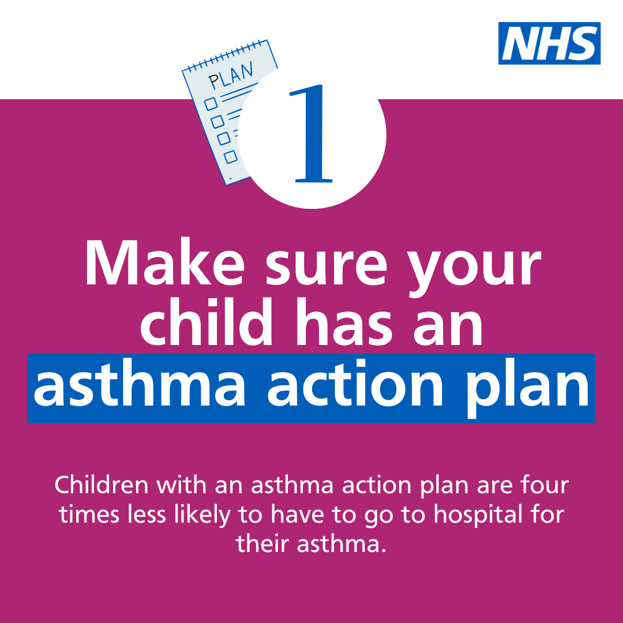  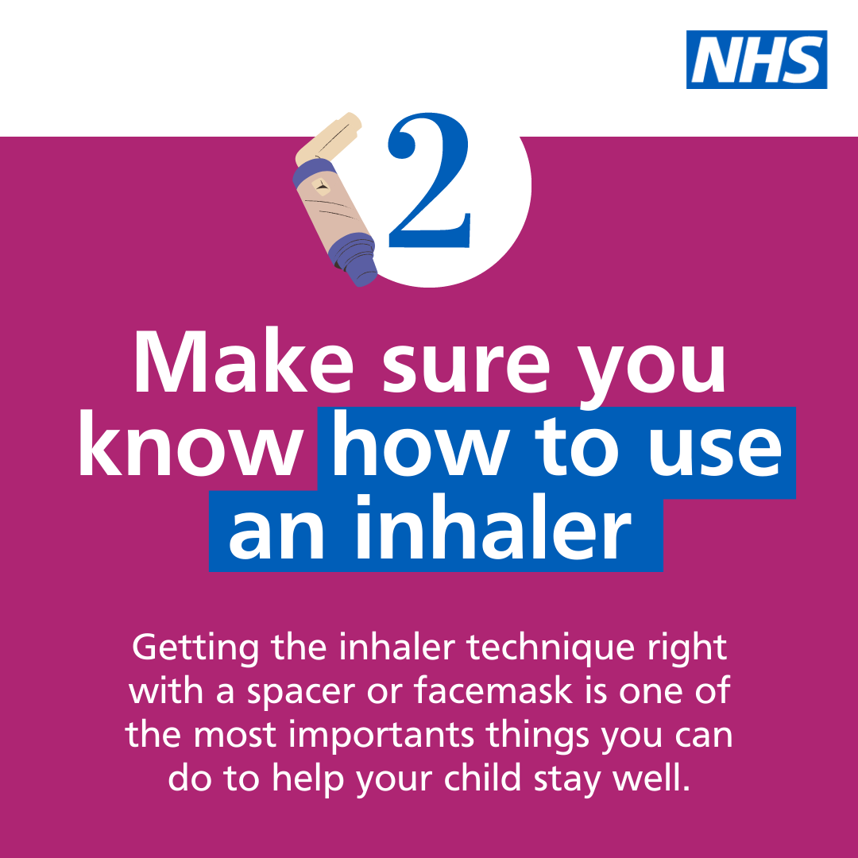  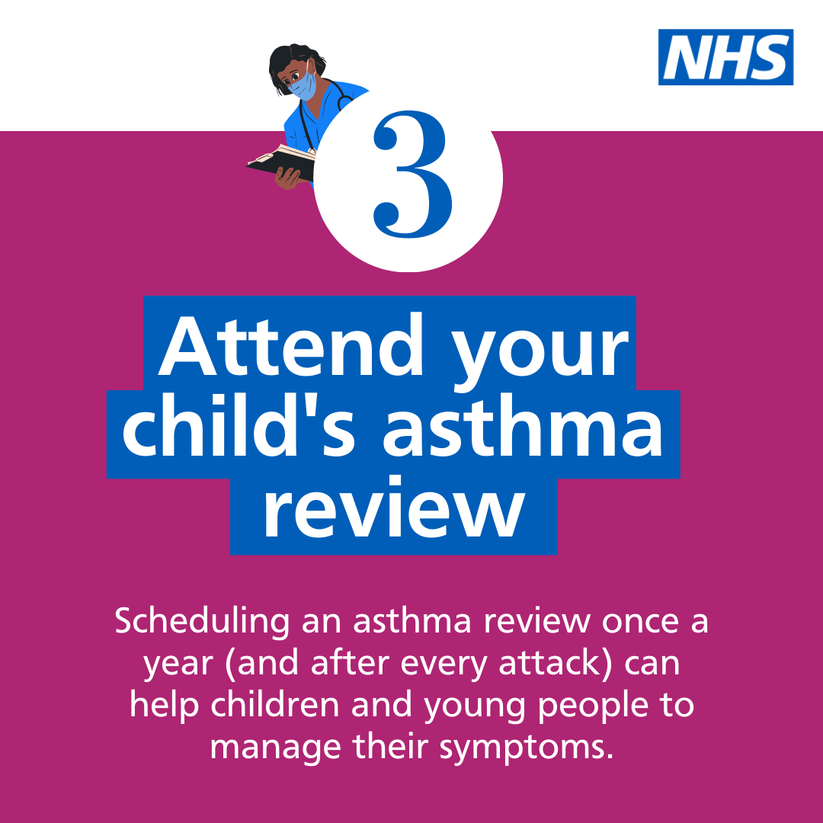  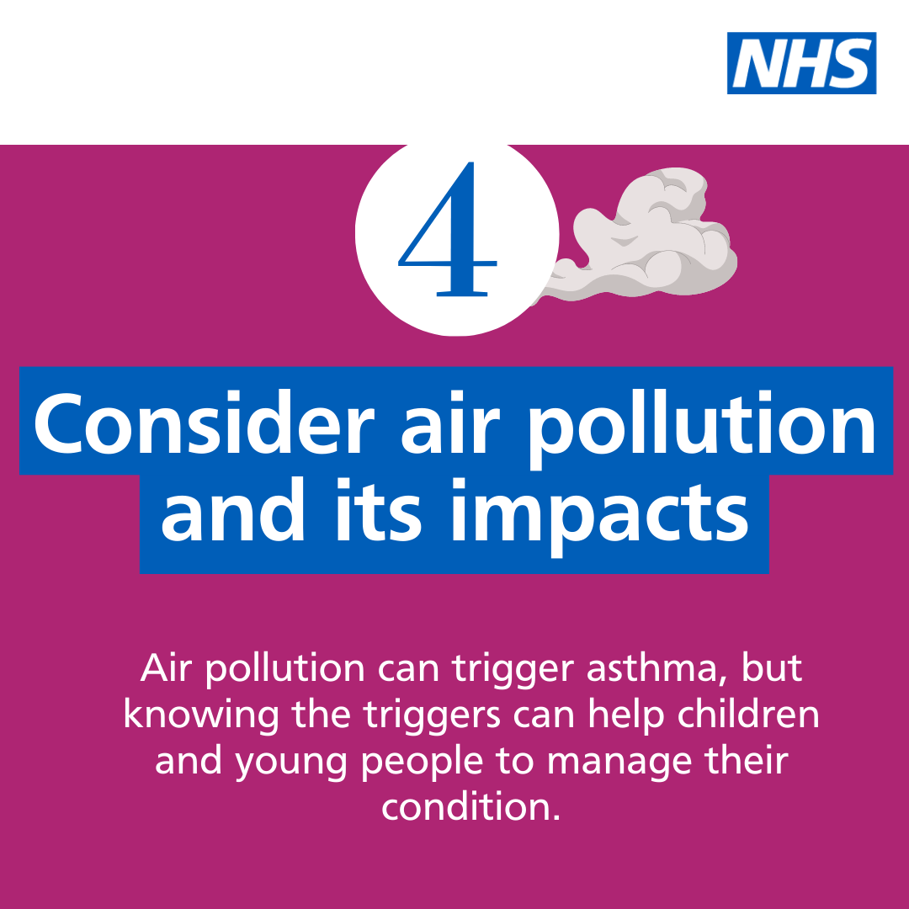  Asset: Upload rotating .mp4 file  Alt text: Text reads: Follow the four steps to help manage your child’s asthma. 1. Get an asthma action plan in place. Children with an asthma action plan are four times less likely to have to go to hospital for their asthma. 2. Understand how to use inhalers correctly. Getting the inhaler technique right with a spacer or facemask is one of the most important things you can do to help your child stay well. 3. Schedule an asthma review – every year and after every attack. Scheduling an asthma review once a year (and after every attack) can help children and young people to manage their symptoms. 4. Consider air pollution and its impact on lung health. Air pollution can trigger asthma; knowing the triggers can help children and young people to manage their condition.  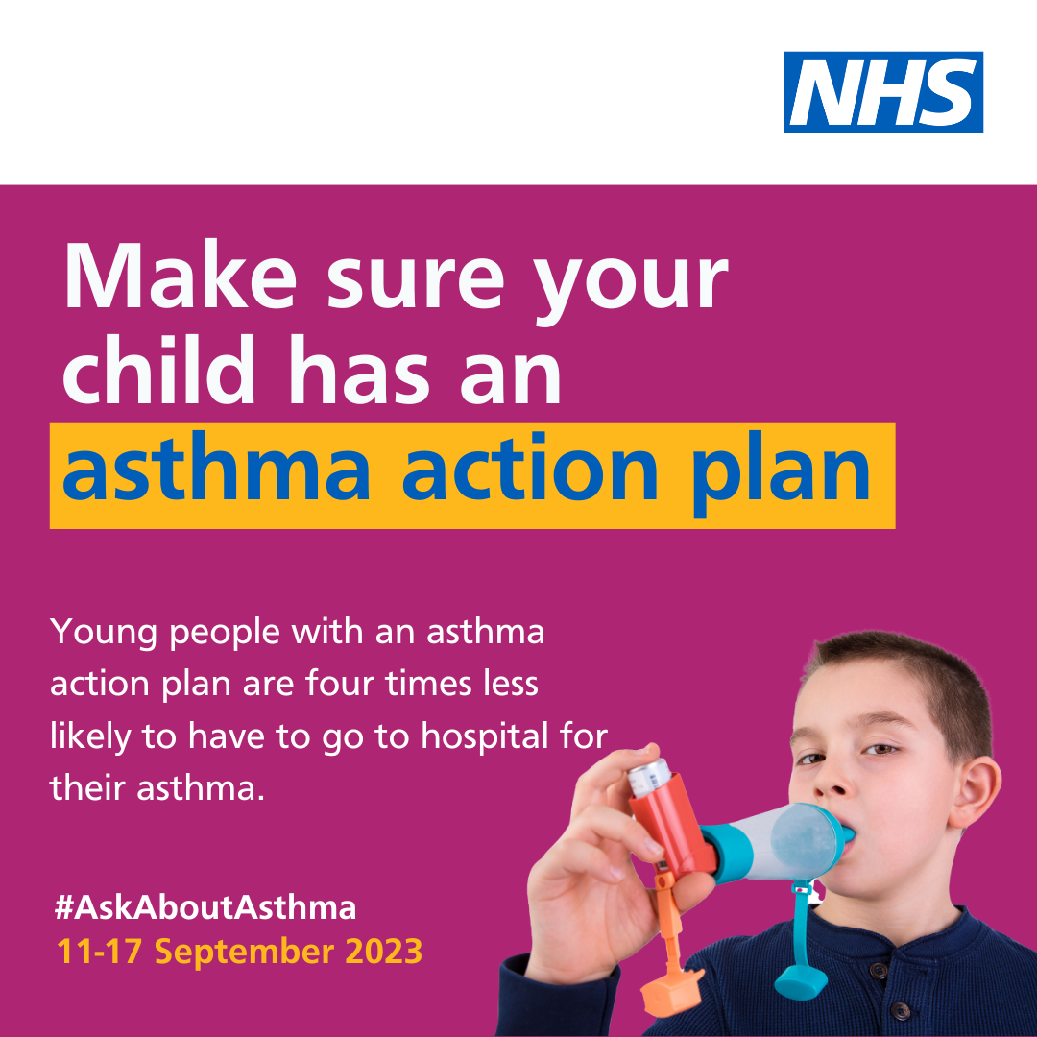  Alt text: An image of a young boy using an inhaler. Text reads: Make sure your child has an asthma action plan. Young people with an asthma action plan are four times less likely to have to go to hospital for their asthma. #AskAboutAsthma. 11-17 September 2023  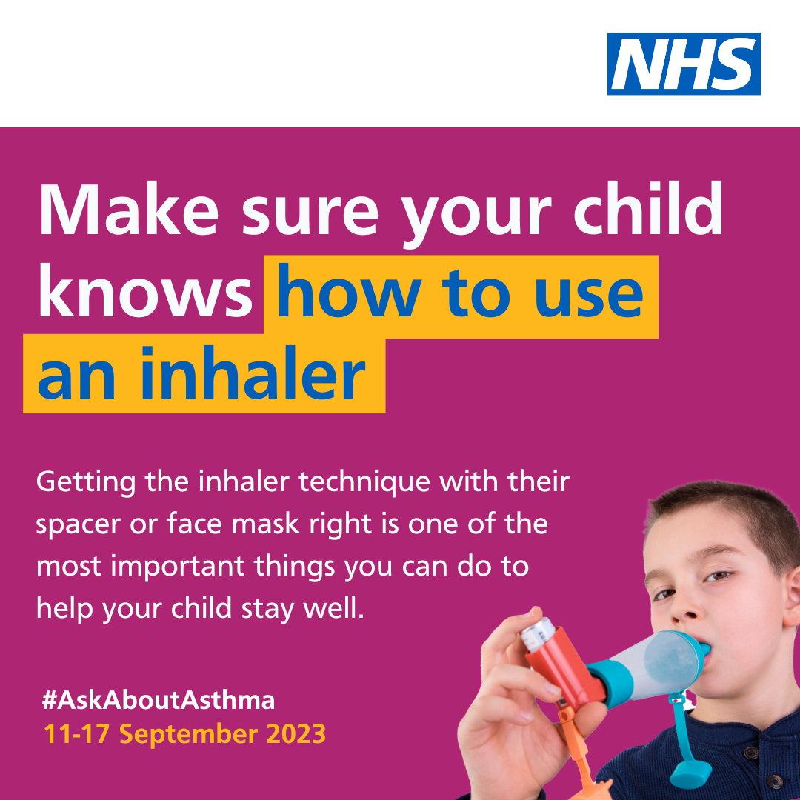  Alt text: An image of a young boy using an inhaler and spacer device. Text reads: Make sure your child knows how to use an inhaler. Getting the inhaler technique right is one of the most important things you can do to manage your asthma and stay well. #AskAboutAsthma. 11-17 September 2023  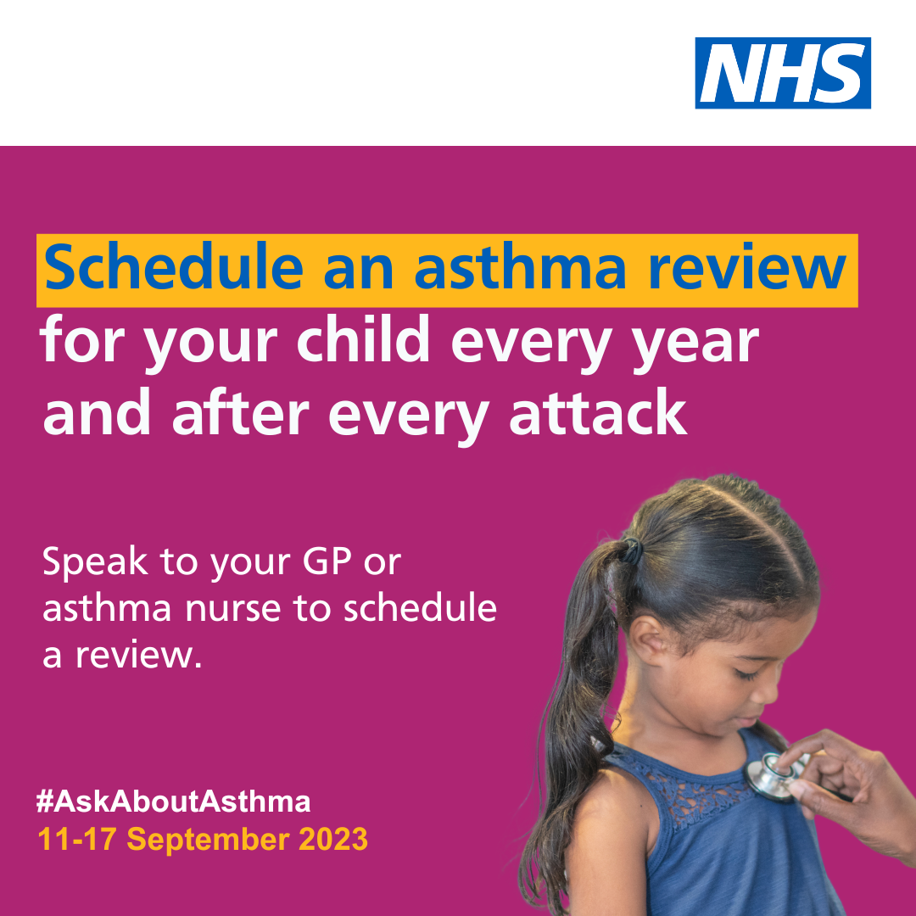  Alt text: An image of a young girl being checked with a stethoscope. Text reads: Schedule an asthma review for your child every year and after every attack. Speak to your GP or asthma nurse to schedule a review. #AskAboutAsthma. 11-17 September 2023  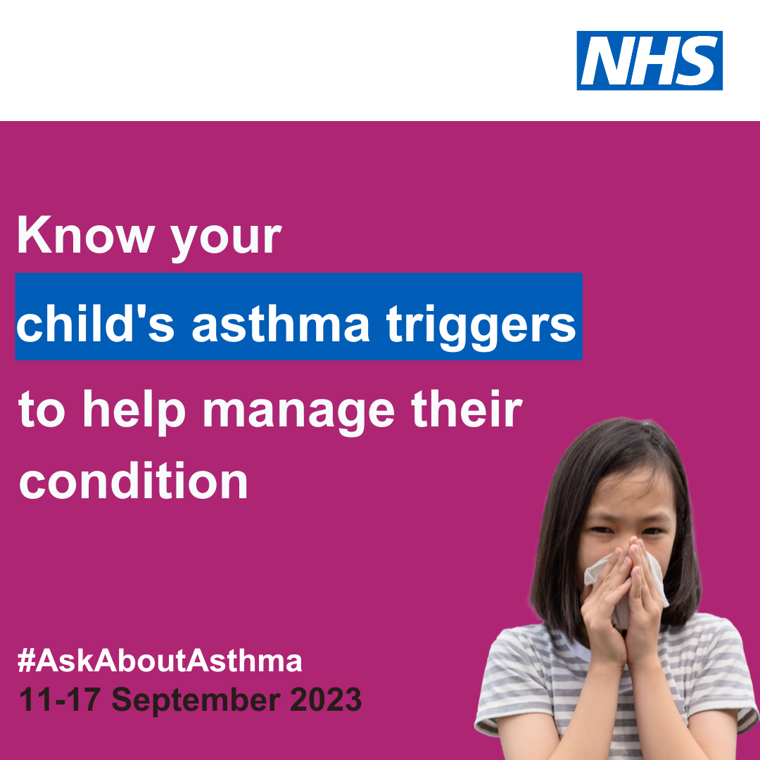  Alt text: An image of a young girl coughing into a tissue. Text reads: Know your asthma triggers to help manage your condition. #AskAboutAsthma. 11-17 September 2023
Twitter asset 3: widening our view  With the right support, every child and young person with asthma can learn to manage their condition.  That’s why #AskAboutAsthma 2023 is encouraging us all to widen our view of children and young people’s asthma.  🔗Learn more at: https://www.transformationpartnersinhealthandcare.nhs.uk/your-asthma-care/ | 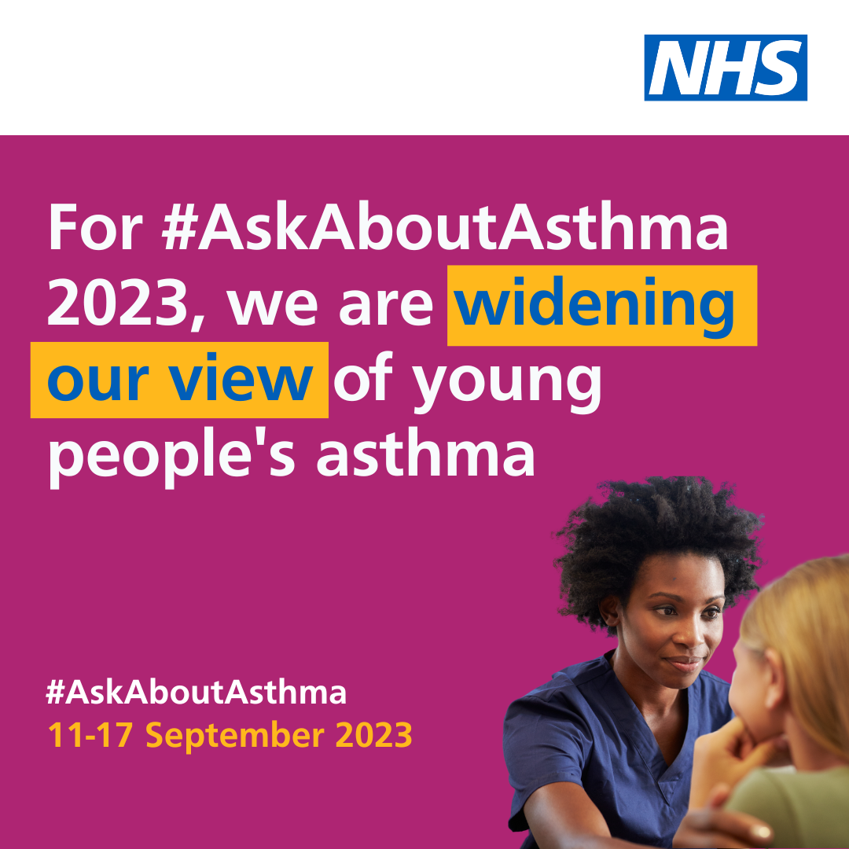  Alt text: An image of a nurse and a young girl. Text reads: For #AskAboutAsthma 2023, we are widening our view of young people's asthma. #AskAboutAsthma. 11-17 September 2023
Instagram asset 1 (carousel video post) – four asks:  There are four steps that can help children and young people to manage their asthma and reduce the risk of asthma attacks:  1. Get an asthma action plan in place  2. Understand how to use inhalers correctly  3. Schedule an asthma review – every year and after every attack  4. Consider air pollution and its impact on lung health  🔗 Search #AskAboutAsthma or follow the link in our bio to learn more about children and young people’s asthma care. | Asset: Upload rotating .mp4 file  Alt text: Text reads: Follow the four steps to help manage your child’s asthma. 1. Get an asthma action plan in place. Children with an asthma action plan are four times less likely to have to go to hospital for their asthma. 2. Understand how to use inhalers correctly. Getting the inhaler technique right with a spacer or facemask is one of the most important things you can do to help your child stay well. 3. Schedule an asthma review – every year and after every attack. Scheduling an asthma review once a year (and after every attack) can help children and young people to manage their symptoms. 4. Consider air pollution and its impact on lung health. Air pollution can trigger asthma; knowing the triggers can help children and young people to manage their condition.
Instagram asset 2 – widening our view:  #AskAboutAsthma 2023 is encouraging us all to  widen our view of children and young people’s asthma and reach out to everyone who has asthma, their friends, families and the whole system that cares for them.  The campaign is shining a light on the wider factors of asthma care including housing, mould and vaping, as well as the key four steps you can take to help manage asthma:  1. Get an asthma action plan in place  2. Understand how to use inhalers correctly  3. Schedule an asthma review – every year and after every attack  4. Consider air pollution and its impact on lung health.  🔗 Search #AskAboutAsthma or follow the link in our bio to learn more about children and young people’s asthma care. | Alt text: An image of a nurse and young girl. Text reads: For #AskAboutAsthma 2023, we are widening our view of young people's asthma. #AskAboutAsthma. 11-17 September 2023  Change bio link to: https://www.transformationpartnersinhealthandcare.nhs.uk/your-asthma-care/
Facebook/LinkedIn asset 1 – 4 asks (carousel video post):  There are four steps that can help children and young people to manage their asthma and reduce the risk of asthma attacks:  1. Get an asthma action plan in place  2. Understand how to use inhalers correctly  3. Schedule an asthma review – every year and after every attack  4. Consider air pollution and its impact on lung health.  Learn more about children and young people’s asthma care at: https://www.transformationpartnersinhealthandcare.nhs.uk/your-asthma-care/ | Asset: Upload rotating .mp4 file  Alt text: Text reads: Follow the four steps to help manage your child’s asthma. 1. Get an asthma action plan in place. Children with an asthma action plan are four times less likely to have to go to hospital for their asthma. 2. Understand how to use inhalers correctly. Getting the inhaler technique right with a spacer or facemask is one of the most important things you can do to help your child stay well. 3. Schedule an asthma review – every year and after every attack. Scheduling an asthma review once a year (and after every attack) can help children and young people to manage their symptoms. 4. Consider air pollution and its impact on lung health. Air pollution can trigger asthma; knowing the triggers can help children and young people to manage their condition.
Facebook/LinkedIn asset 2 – widening our view:  #AskAboutAsthma 2023 is encouraging us all to  widen our view of children and young people’s asthma, helping to raise the profile of asthma and reach out to everyone who has asthma, their friends, families and the whole system that cares for them.  The campaign is shining a light on the wider factors of asthma care including housing, mould and vaping, in addition to the four campaign asks:  - have an asthma review after every attack and at least once a year by an appropriately trained clinician,  - know how to use your inhaler correctly,  - have a written asthma action plan, and,  4. know about the potential impact of air pollution on your lungs.  🔗Learn more at: www.transformationpartnersinhealthandcare.nhs.uk/ask-about-asthma | Alt text: An image of a nurse and young girl. Text reads: For #AskAboutAsthma 2023, we are widening our view of young people's asthma. #AskAboutAsthma. 11-17 September 2023

Downloadable campaign resources
- #AskAboutAsthma campaign poster and easy read version which can be printed out and displayed locally
- Click here to download a digital poster about signs/symptoms of asthma

Asthma fact sheet
Good asthma management reduces exacerbations and allows children and young people to lead full lives. Find information and facts which highlight the risks and outcomes of poorly managed asthma below.
1 in 11 children and young people are affected by asthma, which is around 3 in every London classroom – it is the most common long-term medical condition affecting this group.
Many have badly managed asthma, with over 20,000 admitted to hospital every year in England. Over 4% of these have such a severe episode that they are admitted to intensive care.
Children die in London because of asthma every year. 90% of asthma deaths are preventable with good asthma management: these children should have gone on to lead full and productive lives.
London has a higher rate of illness and death in children and young people because of asthma compared to other European countries.
Asthma is one of the top three causes of emergency admission to hospital (4,000 in London each year).
75% of these admissions would be avoidable through the implementation of simple interventions such as having a regular asthma review by an appropriately trained clinician, knowing how to use inhalers correctly, having a written asthma action plan and knowing about the potential impact of air pollution.
Nearly half of children admitted to hospital have had an asthma attack in the previous year and 30% have had daytime symptoms in the previous week. But only a fraction have a personalised asthma action plan on how their asthma should be managed.
Nitrogen dioxide, particulate matter and other forms of air pollution are known triggers for asthma and poor health more widely, particularly in children and young people.
In 2022 London Ambulance Services (LAS) took 1,375 children to hospital for asthma and 6,191 children for breathlessness.
In 2021/22 there were 132 children admitted into London intensive care units who had a primary diagnosis of asthma (compared to 76 in 2020/21). The average length of stay was 3.7 days.
Rates in 2020/21 were lower due to lower exposure to pollution as well as (non-Covid) viral infections.
While COVID-19 is not thought to be a particular risk for children and young people with asthma, good asthma control and avoidance of unnecessary ED attendances is more important than ever.
Using nebuliser devices at home for the acute treatment of asthma in children and adolescents, without medical supervision, can make it harder to spot signs of worsening asthma. This could result in delays in seeking medical attention and have serious and even fatal consequences.
Only use nebuliser devices at home for the acute treatment of asthma in under 18s if recommended, initiated, and managed by an asthma specialist.

We do not have to wait for new medicines or a cure for asthma: together we can raise awareness and encourage everyone treating or supporting children and young people with asthma to use existing tools and work together to achieve improved outcomes for them.

Other useful resources
- Children and young people’s asthma fact sheet (online version)
- Asthma and Lung UK
- NHS England – London children and young people’s asthma programme
- London toolkit for children and young people with asthma
- London schools’ guide for the care of children and young people with asthma
- The International Primary Care Respiratory Group (IPCRG) image gallery
- Messaging on vaping for young people
- Advice on indoor allergies including mould

