#AskAboutAsthma 2023 campaign communications toolkit for youth organisations

#AskAboutAsthma returns for its seventh year, led by the NHS England – London Babies, Children and Young People’s Transformation team. The #AskAboutAsthma campaign is about making simple changes to children and young people’s care that will make a big difference to how they experience their asthma. The campaign takes place this year from 11-17 September 2023.

How can youth organisations help?
All children and young people should have an asthma plan, a review every year and after every attack, and know how to use their inhalers properly. They should also be aware of the impact of air pollution on their asthma.
Youth groups play an important part in supporting the overall wellbeing of children and young people. By supporting this campaign, you can encourage and support your kids with asthma to manage their condition so they are more likely to be able to participate fully in activities, whether that’s dance, drama, team or individual sports.
This communications toolkit has been produced to help you join the #AskAboutAsthma 2023 campaign week and raise awareness of the simple measures to manage asthma that children, young people and their supporters should be aware of.

What’s included in the toolkit:
- How to get involved with the #AskAboutAsthma 2023 campaign
  - Suggested copy for your websites, newsletters and publications
  - Social media assets and accompanying messages for Twitter, Facebook, Instagram and LinkedIn
  - Downloadable posters
- Further information and resources on asthma

How you can support the #AskAboutAsthma 2023 campaign
The #AskAboutAsthma 2023 campaign will run from 11 – 17 September, ahead of the annual rise in asthma attacks when students go back to school after the summer holidays. Staff working with young people through youth groups and organisations can get involved in a number of ways:
- Enhance your own knowledge and understanding of children and young people’s asthma by joining the #AskAboutAsthma conference and daily webinars, reading our blogs, listening to our podcasts and sharing what you learn on social media. During the campaign week, new content will be released daily, so check out the 2023 campaign webpage for more details and join in as much as you can.
- Spread awareness among colleagues, parents, carers and young people in your organisations that asthma is a chronic condition which can be managed with the ‘four asks’.
- Display the #AskAboutAsthma campaign poster (found later in this toolkit) in your venues to encourage children, young people and their parents/carers to speak to their GP, nurse or pharmacist if they need help managing their asthma.
- Promote an inclusive environment in all of your groups and clubs by sharing information about asthma more generally so your kids understand what it is and how it might impact people who have the condition. See our spotting signs/symptoms of asthma poster to help you share information about asthma and common triggers.
- Encourage young people and their families to think about the impact of indoor and outdoor air quality at home and on the way to/from school and afterschool clubs – air pollution, smoking and vaping can trigger asthma so it’s important to minimise exposure where practical and possible. Support and more information is available on smoking cessation from Stop Smoking London.
- While vaping can help smokers quit, it is not harmless and is not for young people under 18. It is especially important to protect young lungs and brains. Youth groups can help by talking to young people about vaping.

From page 3 of this toolkit, you can find a range of resources and ideas to help publicise the campaign locally, including newsletter copy, social media assets and campaign posters.

Campaign aims
The #AskAboutAsthma campaign encourages children and young people, their families, and those involved in their care to ensure four simple and effective measures to help them control their asthma:
1. Get an asthma action plan in place
A written asthma action plan drawn up between a clinician and patient means people are four times less likely to have to go to hospital for their asthma.

2.Understand how to use inhalers correctly
Less than three-quarters of children and young people have any form of instruction in how to use their inhaler. Poor inhaler technique means patients don’t get the full benefit of their asthma medication.

3. Schedule an asthma review – every year and after every attack
An asthma review by an appropriately trained clinician after every attack helps to work out what went wrong. An annual review ensures effective management of the condition.

4. Consider air pollution and its impact on lung health
We want to ensure that every asthma conversation considers the impact of outdoor and indoor air pollution on children and young people’s asthma.

This year’s theme is “Widening our view” and is shining a light on the wider factors of children and young people’s asthma care including housing, mould and vaping.
Youth organisations play a vital role in local communities across London. By supporting this campaign you can help us to raise the profile of asthma by reaching out to your members who have asthma, and their families, to help them know what good asthma care looks like and that their asthma can be managed with the right measures in place.

Tailored resources for your use
Longer article copy for use in your blogs, local newsletters, community forums

#AskAboutAsthma 2023: widening our view
#AskAboutAsthma is back for 2023. Now in its seventh year the campaign encourages simple changes to children and young people’s care that will make a big difference to how they experience their asthma. The 2023 #AskAboutAsthma campaign will run from 11 – 17 September, ahead of the rise in asthma attacks in September when students go back to school after their summer holidays. The campaign is run by the NHS England – London Babies, Children and Young People’s Transformation team and centres around four steps to help manage asthma:
1. get an asthma action plan in place.
2. understand how to use inhalers correctly.
3. schedule an asthma review every year and after every attack.
4. consider air pollution and its impact on lung health – every asthma conversation should include indoor and outdoor air pollution.
This year’s theme is “Widening our view” and is shining a light on the wider factors of children and young people’s asthma care including housing, mould and vaping. “Widening our view” also helps us to raise the profile of asthma; reaching out to everyone who has asthma, their friends, families and the whole system that cares for them.
Help share the four asks so even more children and young people can be supported to manage their asthma and be more likely to participate fully in sports, dance and other activities.
Visit the 2023 campaign webpage for more information and resources.
(233 words)

Short form article copy for newsletters, bulletins, community forums or WhatsApp groups:

#AskAboutAsthma 2023 – widening our view
#AskAboutAsthma 2023 takes place from 11 – 17 September. This NHS campaign encourages children, young people and their parents and carers to understand how to best manage their asthma. with four measures: 1. get an asthma action plan in place, 2. understand how to use inhalers correctly, 3. schedule an asthma review – every year and after every attack, and 4. consider air pollution and its impact on lung health.
Visit the campaign webpage at www.transformationpartnersinhealthandcare.nhs.uk/ask-about-asthma to learn more about the campaign.
(80 words)

Social media assets and accompanying messaging

Get involved on social media leading up to, and during the #AskAboutAsthma campaign. You can use our social media assets and messaging to raise awareness around #AskAboutAsthma on your channels.
Remember use the campaign hashtag #AskAboutAsthma. We will retweet and like any messages you share.
Follow the NHS England – London babies, children and young people’s transformation team on:

Twitter: @BCYP_NHSLDN
Instagram: @BCYP_NHSLDN

You can find social media suggested messaging on the next page.

To download full-sized images for each social media channel, follow this link to our Google Drive folder.

Suggested messaging and which assets to use
Twitter posts:  - Asset 1: Four asks (rotating carousel)  Is your asthma stopping you from getting active?  A pharmacist, asthma nurse or GP can help you and your parents or carers to put four steps in place so you can manage your asthma.  🔗Learn more about asthma care: https://www.transformationpartnersinhealthandcare.nhs.uk/your-asthma-care/  #AskAboutAsthma  2.1  An asthma action plan has all the information you need to manage your asthma. Speak to a GP or asthma nurse if you do not have an asthma plan.  🔗Find out more about asthma action plans for children and young people: http://www.asthmaandlung.org.uk/conditions/asthma/child/manage/action-plan  #AskAboutAsthma  2.2  Knowing how to use an inhaler correctly can help prevent 75% of asthma hospital admissions in London each year.  Check if you are using your inhaler correctly:  https://www.asthmaandlung.org.uk/conditions/asthma/child/medicines/help  #AskAboutAsthma  2.3  Scheduling an asthma review once a year (and after every attack) can help you to manage your symptoms.  Speak to your pharmacist, GP or asthma nurse to book your next asthma review.  🔗Learn more about asthma care: https://www.transformationpartnersinhealthandcare.nhs.uk/your-asthma-care/  #AskAboutAsthma  2.4  Air pollution, smoking and vaping can trigger asthma. Knowing your triggers can help manage your condition so you don’t miss out on school, sports or other activities.  🔗Learn more about asthma triggers: https://www.asthmaandlung.org.uk/living-with/air-pollution  #AskAboutAsthma | Asset: Upload rotating .mp4 file, or 4 x static images as a carousel post.  Tag: @BCYP_NHSLDN  Alt text: An animation showing four steps to help manage your child’s asthma. 1. Get an asthma action plan in place. 2. Understand how to use inhalers correctly. 3. Schedule an asthma review – every year and after every attack. 4. Consider air pollution and its impact on lung health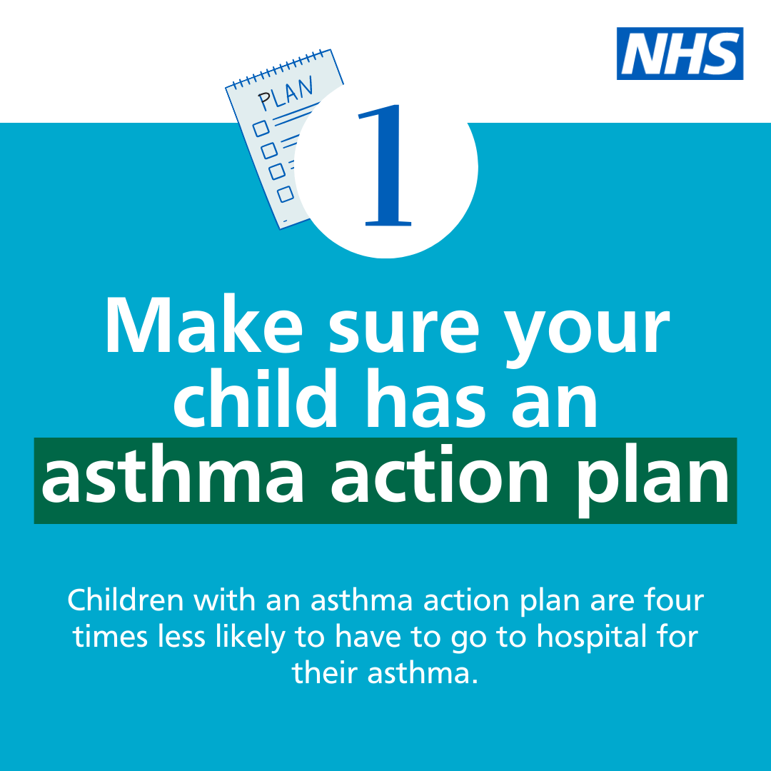  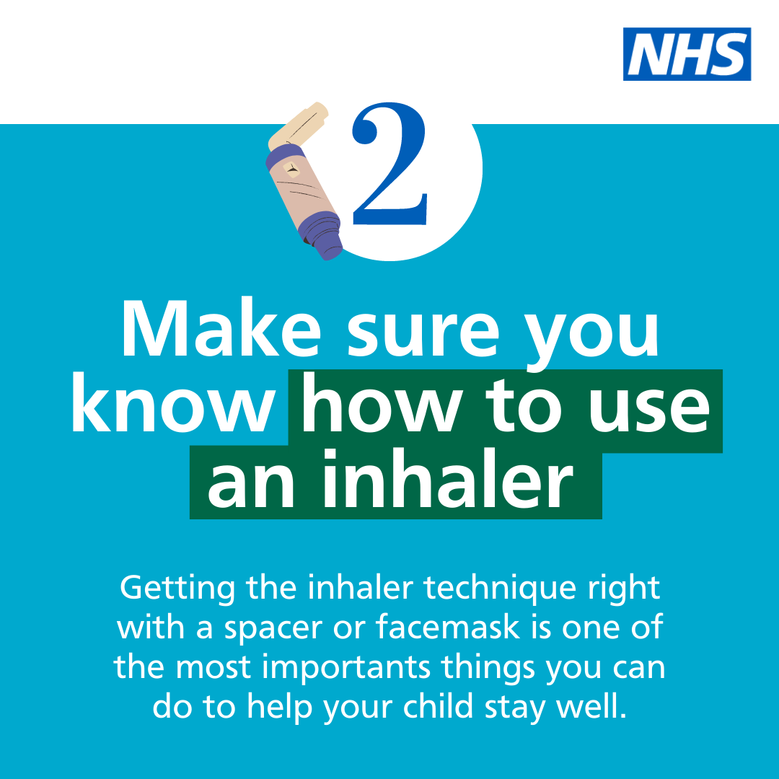  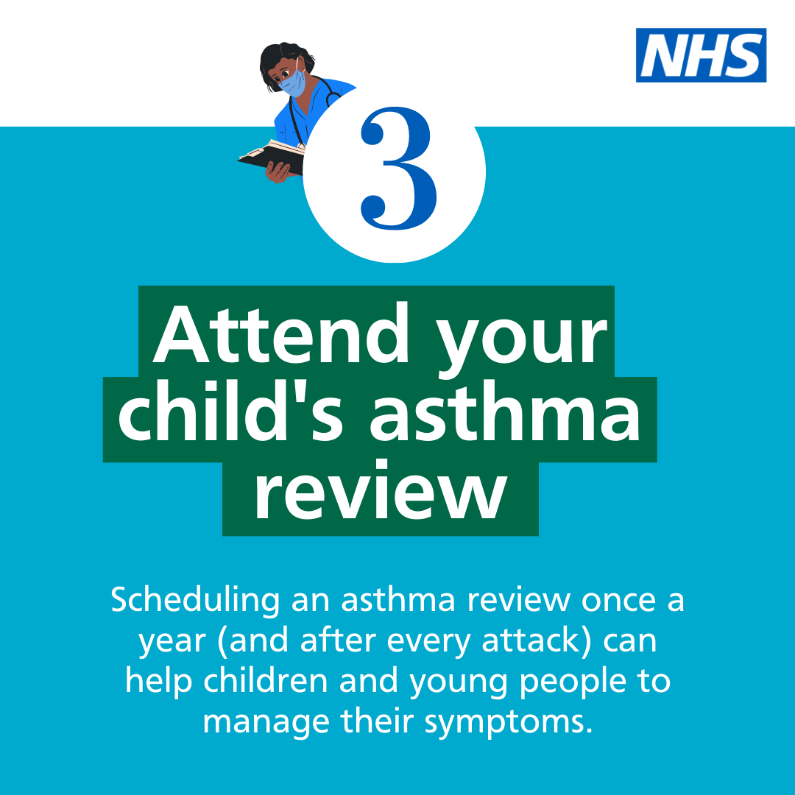  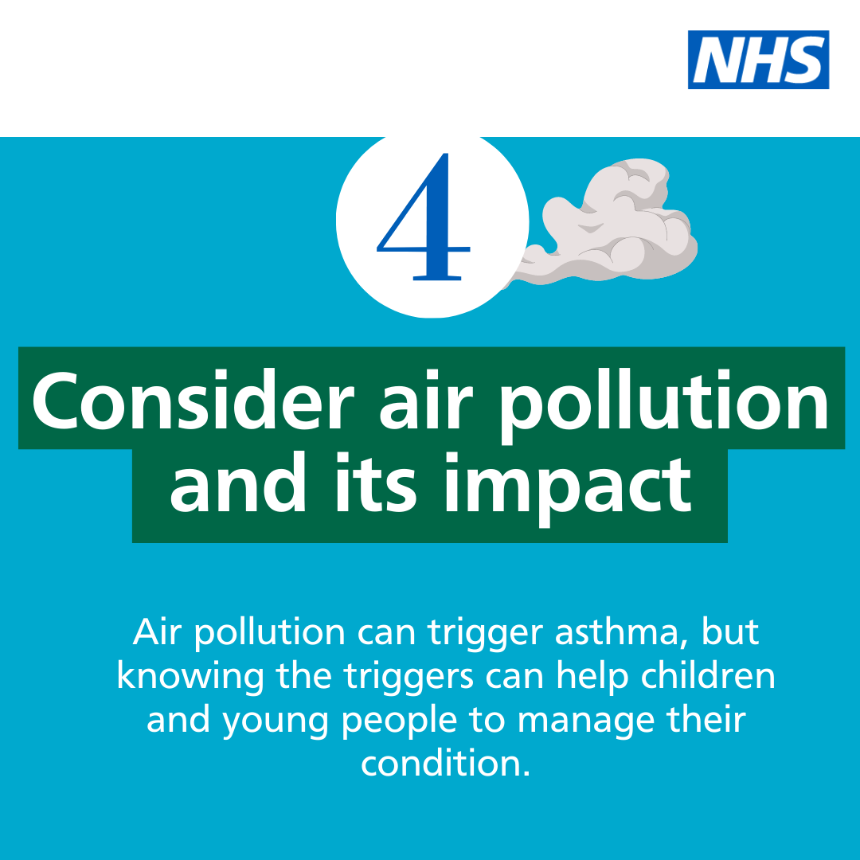  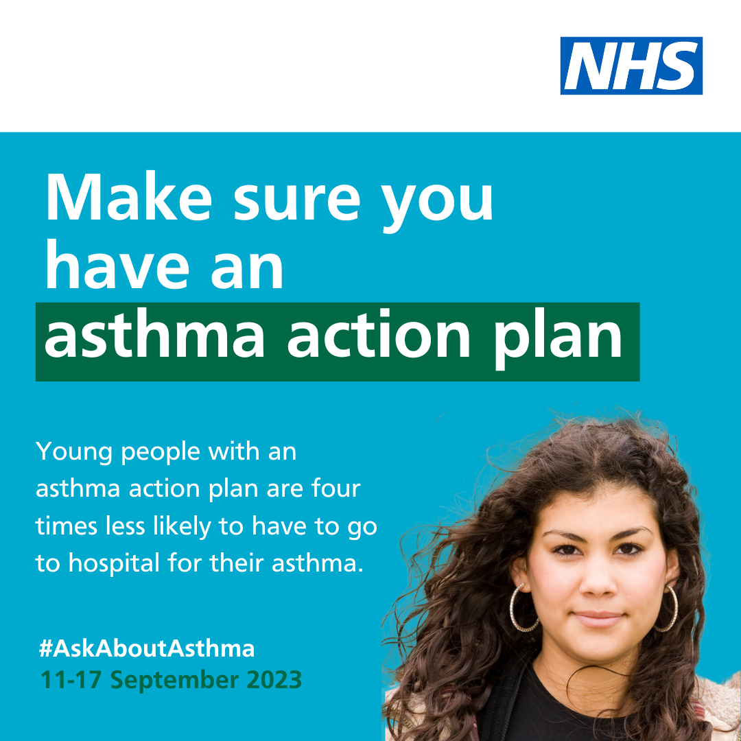  Alt text: An image of a teenage girl. Text reads: Young people with an asthma action plan are four times less likely to have to go to hospital for their asthma. #AskAboutAsthma. 11-17 September 2023  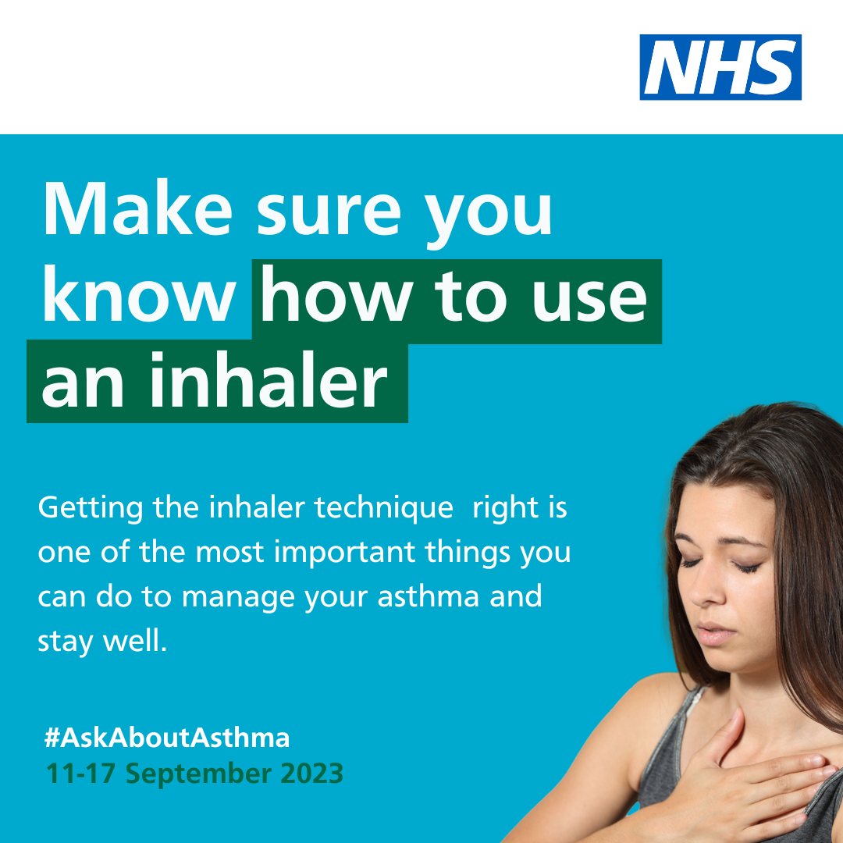  Alt text: An image of a teenage girl holding her chest. Text reads: Make sure you know how to use an inhaler. Getting the inhaler technique is one of the most important things you can do to manage your asthma and stay well. #AskAboutAsthma. 11-17 September 2023  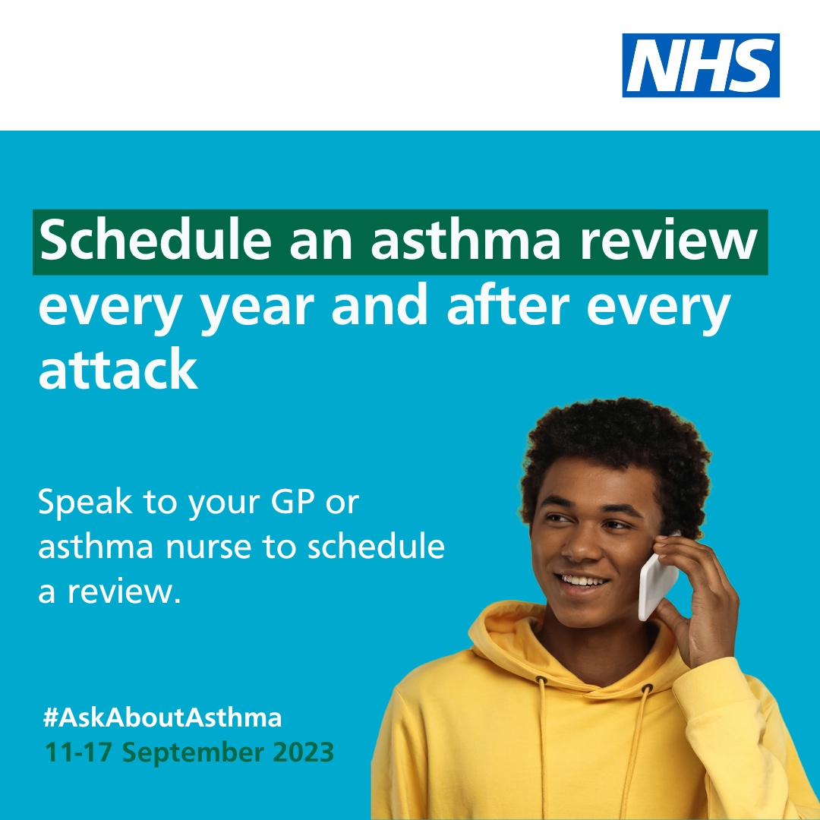  Alt text: An image of a young boy smiling and talking on a mobile phone. Text reads: schedule an asthma review every year and after every attack. Speak to your GP or asthma nurse to schedule a review. #AskAboutAsthma. 11-17 September 2023  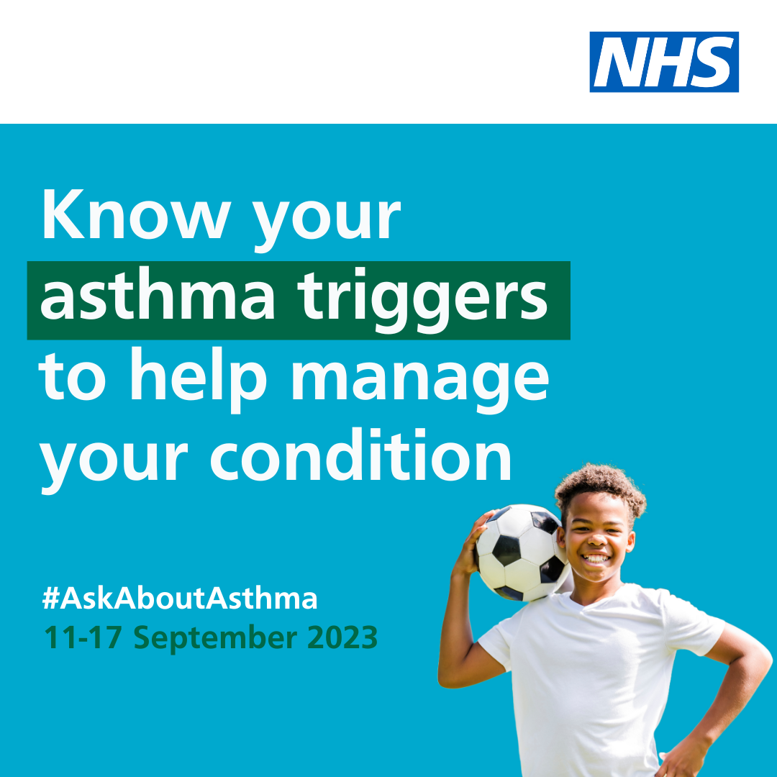  Alt Text: An image of a young boy smiling and balancing a football on his shoulder.  Text reads: Know your asthma triggers to help manage your condition. #AskAboutAsthma. 11-17 September 2023
Twitter asset 2: widening our view  With the right support, every child and young person with asthma can learn to manage their condition.  That’s why #AskAboutAsthma 2023 is encouraging us all to widen our view of children and young people’s asthma.  🔗Learn more at: https://www.transformationpartnersinhealthandcare.nhs.uk/your-asthma-care/ | Alt text: Two teenager girls are pictured and text reads: For #AskAboutAsthma 2023, we are widening our view of young people’s asthma. 11-17 September 2023  Tag: @BCYP_NHSLDN  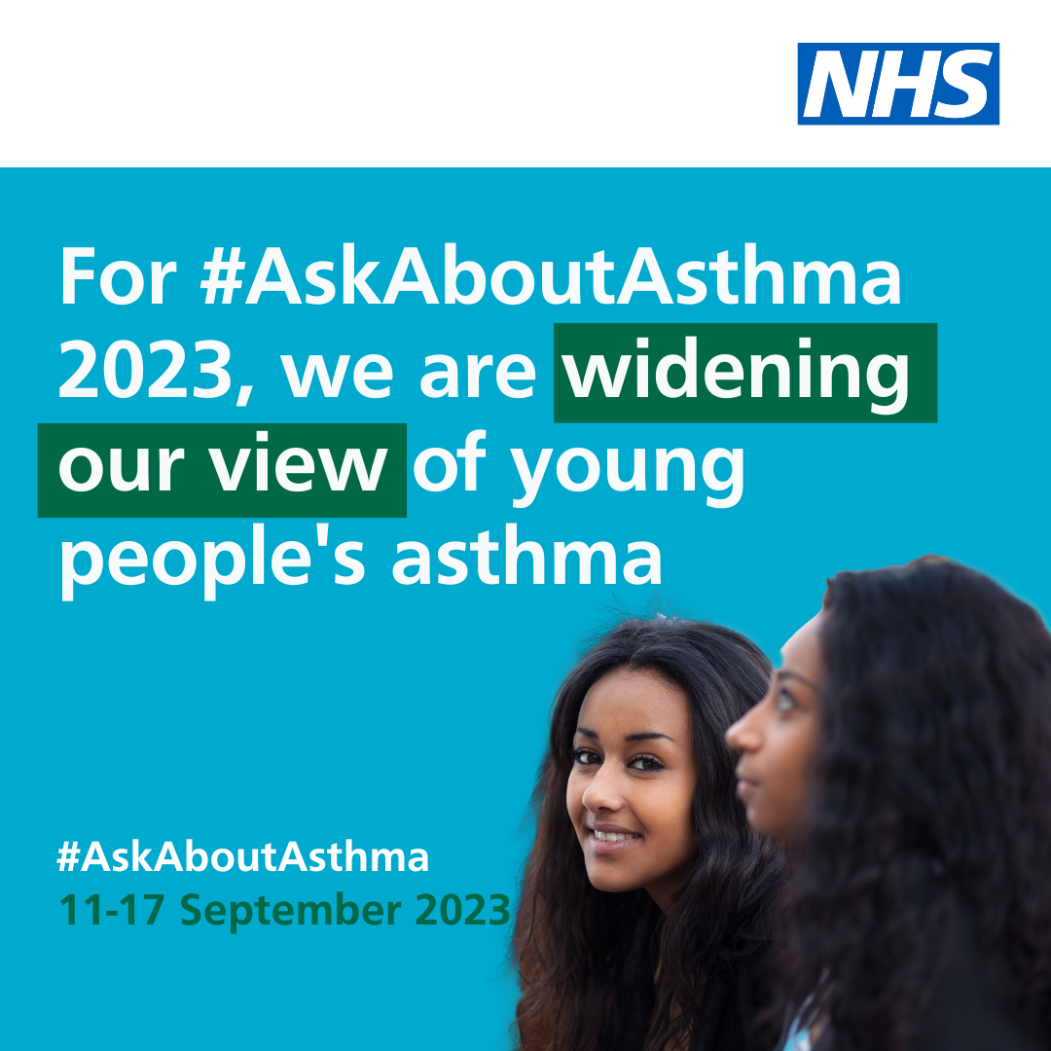
Instagram post 1 – 4 asks:  Have you heard about #AskAboutAsthma? It’s an NHS London campaign that aims to help children and teenagers to learn how to manage their asthma by following four steps:  1. Get an asthma action plan in place  2. Understand how to use inhalers correctly  3. Schedule an asthma review – every year and after every attack  4. Consider air pollution and its impact on lung health  A pharmacist, asthma nurse or GP can help you and your parents or carers to put these four steps in place so you can manage your asthma, get active and join in sports, dance and other activities.  Follow the link in our bio or search #AskAboutAsthma to learn more about this campaign. | Asset: Upload rotating .mp4 file, or 4 x static images as a carousel post.  Change bio link to: https://www.transformationpartnersinhealthandcare.nhs.uk/your-asthma-care/  Alt text: An animation showing four steps to help manage your child’s asthma. 1. Get an asthma action plan in place. 2. Understand how to use inhalers correctly. 3. Schedule an asthma review – every year and after every attack. 4. Consider air pollution and its impact on lung health  Tag: @BCYP_NHSLDN
Instagram post 2 – widening our view:  #AskAboutAsthma 2023 is encouraging us all to  widen our view of children and young people’s asthma and reach out to everyone who has asthma, their friends, families and the whole system that cares for them.  The campaign is shining a light on the wider factors of asthma care including housing, mould and vaping, as well as the key four steps you can take to help manage asthma:  1. Get an asthma action plan in place  2. Understand how to use inhalers correctly  3. Schedule an asthma review – every year and after every attack  4. Consider air pollution and its impact on lung health.  🔗 Search #AskAboutAsthma or follow the link in our bio to learn more about children and young people’s asthma care. | Alt text: Two teenager girls are pictured and text reads: For #AskAboutAsthma 2023, we are widening our view of young people’s asthma. 11-17 September 2023  Tag: @BCYP_NHSLDN  Change bio link to: https://www.transformationpartnersinhealthandcare.nhs.uk/your-asthma-care/
Facebook/LinkedIn asset 1 – 4 asks (carousel video post):  Have you heard about #AskAboutAsthma? It’s an NHS London campaign that aims to help children and teenagers to learn how to manage their asthma by following four steps:  1. Get an asthma action plan in place  2. Understand how to use inhalers correctly  3. Schedule an asthma review – every year and after every attack  4. Consider air pollution and its impact on lung health.  A pharmacist, asthma nurse or GP can help you and your parents or carers to put these four steps in place so you can manage your asthma, get active and join in sports, dance and other activities.  .  Learn more about children and young people’s asthma care at: https://www.transformationpartnersinhealthandcare.nhs.uk/your-asthma-care/ | Asset: Upload rotating .mp4 file, or 4 x static images as a carousel post.  Change bio link to: https://www.transformationpartnersinhealthandcare.nhs.uk/your-asthma-care/  Alt text: An animation showing four steps to help manage your child’s asthma. 1. Get an asthma action plan in place. 2. Understand how to use inhalers correctly. 3. Schedule an asthma review – every year and after every attack. 4. Consider air pollution and its impact on lung health
Facebook/LinkedIn asset 2 – widening our view:  #AskAboutAsthma 2023 is encouraging us all to  widen our view of children and young people’s asthma, helping to raise the profile of asthma and reach out to everyone who has asthma, their friends, families and the whole system that cares for them.  The campaign is shining a light on the wider factors of asthma care including housing, mould and vaping, in addition to the four campaign asks:  - have an asthma review after every attack and at least once a year by an appropriately trained clinician,  - know how to use your inhaler correctly,  - have a written asthma action plan, and,  - know about the potential impact of air pollution on your lungs.  🔗Learn more at: www.transformationpartnersinhealthandcare.nhs.uk/ask-about-asthma | Alt text: Two teenager girls are pictured and text reads: For #AskAboutAsthma 2023, we are widening our view of young people’s asthma. 11-17 September 2023

Downloadable posters for use in local community settings
- #AskAboutAsthma campaign poster and easy read version which can be printed out and displayed locally
- Click here to download a digital poster about signs/symptoms of asthma

Other useful resources
- Children and young people’s asthma fact sheet
- Asthma and Lung UK
- NHS England – London children and young people’s asthma programme
- London toolkit for children and young people with asthma
- London schools’ guide for the care of children and young people with asthma
- The International Primary Care Respiratory Group (IPCRG) image gallery
- Messaging on vaping for young people
- Advice on indoor allergies including mould

We do not have to wait for new medicines or a cure for asthma: we need to educate and support everyone treating or supporting children and young with asthma to use these tools and work together to achieve improved outcomes.

