#AskAboutAsthma 2023 communications toolkit for local authorities and public health teams

#AskAboutAsthma returns for its seventh year, led by the NHS England – London Babies, Children and Young People’s Transformation team. The #AskAboutAsthma campaign is about making simple changes to children and young people’s care that will make a big difference to how they experience their asthma.
The campaign takes place this year from 11-17 September 2023.
Local Authorities and public health teams have a major role in understanding the impact of childhood asthma in their local boroughs, spreading awareness about asthma and how it can be managed, the health impacts of air pollution (indoor and outdoor), and ensuring London is a safe and equitable place to live.

Our aims

The #AskAboutAsthma campaign encourages children and young people, their families, and those involved in their care, to ensure simple and effective measures to help them control their asthma:

1. Get an asthma action plan in place,

2. Understand how to use inhalers correctly,

3. Schedule an asthma review – every year and after every attack.
4. Consider air pollution and its impact on lung health.

This year’s campaign theme is “Widening our view” to shine a light on the wider factors of children and young people’s asthma care including housing, mould and vaping.
Widening our view also helps us to raise the profile of asthma; reaching out to everyone who has asthma, their friends, families and the whole system that cares for them.
Your local authority and public health team can play an important part by bringing together colleagues across services including health, children and young people, education, and environment to raise awareness of the asthma management measures that enable children and young people with asthma in your borough to live full lives.

What’s included in the toolkit:
- How to get involved with the #AskAboutAsthma 2023 campaign
  - Suggested copy for borough websites, residents’ newsletters, housing associations and internal communications
  - Social media and suggested messages for Facebook, Instagram, Twitter and LinkedIn
- Downloadable posters
- Further information

How to get involved with the #AskAboutAsthma 2023 campaign

Getting ahead of week 38
#AskAboutAsthma will take place from 11-17 September 2023.
Supporters of the campaign can take the learning, resources and key information shared to be even more prepared for week 38 (in 2023 this is from 18-24 September) – the week where, nationally, there is a rise in asthma attacks following the return to school after the summer holidays.

This communications toolkit has been prepared for colleagues working within London’s local authorities and Directors of Public Health to get involved in the #AskAboutAsthma 2023 campaign. Activities could include:
- Spreading the word using our assets (found later in this toolkit) in localised campaigns to raise awareness around the four asthma asks.
- Sharing the campaign on your public facing website, through your resident newsletters, housing associations and on social media so you can help improve knowledge and confidence across members of your communities to seek the right asthma care.
- Sharing the campaign through your internal communications channels to reach frontline staff and service leads within your council, helping to develop understanding of children and young people’s asthma by joining virtual events or browsing new blogs, videos and podcasts on asthma care, which will be shared during the campaign week.
- Considering how to work with your integrated care system, housing, education and air quality teams to develop longer term strategies that consider health inequalities and air quality to improve children and young people’s asthma care. This could mean:
  - Connecting with your schools by sharing campaign information in your boroughs’ school newsletters
  - Supporting your schools to become asthma friendly – good asthma management and care will reduce school absences due to asthma attacks and help pupils to take part in physical activities to support their overall health and wellbeing, as well as reducing their risk of childhood obesity.
  - Sharing clear and accessible messaging to help inform young people under the age of 18 in your borough of the risks of vaping – see suggested messaging here.
  - Discussing asthma with housing colleagues as damp and mould have health implications for asthma sufferers.
  - Encouraging borough-wide initiatives to improve local air quality – for example, no idling outside schools or parks, active travel to get around locally, etc.

Virtual events and learning resources
During the campaign week, new content will be released daily, so check out the 2023 campaign web page for more details and join in as much as you can. Find information about the focus areas of the campaign week below:
11-Sep | 12-Sep | 13-Sep | 14-Sep | 15-Sep | 16-Sep | 17-Sep
Monday | Tuesday | Wednesday | Thursday | Friday | Saturday | Sunday
Children and young people | Primary care and pharmacy | Nursing | Whole systems Conference | Air pollution | Recap | Recap

Tailored resources for your use

Long form article copy for websites, blogs, publications etc:
#AskAboutAsthma 2023: widening our view
#AskAboutAsthma is back for 2023. Now in its seventh year the campaign encourages simple changes to children and young people’s care that will make a big difference to how they experience their asthma. The 2023 #AskAboutAsthma campaign will run from 11 – 17 September, ahead of the rise in asthma attacks in September when students go back to school after their summer holidays.
The campaign is run by the NHS England – London Babies, Children and Young People’s Transformation team and centres around four steps to help manage asthma:
1. get an asthma action plan in place.
2. understand how to use inhalers correctly.
3. schedule an asthma review every year and after every attack.
4. consider air pollution and its impact on lung health – every asthma conversation should include indoor and outdoor air pollution.
This year’s theme is “Widening our view” and is highlighting wider factors including air quality, housing, mould and vaping which affect all residents across [insert borough], and particularly people with respiratory conditions including asthma. “Widening our view” also helps us to raise the profile of asthma; reaching out to everyone who has asthma, their friends, families and the whole system that cares for them.
For more information about the campaign and four steps to managing asthma, visit the 2023 #AskAboutAsthma for more information and resources.
(218 words)

Short form article copy or newsletters, bulletins, community forums or WhatsApp groups:
#AskAboutAsthma 2023 – widening our view
#AskAboutAsthma 2023 takes place from 11 – 17 September. The campaign encourages children, young people and their parents and carers to understand how to best manage their asthma by following four steps:
1. get an asthma action plan in place,
2. understand how to use inhalers correctly,
3. schedule an asthma review – every year and after every attack, and
4. consider air pollution and its impact on lung health.
The campaign is also highlighting wider factors including housing, mould and vaping which affect all residents across [insert borough], and particularly children and young people with respiratory conditions such as asthma.
Learn more about the campaign at: www.transformationpartnersinhealthandcare.nhs.uk/ask-about-asthma.
(106 words)

Social media assets and accompanying messaging

You can post about #AskAboutAsthma on your social media channels leading up to the campaign week and during it (11-17 September).

Remember to use the campaign hashtag: #AskAboutAsthma so we can reshare your posts.

Follow the NHS England – London babies, children and young people’s transformation team on:

Twitter: @BCYP_NHSLDN
Instagram: @BCYP_NHSLDN

You can find social media suggested messaging below. To download full-sized images for each social media channel, follow this link to our Google Drive folder.

Suggested messaging and which assets to use
Twitter asset 1 – four asks (MP4 video):  - 4 asks overview:  There are four steps that can help children and young people in [insert borough] to manage their asthma and live full, active lives.  🔗Learn more about asthma care: https://www.transformationpartnersinhealthandcare.nhs.uk/your-asthma-care/  #AskAboutAsthma  2.1  An asthma action plan has all the information you need to manage a child or young person’s asthma. Speak to a GP or asthma nurse if you do not have an asthma plan.  🔗Find out more about asthma action plans for children and young people: http://www.asthmaandlung.org.uk/conditions/asthma/child/manage/action-plan  #AskAboutAsthma  2.2  Knowing how to use an inhaler correctly can help prevent 75% of asthma hospital admissions in London each year.  Check if you or your child is using their inhaler correctly:  http://www.asthmaandlung.org.uk\\conditions\\asthma\\child\\medicines\\help  #AskAboutAsthma  2.3  Scheduling an asthma review once a year (and after every attack) can help children and young people to manage their symptoms.  Speak to your GP or asthma nurse to book your next asthma review.  🔗Learn more about asthma care: https://www.transformationpartnersinhealthandcare.nhs.uk/your-asthma-care/  #AskAboutAsthma  2.4  Indoor and outdoor air pollution can trigger asthma, but knowing the triggers can help children and young people to manage their condition.  🔗Learn more about managing air pollution triggers: https://www.asthmaandlung.org.uk/living-with/air-pollution  #AskAboutAsthma | 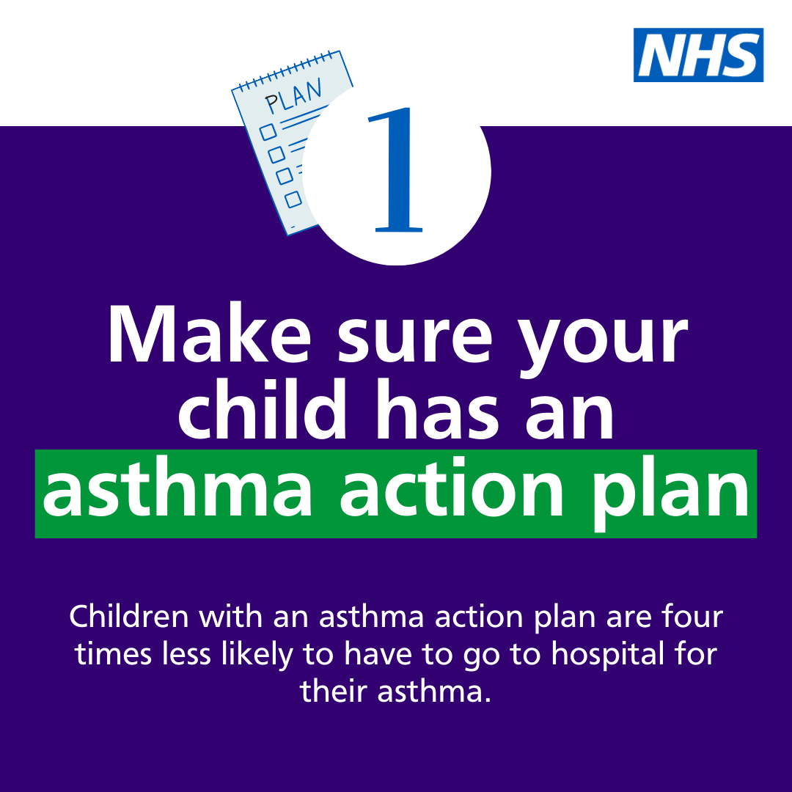  Asset: Upload rotating .mp4 file, or 4 x static images as a carousel post.  Tag: @BCYP_NHSLDN  Alt text: An animation showing four steps to help manage your child’s asthma. 1. Get an asthma action plan in place. 2. Understand how to use inhalers correctly. 3. Schedule an asthma review – every year and after every attack. 4. Consider air pollution and its impact on lung health  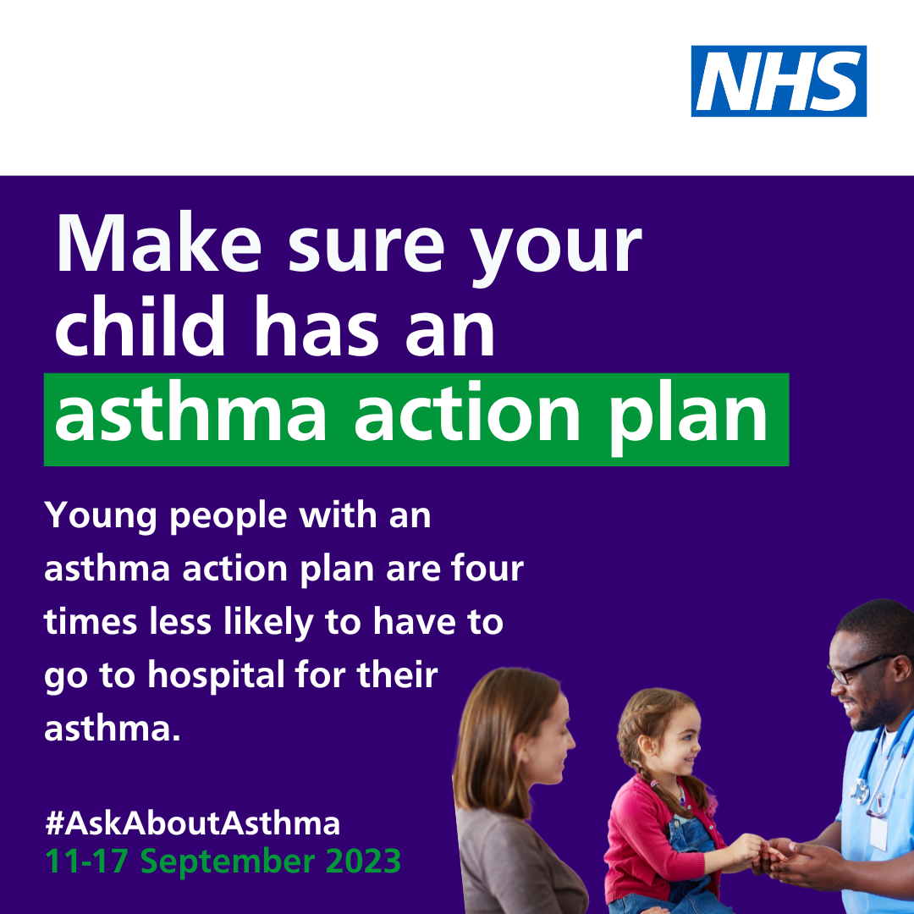  Alt text: An image of a young girl using an inhaler and spacer device. Text reads: Make sure your child has an asthma action plan. Young people with an asthma action plan are four times less likely to have to go to hospital for their asthma. #AskAboutAsthma. 11-17 September 2023  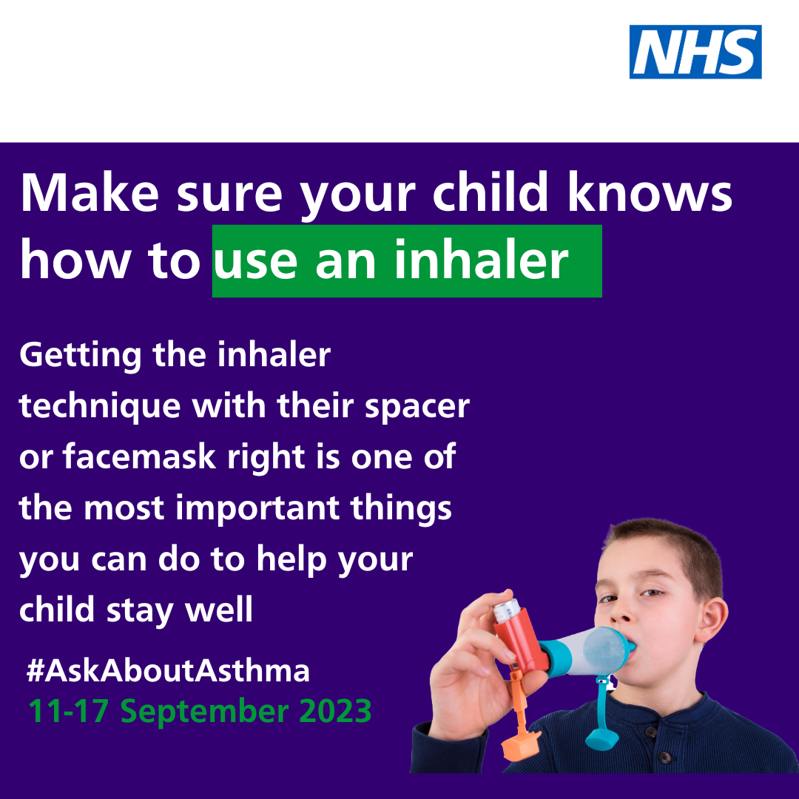  Alt text: An image of a young boy using an inhaler and spacer device. Text reads: Make sure your child knows how to use an inhaler. Getting the inhaler technique with their spacer or facemask right is one of the most important things you can do to help your child stay well. #AskAboutAsthma. 11-17 September 2023  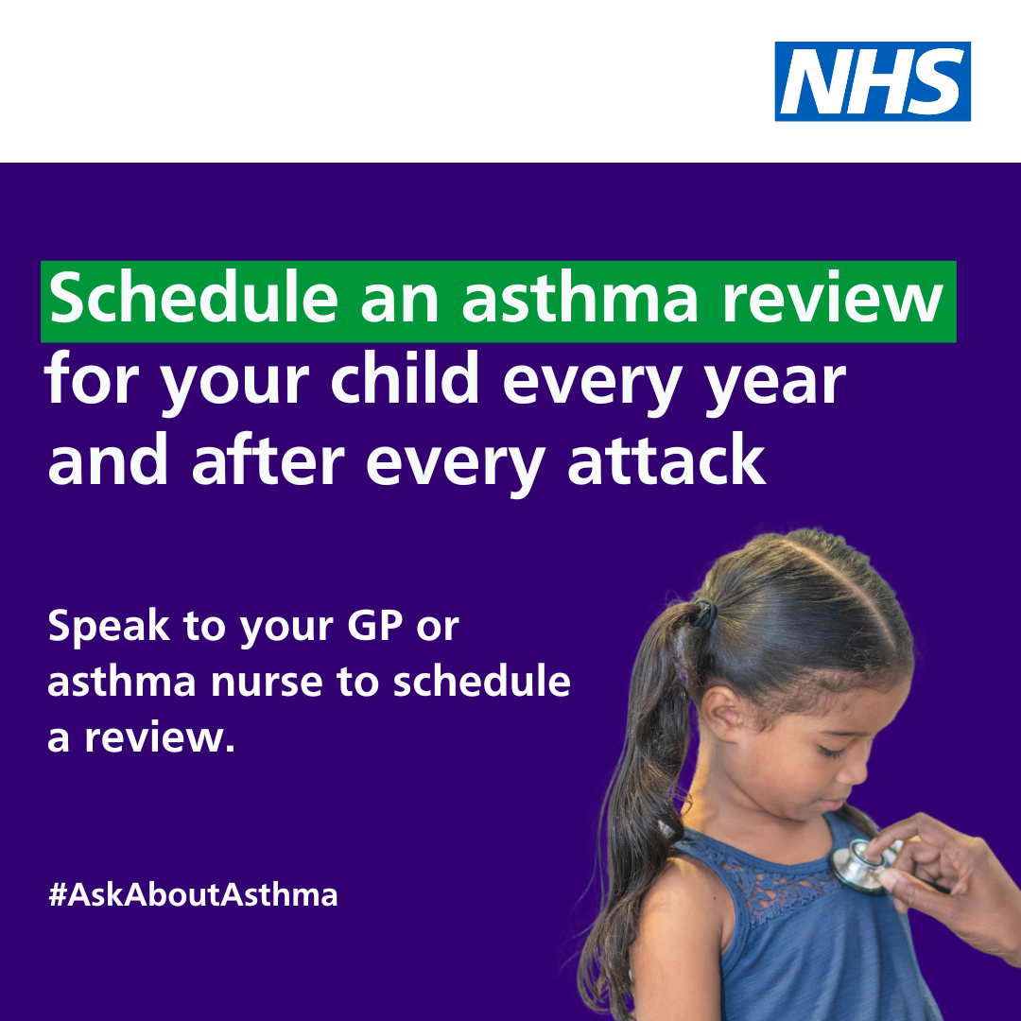  Alt text: An image of a young girl being checked with a stethoscope. Text reads: Schedule an asthma review for your child every year and after every attack. Speak to your GP or asthma nurse to schedule a review. #AskAboutAsthma. 11-17 September 2023  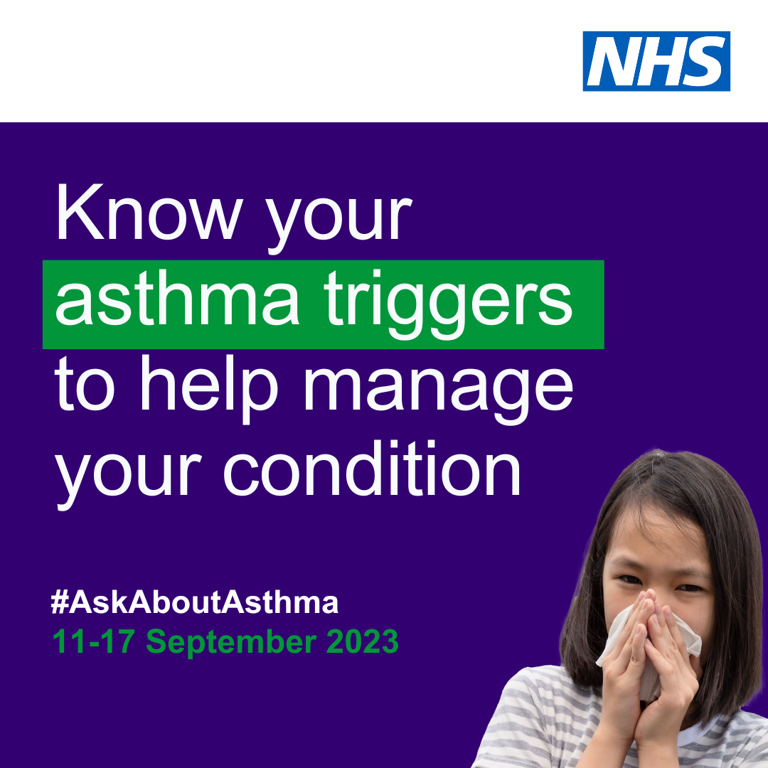  Alt Text: An image of a young girl coughing into a tissue. Text reads: Know your child’s asthma triggers to help manage their condition. #AskAboutAsthma. 11-17 September 2023
Twitter asset 2: widening our view  With the right support, every child and young person with asthma in [insert borough] can learn to manage their condition.  That’s why #AskAboutAsthma 2023 is encouraging us all to widen our view of children and young people’s asthma.  🔗Learn more at: https://www.transformationpartnersinhealthandcare.nhs.uk/your-asthma-care/ | I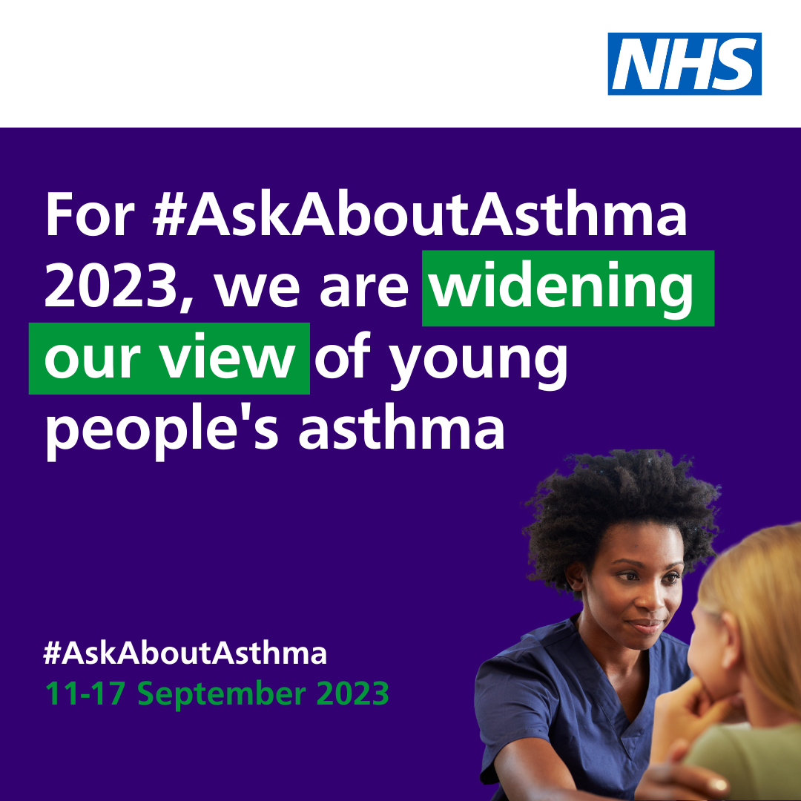  Alt text: An image of a nurse talking to a child. Text reads: For #AskAboutAsthma 2023, we are widening our view of children and young people's asthma. #AskAboutAsthma. 11-17 September 2023  Tag: @BCYP_NHSLDD
Instagram asset 1 – four asks:  There are four steps that can help children and young people to manage their asthma and live full, active lives:  1. Get an asthma action plan in place  2. Understand how to use inhalers correctly  3. Schedule an asthma review – every year and after every attack  4. Consider air pollution and its impact on lung health  🔗 Search #AskAboutAsthma or follow the link in our bio to learn more about children and young people’s asthma care. | Asset: Upload rotating .mp4 file, or 4 x static images as a carousel post.  Alt text: Text reads: Follow the four steps to help manage your child’s asthma. 1. Get an asthma action plan in place. 2. Understand how to use inhalers correctly. 3. Schedule an asthma review – every year and after every attack. 4. Consider air pollution and its impact on lung health  Tag: @BCYP_NHSLDN  Change bio link to: https://www.transformationpartnersinhealthandcare.nhs.uk/your-asthma-care/
Instagram asset 2 – widening our view:  #AskAboutAsthma 2023 is encouraging us all to  widen our view of children and young people’s asthma and reach out to everyone who has asthma, their friends, families and the whole system that cares for them.  The campaign is shining a light on the wider factors of asthma care including housing, mould and vaping, as well as the key four steps you can take to help manage asthma:  1. Get an asthma action plan in place  2. Understand how to use inhalers correctly  3. Schedule an asthma review – every year and after every attack  4. Consider air pollution and its impact on lung health.  🔗 Search #AskAboutAsthma or follow the link in our bio to learn more about children and young people’s asthma care. | Alt text: An image of a young boy coughing into his arm. Text reads: For #AskAboutAsthma 2023, we are widening our view of children and young people's asthma. #AskAboutAsthma. 11-17 September 2023  Tag: @BCYP_NHSLDN  Change bio link to: https://www.transformationpartnersinhealthandcare.nhs.uk/your-asthma-care/
Facebook/LinkedIn asset 1 – 4 asks:  There are four steps that can help children and young people in [insert borough] to manage their asthma and live full, active lives:  1. Get an asthma action plan in place  2. Understand how to use inhalers correctly  3. Schedule an asthma review – every year and after every attack  4. Consider air pollution and its impact on lung health.  Learn more about children and young people’s asthma care at: https://www.transformationpartnersinhealthandcare.nhs.uk/your-asthma-care/ | Asset: Upload rotating .mp4 file, or 4 x static images as a carousel post.  Alt text: Text reads: Follow the four steps to help manage your child’s asthma. 1. Get an asthma action plan in place. 2. Understand how to use inhalers correctly. 3. Schedule an asthma review – every year and after every attack. 4. Consider air pollution and its impact on lung health
Facebook/LinkedIn asset 2 – widening our view:  #AskAboutAsthma 2023 is encouraging us all to  widen our view of children and young people’s asthma, helping to raise the profile of asthma and reach out to everyone who has asthma, their friends, families and the whole system that cares for them.  The campaign is shining a light on the wider factors of asthma care including housing, mould and vaping, in addition to the four campaign asks:  - have an asthma review after every attack and at least once a year by an appropriately trained clinician,  - know how to use your inhaler correctly,  - have a written asthma action plan, and,  4. know about the potential impact of air pollution on your lungs.  🔗Learn more at: www.transformationpartnersinhealthandcare.nhs.uk/ask-about-asthma | Alt text: An image of a young boy coughing into his arm. Text reads: For #AskAboutAsthma 2023, we are widening our view of children and young people's asthma. #AskAboutAsthma. 11-17 September 2023

Downloadable campaign poster
- #AskAboutAsthma campaign poster and easy read version which can be printed out and displayed locally
- Click here to download a digital poster about signs/symptoms of asthma

We do not have to wait for new medicines or a cure for asthma: we need to educate and support everyone treating or caring for children and young people with asthma to use these tools and work together to achieve improved outcomes.

More information

- Children and young people’s asthma fact sheet
- Asthma and Lung UK
- NHS England – London children and young people’s asthma programme
- London toolkit for children and young people with asthma
- London schools’ guide for the care of children and young people with asthma
- The International Primary Care Respiratory Group (IPCRG) image gallery
- Messaging on vaping for young people
- Indoor allergies including mould and damp

