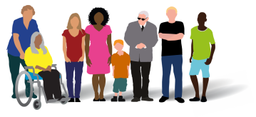

Business Case
Proposal: Introducing non-clinical roles within community MH transformation for older adults in London

February 2022

- Executive summary

  - Purpose of this document

The purpose of this document is to highlight the value that non-clinical older adult roles can add to community mental health (MH) transformation across London. It draws on learning from existing roles and makes recommendations to strengthen and sustain these roles to support community transformation for older adult populations.
The document proposes to:
- Provide clarity on the different roles, their function and responsibilities;
- Share learning and good practice from existing roles;
- Make the case for the value that older adult and carer roles add to support the unique needs of older adults with complex MH needs.
The document has been developed by Healthy London Partnership (HLP), together with an advisory group of clinical and technical leads in people participation and people with lived experience.

  - Policy context & the case for change

The Community Mental Health Framework for Adults and Older Adults proposes fundamental transformation and changes to how people with severe mental illness (SMI) are supported in their communities. Implementing the Framework will involve developing new ways of working, the creation of new roles and building skills across the health and care workforce.
Non-clinical roles such as Peer Support Workers, Community Connectors and Lived Experience Practitioners are identified in the framework as essential to delivering this ambitious, important community transformation. London has seen been a significant increase in recruitment of non-clinical roles into MH services, but with a focus on working age adults.
To better meet the unique needs of older adults, tailored non-clinical roles with experience and skills in providing support to older people will be essential.

  - The proposal

This business case provides a framework for developing and commissioning older adult non-clinical roles. It essentially provides a proposal for MH Trusts to:
- Understand the specific non-clinical role that is required to meet the needs of their older adult population (see page 5);
- Identify the specific functions and responsibilities that role will need to include, e.g. as a starting point for developing a more detailed job description (see pages 7-8);
- Identify the benefits that the role will bring to help services meet the needs of older people, and how they will support the wider objectives of older adult MH services within the Trust (see pages 8-11).

The business case includes a proposal of 10 core functions for these roles. HLP has developed these functions through consultation with the advisory group and drawing on key literature and evidence. The proposal makes a case for the essential part non-clinical roles can play in enabling older people with SMI to live well in their communities.

- Strategic context

  - The Community Mental Health Framework for Adults and Older Adults: supporting new ways of working

High quality community MH services for people living with serious or complex mental health needs are more important now than ever before – a recent report from the charity MIND confirmed that people who were more likely to struggle with their MH before the COVID-19 pandemic have experienced the greatest impact.
The Community Mental Health Framework for Adults and Older Adults recognises the importance of older people with SMI being able to receive care closer to home. At the same time, the framework acknowledges the fundamental transformation and modernisation needed to achieve this. The framework describes how community services for older people can be centred around the different complexity of need:
“Older adults may have differing types of needs and therefore may require support in different ways to meet these needs. Services providing care need to meet the person’s complexity of need, taking into account any impact from the person’s age and whether specialist older adult expertise is required.” Community MH Framework, part 1, p.26

Implementing the framework will therefore involve developing new ways of working, the creation of new roles and building the skills across the health and care workforce. Non-clinical roles such as Peer Support Workers, Community Connectors and Lived Experience Practitioners will be an essential part of delivering the ambitious, important community transformation set out in the Community Mental Health Framework.

  - The specific needs of older adults living with severe mental illness

There is a rapidly rising population of older people in England, among whom the prevalence of MH problems is itself increasing. A previous report from the King’s Fund suggests that by 2026 ageing will be the sole driver for increasing the numbers of people with any form of mental disorder.
Health Education England’s Older People’s Mental Health Competency Framework highlights how health and social care staff working with older adults need to understand that as people age it leads to biological, psychological and social changes. In turn, it is essential that non-clinical roles for older adults are tailored to these unique needs.
Working with an advisory group of clinical and technical older adult specialists, HLP has reviewed existing research and evidence to define the specific needs of older adults.
Biological
- Frailty and depressive symptoms can increase risk of nursing home admission and falls among older people. Depression and anxiety are common amongst people living with frailty.
- Polypharmacy is common in older adults for management of co-morbidities and older people have a higher risk for experiencing bad drug interactions, missing doses, or overdosing.
- Falls can reduce independence, destroy confidence and increase isolation. An estimated 20% of older people require medical attention for a fall.
Psychological
- Older people are at increased risk of crisis, including self-harm and suicide. Older adults (older than 65 years) have reportedly greater suicidal intent than any other age group.
- Side effects from psychotropic medications are more common in older adults and dramatically increase with the number of medications taken.
- Dementia can pose challenges to diagnosis of SMI, given the overlaps in symptoms and experiences of people living with either or both conditions. People with dementia are more likely to experience SMI.
- Self-neglect can be common in older age and is associated with higher levels of cognitive and physical impairments.
Social
- Social isolation and loneliness is a key driver for poor mental and physical health in later life.
- Poverty among older people is steadily increasing. The number of older adults living in poverty in the UK now sits at over 2 million people.
- Ageism and discrimination are a significant concern within services and are compounded by other forms of discrimination relating to ethnicity, gender, sexuality and mobility.
- Older people are at a high risk of abuse and neglect, including domestic abuse and financial abuse.
Barriers
- Older people are at a higher risk of readmission to acute inpatient services. Relapse and readmission to acute mental healthcare are common following discharge and occur early.
- Older people experience specific challenges related to other transitions in care, including between adult and older adult services.
- Poor access to advice on self-care strategies and challenges with communication and coordination of services are key barriers to independence among older people.
- Older people are less likely to access care and often feel unworthy of care.

  - Defining non-clinical roles within community MH transformation

Across London, each Trust/ICS takes a slightly different approach to developing non-clinical roles. It is therefore important to have a consistent understanding to the core responsibilities of each role.
HLP has defined “non-clinical roles” by drawing on the following policies and guidance:
The Community MH Framework for Adults and Older Adults
Health Education England’s Competency Framework for Mental Health Peer Support Workers
The Network Contract Directed Enhanced Service (DES) Contract Specification for PCN Requirements & Entitlements

In this document, the term “non-clinical roles” refers to four specific roles that are referenced within the Community MH Framework. These roles, including their core functions are as follows:
Peer support worker/Lived experience practitioner:
- Uses their lived experience to develop empathetic relationships and inspire hope in people facing similar challenges.
- Draws on their lived experience to give people the right level of support.
- Brings about change in their organisation by promoting values of peer support and personal recovery.

Community connector
- Identifies and facilitates access to community assets and resources that meet an individual’s needs.
- Assesses a person’s ability to engage with certain community activities and if adjustments are needed.
- A connector may be a standalone role, or elements may be folded into other roles (e.g. peer support workers or care coordinators).

Care coordinator
- Works with a person to develop and then coordinate a comprehensive personalised care and support plan (PCSP).
- Uses population health intelligence to proactively identify and work with a caseload of patients.
- Links to pharmacy, mental health teams, GPs and other health teams to discuss a patient’s health outcomes.

Social prescribing link worker
- Supports patients’ wellbeing by linking to community groups and statutory services, taking referrals from PCN practices and external agencies (e.g. VCSE, hospital discharge teams, social care services, emergency services).
- Builds capacity of VCSE organisations and community groups to take social prescribing referrals.
- Has a role in educating non-clinical and clinical staff on social prescribing approaches and local community services.

Although each role is distinct, they also fulfil some common roles and responsibilities. These are shown in Box 1.
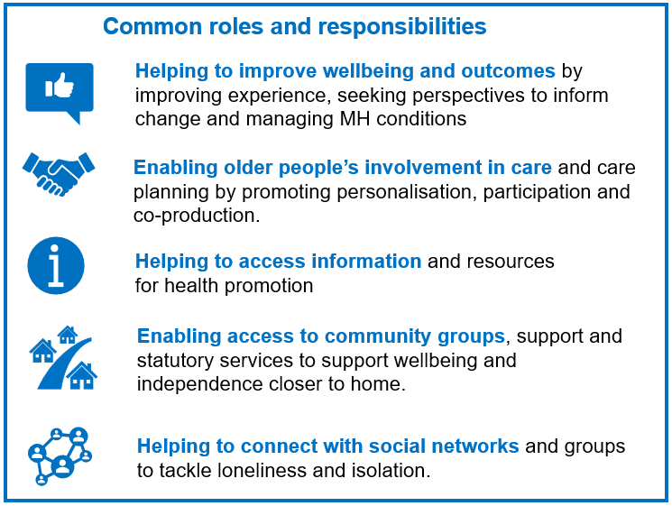
Box 1 – common functions of non-clinical roles in community MH services

  - Findings from a review of existing roles in London and nationally

HLP conducted a review of existing roles across London that are supporting the specific needs of older adults and carers in community MH transformation.
There are currently three different non-clinical roles in London supporting services for older adults and carers. The roles include:
- A Carer Peer Support Worker role at Central North West London NHS Foundation Trust (CNWL) that is providing support to older adults and carers on an acute inpatient ward.

- A People Participation Worker role at East London NHS Foundation Trust (ELFT) that specifically focuses on engaging older people in co-design and development of Trust services.

- A Community Connector role contract to ELFT from the charity MIND that focuses on working age adults but where the current staff member has significant experience of working with older people.

A review of the job descriptions and feedback from those currently in these roles have been used as a starting point to shape the guidance and recommendations in this document. However, there are some unique aspects of each role that need to be taken into consideration that not all of the above roles:
- contain all features of a typical Peer Worker role as described by the Community MH Framework;
- directly work within community transformation services;
- are specifically tailored to older adults inclusively as the role has developed.

A comprehensive summary of the responsibilities and personal specifications of these roles is provided as an appendix to this document.

- The proposal

  - Overview

This business case emphasises the value of introducing older adult-specific non-clinical roles within new models of community MH care. The document provides a recommendation for the core functions of these roles for a standardised approach across London.
This proposal identifies 10 core functions of these roles, which are required to meet the unique needs of older adults and their carers. HLP has developed these functions through:
- drawing on policy documents and research evidence identified through a literature review conducted by HLP;
- drawing on learning from job descriptions for existing older adult non-clinical roles in London;
- consultation with the advisory group of older adult clinicians, participation experts and people with lived experience convened to support development of this business case.

  - Recommended job functions for non-clinical roles aligned to OA and carer needs

These functions are intended to be used in a flexible way where organisations can select functions based on tailored support required. For example, identified need to support people to access services may select core functions 5, 6, 7, 9 and 10.
Biological
- Enabling older people with multiple illnesses and frailty to access timely, personalised care that meets both their physical and mental health needs.
- Enabling older people to live safely and independently in their homes and manage key risks such as falls and poor medication compliance.

Psychological
- Playing an important role in enabling early interventions in crisis and supporting older people to recover from existing crises.
- Helping older people to manage the side effects of psychotropic medications and link to expert advice and support.
- Helping older people with dementia access care and support to manage their SMI (wherever relevant).

Social
- Helping older adults to address social isolation and loneliness by connecting them with community services, assets and social networks.
- Playing a significant role in safeguarding older adults, preventing harm and reducing the risk of abuse and neglect.
- Playing a key role in tackling age discrimination and providing a voice for older people within services.

Barriers
- Supporting older people to navigate complex care systems and access the right information through transition from services - including transitions from acute care to community care and from adult to older adult services.
- Empowering older adults to be involved in their own care and to influence the way services are designed, to meet their specific needs.

  - Proposed roles [to be completed by Trusts]

[Trusts to add:
- Role title/s being proposed for the business case
- Where the role/s will sit (e.g. PCN, CMHT, inpatient ward, etc)
- Salary banding
- Line management/accountability
- Comprehensive summary of core functions and responsibilities
- Summary of essential knowledge, experience and qualifications.]

- Benefits

  - How non-clinical roles can benefit community MH services for older adults

    - The value that lived experience adds

“When you talk with the patients; the one thing that they all mention is the gift of hope and companionship that the Lived Experience Practitioners (LXP’s) bring with them, as someone who has had similar experiences, and this cannot be replaced by anything else that they receive”
Japleen Kaur, Head of Volunteering Services, Lived Experience Practitioner Programme and Service User Involvement Lead, Oxleas NHS Foundation Trust

Having lived experience is particularly important for older adults that may feel there is a stigma of mental health and/or feel they are not worthy of care. Evidence suggests that direct lived experience can help others with feelings of mutuality, empathy and hope. In practice this could mean:
- Sharing lived experience to provide hope of recovery for people with complex MH needs.
- Drawing on lived experience to ensure a person is given the right level of support.
- Engaging and supporting marginalised groups, e.g. through bringing language skills and cultural competency into services.
- Challenging ageism, racism and other forms of discrimination within services.

    - Supporting older adults to prevent or recover from crisis
“Our role is to help support those people at the very difficult time either when you've been discharged or you're trying to prevent a hospital admission, people at that point are quite often either on the edge of crisis or maybe in crisis. Our role is to support them and to help them make that transition and also where appropriate to either get them community Mental Health support, maybe by getting a key worker in the Community”
Marie-France Mutti, Lived Experience Practitioner, Oxleas NHS Foundation Trust

Evidence points to the effectiveness of peer support for reducing the likelihood of readmission to hospital for people with severe mental illness. In addition, research has also shown that indicators of suicide risk may be decreased through peer support. In practice this could mean:
- Supporting someone during a time of crisis, including transitions between community and acute inpatient services.
- Enabling early interventions in crisis, preventing admissions to inpatient services and other more acute forms of care.
- Identifying and acting upon risk of self-harm and suicide in older people, referring to specialist support as appropriate.
- Working with older people to enact suicide and self-harm prevention strategies, including linking them to relevant health, community and statutory services.

    - Navigating a complex system and access to the right information
The team would go with people to particular appointments for instance so that they can connect up and ask good questions of health providers but also attend particular things they might feel anxious about as well; but also being a bit of a bridge between organisations so helping people step away from statutory services or make connections with specialist services they might need as well
Cerdic Hall, Manager of the Choice and Control Peer Coaching Service, Camden and Islington NHS Foundation Trust

People who take part in shared decision making in their care are more likely to stick to their treatment plan, to take their medicines correctly and avoid emergency hospital services. The inclusion of peers in the workforce has been shown to produce the same or better results in a range of outcomes when compared with services without peer staff. In practice this could mean:
- Helping patients to prepare for clinical appointments, so that they are able to raise concerns, communicate challenges and ask important questions.
- Supporting people during transition, including from acute care to community care and from adult to older adult services.
- Supporting the development of care plans that recognise holistic needs and include the person’s wishes.
- Supporting mental health outreach services by providing knowledge of local community networks, including for marginalised populations.

    - Reducing readmission

Improved access to primary care, self-management and crisis planning decrease the chances of relapse and/or readmission to inpatient care for people with severe mental illness. As stated above, evidence points to the potential for peer support to reduce readmissions to acute inpatient services. In practice, this could include:
- Enabling older people to regain control over their lives and access self-management and crisis planning.
- Maximising support from primary care by accompanying older people through service pathways and enabling coordinated, personalised care.
- Being proactive in developing strong links with local agencies and helping to build their capacity to take referrals of older adults.
- Enabling culturally appropriate care and support, e.g. helping someone that does not speak English as their first language to access community services.

    - Tackling social isolation and loneliness

When the client feels stuck and feels alone, isolated and feels like no one understands them, as people who share a similar background we are there first of all to show them that they are not alone and then explore the goals before maybe even being linked up with the service, when you are not sure even if you have the energy to do anything but you know you need some help.”
Z. Nil Suner, Senior Peer Coach, Camden and Islington NHS Foundation Trust

Patients receiving peer support have shown improvements in community integration and social functioning. Social prescribing has been shown to improve well-being and social connectedness, as well as significantly reducing demand on primary and secondary care. In practice, this could include:
- Helping people to rebuild social and community networks, or to get involved again with their chosen communities.
- Where necessary, physically introducing and accompany people to community groups, activities and statutory services.
- Identifying and addressing barriers to older people’s social engagement, including mobility, social confidence and digital exclusion.
- Giving support, companionship and encouragement to people experiencing mental health difficulties.

    - Supporting carers
A peer support person can encourage carers/patients not to get discouraged and give up, or suggest other ways of achieving the same thing… Well run carers groups or support groups for people with the same illness can provide a lot of help. It is in these groups that we can laugh about the indignities of incontinence or sympathise with managing difficult behaviour…and the like
Patient and Carer representative, West London NHS Trust

There is evidence that peer support can play an important role for carers, including reducing isolation, increasing confidence in their caring role and identifying coping strategies. In practice, this could include:
- Providing advice on accessing local community and statutory services, including benefits, housing, social care, support groups, etc.
- Providing support or information to families and carers to help them navigate the system, policies, processes or legal structures that may affect them.
- Supporting carers to look after their own mental health and wellbeing.
- Helping families and carers feel comfortable and confident to ask questions when they are uncertain or confused.

- Costs

[to be completed by Trusts
- HLP’s review for this business case suggested that Peer Support Worker roles in London are introduced at a Band 3 or 4.
- Some PSWs working within specialist teams may be introduced at Band 4 (e.g. those working within At Risk Mental State Teams)
- Senior Peer Support Workers would be introduced at Band 4 or 5.
- Additional costs to be considered are related to completion of accredited peer support training and travel (e.g. for a PSW who is providing home-based care and/or is required to work across multiple sites)]

- Implementation plan
  - [to be completed by Trusts]

- Appendices

Appendix 1 - Existing London non-clinical older adult roles – core responsibilities
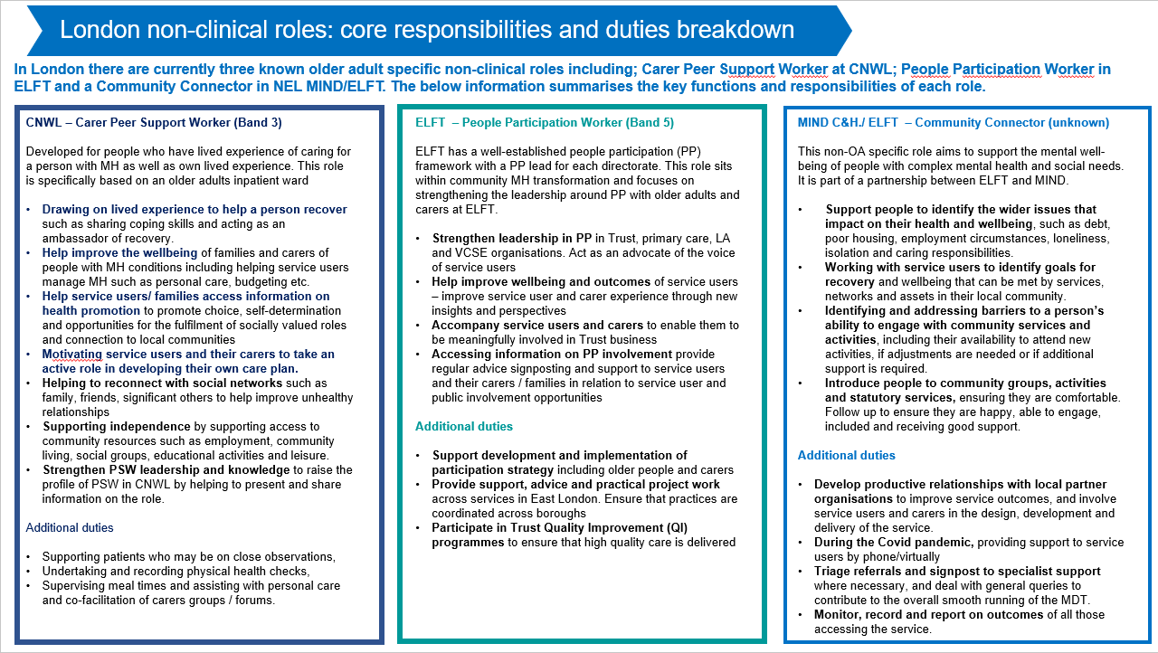
Appendix 2 – Existing London non-clinical older adult roles – personal specifications
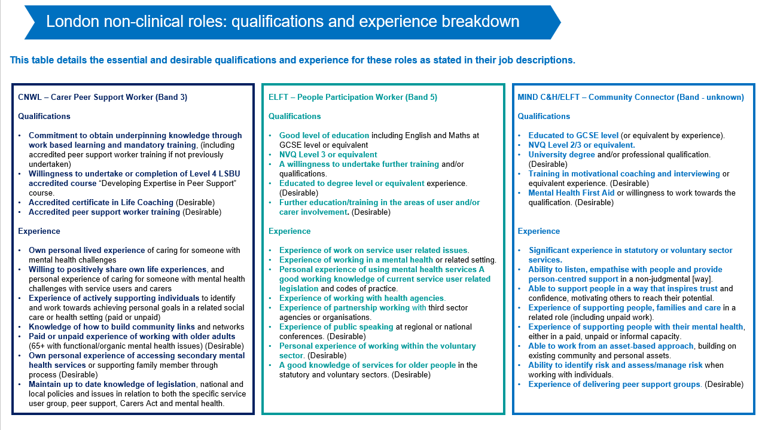

Appendix 3. References

Coronavirus: the consequences for mental health (Mind, 2021) Link
Suffering in silence: age inequality in older people’s mental health care, (Royal College of Psychiatrists, 2020) Link
McCrone et al, 2008, Paying the Price: The cost of mental health care in England to 2026 (Kings Fund) Link
Frailty: Ensuring the best outcomes for frail older people (Royal College of Psychiatrists, 2020) Link
Suffering in silence: age inequality in older people’s mental health care, (Royal College of Psychiatrists, 2020) Link
Falls and Fragility Fractures Pathway (NHSE) Link
Exploring the system-wide costs of falls in older people in Torbay (Kings Fund 2018) Link
Morgan C, et al, Self-harm in a primary care cohort of older people: incidence, clinical management, and risk of suicide and other causes of death, The Lancet, 2018. Link
Psychotropic Medication Use among Older Adults: What All Nurses Need to Know (NIH, 2009) Link
The interface between dementia and mental health (Mental Health Foundation, 2016) Link
Dong, QX, 2017, Elder self-neglect: research and practice, Clinical Interventions in Aging, Link
Martineau et al, 2021, Social care responses to self neglect among older people, NIHR Policy Research Unit in Health and Social Care Workforce Link
Growing older in the UK: A series of expert-authored briefing papers on ageing and health, (BMA, 2016) Link
Number of pensioners living in poverty tops two million, Press release (Age UK, 2021) Link
Suffering in silence: age inequality in older people’s mental health care (Royal College of Psychiatrists, 2020) Link
Compounding inequalities: racism, ageism, and health (Lancet Editorial, 2021) Link
Abuse of older people at ‘unprecedented levels’ as 2.7 million over 65s revealed to be affected, warns charity, Press Release (Hourglass) Link
Safe Later Lives - Older people and domestic abuse (Safelives, 2016) Link
Financial Abuse Evidence Review (Age UK, 2015) Link
Osborn et al, 2021, Readmission after discharge from acute mental healthcare among 231 988 people in England: cohort study exploring predictors of readmission including availability of acute day units in local areas, BJPsych Open Link
Baxter et al, 2020, Delivering exceptionally safe transitions of care to older people: a qualitative study of multidisciplinary staff perspectives, BMC Health Services Research Link
Community Mental Health Framework for Adults and Older Adults (NHSE, 2019) Link
Abdi et al, 2019, Understanding the care and support needs of older people: a scoping review and categorisation using the WHO international classification of functioning, disability and health framework (ICF), BMC Geriatrics Link
Growing older in the UK: A series of expert-authored briefing papers on ageing and health (BMA, 2016) Link
Socially excluded older people and their access to health and care services (Age UK, 2020). Link
Growing older in the UK: A series of expert-authored briefing papers on ageing and health (BMA, 2016) Link
Peer support roles in mental health services (Iriss, 2016) Link
Johson et al, 2018, Peer-supported self-management for people discharged from a mental health crisis team: a randomised controlled trial, Lancet Link
Simpson et al, 2019, Results of a pilot randomised controlled trial to measure the clinical and cost effectiveness of peer support in increasing hope and quality of life in mental health patients discharged from hospital in the UK, BMC Psychiatry Link
Helping people share decision making (The Health Foundation, 2012) Link
Peer support in mental health care: is it good value for money? (Centre for Mental Health, 2013) Link
Osborn, et al, 2021, Readmission after discharge from acute mental healthcare among 231 988 people in England: cohort study exploring predictors of readmission including availability of acute day units in local areas, BJPsych Open Link
Johson et al, 2018, Peer-supported self-management for people discharged from a mental health crisis team: a randomised controlled trial, Lancet Link
Peer support in mental health care: is it good value for money? (Centre for Mental Health, 2013) Link
Social prescribing (Royal College of Psychiatrists, 2021) Link
Greenwood et al, 2013, Peer Support for Carers: A Qualitative Investigation of the Experiences of Carers and Peer Volunteers, American Journal of Alzheimer’s Disease & Other Dementias Link

