Free urgent 24/7 mental health support for young people
  - Communications toolkit
Updated November 2022

Campaign background
In December 2021, Healthy London Partnership launched a campaign to raise awareness among young people and their families of London’s free NHS mental health crisis lines.
The campaign was developed with feedback and input from young people and parents with a focus on sharing messaging on social media and in education and community settings, GP surgeries, etc. This winter we all face added pressures from the cost of living, so it is important that young people and their families are reminded that urgent mental health support remains available to them.
Every mental health trust in London has put in place a free telephone service, supported by trained mental health advisors and clinicians, and open 365 days a year. These enable children, young people and their families to get free urgent mental health support 24/7.
This toolkit contains social media assets, posters, and articles for your own websites, newsletters and publications. Please help us to reach young people and families across London by using these assets and messaging on your social media channels and promoting them through your own stakeholders and networks.
Remember, a mental health emergency should be taken as seriously as a physical one. Together we can raise awareness of the crisis lines and help young people and their families to get support when they need it.

What’s included in this toolkit
- Article copy (long and short) for organisations’ own publications, websites and newsletters
- A selection of social media assets and accompanying messages for Facebook, Instagram, Twitter and LinkedIn
- Additional downloadable resources including an e-signature, image for MS Teams and desktop backgrounds, posters in A4 and A3 format, and a digital postcard
- 2023 calendar of mental health awareness days and key dates for schools/colleges
- Other mental health and wellbeing resources

Article copy for organisations’ own publications/websites/newsletters

Longer article

Free 24/7 urgent mental health support for young people

Young people and their families in need of urgent help with their mental health can get free 24/7 support from trained NHS professionals by telephone.
The last few years have been particularly hard for young people’s mental health and wellbeing. The NHS’s 2021 survey of children and young people’s mental health found that one in six had a probable mental disorder – up from one in nine in 2017. Four in 10 6-16 year olds said their mental health had got worse since 2017, with only a fifth (21.8%) saying it had improved.
As a result, there has been an increase in people needing urgent support. Every mental health trust in London has put in place a dedicated phone line, supported by trained mental health advisors and clinicians, and open day and night, 365 days a year. The lines are free to call, and trained advisors can provide immediate help or signpost callers to other sources of support if necessary.
For those caring for someone, whether a parent, teacher, first responder, you can also call your local NHS urgent mental health support line in the first instance for immediate support and advice.

Find your local crisis line number here.
(198 words)

Very short article for use in organisations’ own publications; also as captions on Instagram and Facebook.

Free 24/7 urgent mental health support for young people

The last few years have been hard for young people’s mental health and wellbeing. Young people and their families in need of urgent help with their mental health can get free 24/7 support from trained NHS professionals by telephone.

The NHS has set up free telephone lines across London for young people in distress, open all day, every day, and staffed by trained mental health professionals. They can provide immediate support, or refer young people, or those caring for someone, to other sources of help if needed.

Find your local crisis line number here.
(94 words)

Social media assets and accompanying messaging

The following graphics and suggested copy can be used to raise awareness and signpost to the telephone service.

The images can be used to help share similar messages across Twitter,
Facebook, LinkedIn and Instagram. Also organisations’ webpages.

Remember to tag us on social media:

Instagram: @healthy_ldn Facebook: @HealthyLDN Twitter: @HealthyLDN

LinkedIn: @Healthy London Partnership

And use the campaign hashtag: #urgentMHSupport_youngLDN where you do to continue raising awareness of the lines.

To download the full-sized images, select the images below, right click and select ‘open link’.

Social media channel | Imagery for channel | Messaging for young people | Messaging for parents, carers or other supporters of young people
Facebook asset 1 | 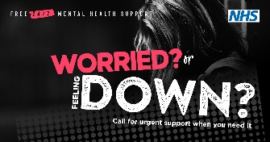  Alt text: A young person is alone, their head bowed down. Text reads ‘Free 24/7 mental health support’ alongside the NHS logo.  A heading reads: Worried or feeling down? Call for urgent support when you need it. | 1. Festive season:  The festive season can be difficult if you’re struggling with your mental health.  If you need to talk to someone, you can call NHS trained advisors for urgent mental health support and advice, whenever you need it.  ℹ️ Find your local helpline here: www.healthylondon.org/urgentsupportlines  2. Return to school or college:  It’s ok to feel nervous about getting back to school or college in the new year.  There are many resources available to support your mental health and wellbeing, but if things feel too much, you can contact NHS trained advisors for free support and advice, any time of the day.  ℹ️Find #mentalhealth resources and helpline phone numbers here: www.healthylondon.org/urgentsupportlines  #urgentMHsupport_youngLDN  3. 24/7 support:  If you’re a young person in London struggling with your mental health, you can contact NHS trained advisors 24/7 for free support and advice.  ℹ️ Find mental health resources and helpline phone numbers here: https://www.healthylondon.org/urgentsupportlines  #urgentMHsupport_youngLDN | 1. Festive season:  The festive season can be overwhelming. If you’re concerned about a young person’s mental health, you can contact NHS trained advisors day and night for free advice.  Find your local helpline here: www.healthylondon.org/urgentsupportlines  2. Return to school or college:  Young people may feel anxious getting back to school or college in January.  There are many resources to support their mental health and wellbeing, but if you’re concerned that they might need urgent help, contact your local NHS mental health helpline for free professional advice from trained advisors.  Find #mentalhealth resources and helpline telephone numbers here: www.healthylondon.org/urgentsupportlines  #mentalhealthsupport  3. 24/7 support:  There are many resources to help young people’s mental health and wellbeing. If you are concerned they need urgent support, you can contact NHS trained advisors for 24/7 advice.  Find mental health resources and helpline telephone numbers here: https://www.healthylondon.org/urgentsupportlines  #mentalhealthsupport
Social media channel | Imagery for channel | Messaging for young people | Messaging for parents, carers or other supporters of young people
Instagram post asset 1  Also suitable for use on WhatsApp | 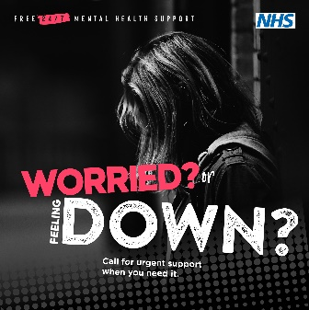  Alt text: A young person is alone, their head bowed down. Text reads ‘Free 24/7 mental health support’ alongside the NHS logo.  A heading reads: Worried or feeling down? Call for urgent support when you need it. | 1. Festive season:  The festive season can be difficult if you’re struggling with your #mentalhealth.  📱If you need to talk to someone, you can call NHS trained advisors for free urgent mental health support, whenever you need it.  ℹ️ Search ‘NHS urgent mental health support’ or find more information on the helplines and other support in London here: www.healthylondon.org/urgentsupportlines  #urgentMHsupportyoungLDN  2. Return to school or college:  It’s ok to feel nervous about getting back to school or college in the new year.  There are many resources available to support your mental health and wellbeing, but if things feel too much, you can contact NHS trained advisors for free support and advice, any time of the day 📱  ℹ️ Search ‘NHS urgent mental health support’ or find resources and helpline phone numbers here: www.healthylondon.org/urgentsupportlines  #urgentMHsupportyoungLDN  3. 24/7 support:  If you’re a young person in London struggling with your #mentalhealth, you can contact NHS trained advisors 24/7 for free support and advice.  ℹ️ Search ‘NHS urgent mental health support’ or find more information here: www.healthylondon.org/urgentsupportlines  #urgentMHsupportyoungLDN | 1. Festive season:  The festive season can be overwhelming. If you’re concerned about a young person’s #mentalhealth, you can contact NHS trained advisors day and night for free advice and support.  ℹ️ Search ‘NHS urgent mental health support’ or find more information on the helplines in London here: www.healthylondon.org/urgentsupportlines  2. Return to school or college:  Young people may feel anxious getting back to school in January.  There are many resources to support their mental health and wellbeing, but if you’re concerned that they need might need urgent help, you can contact local NHS mental health helplines for free professional advice from trained advisors.  ℹ️ Search ‘NHS urgent mental health support’ or find resources and urgent support telephone numbers here: www.healthylondon.org/urgentsupportlines  3. 24/7 support:  There are many resources to help young people’s mental health and wellbeing. But if you’re concerned that they need urgent support, you can contact NHS trained advisors for 24/7 #mentalhealth advice.  ℹ️ Search ‘NHS urgent mental health support’ or find helpline telephone numbers: www.healthylondon.org/urgentsupportlines  #urgentMHsupportyoungLDN
Instagram Story asset 1 | 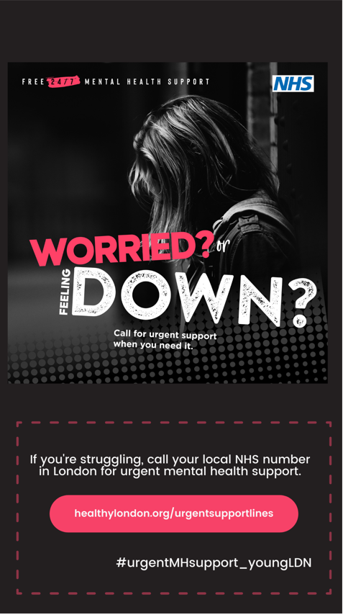 | Add click-through link to: https://www.healthylondon.org/urgentsupportlines
Social media channel | Imagery for channel | Messaging for young people | Messaging for parents, carers, teachers or other professionals supporting young people
LinkedIn asset 1 | 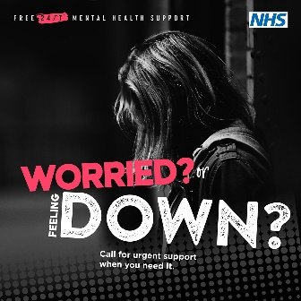  Alt text: A young person is leaning against a wall with their head bowed down. Text reads ‘Free 24/7 mental health support’ alongside the NHS logo.  A heading reads: Worried or feeling down? Call for urgent support when you need it. | 1. Festive season:  The festive season can be difficult if you’re struggling with your mental health.  If you need to talk to someone, you can call NHS trained advisors, day or night, for urgent #mentalhealth support.  You can find information about mental health support from the NHS and other organisations here: www.healthylondon.org/urgentsupportlines  They are all here to help you.  2. Return to school or college:  It’s ok to feel nervous about getting back to school or college in the new year.  There are many resources available to support your mental health and wellbeing, but if things feel too much, you can contact NHS trained advisors for free #mentalhealth support and advice, any time of the day.  Find help here: www.healthylondon.org/urgentsupportlines  3. 24/7 support:  If you’re a young person in London struggling with your #mentalhealth, there are many free resources available to support you.  But if things feel too much, you can contact NHS trained advisors for free urgent support and advice, any time of the day.  Find more information here: www.healthylondon.org/urgentsupportlines | 1. Festive season:  The festive season can be overwhelming. You can call NHS trained advisors day or night for urgent support, if you’re concerned about a young person’s #mentalhealth.  Find more information on London’s urgent mental health support here: www.healthylondon.org/urgentsupportlines  2. Return to school or college:  Young people may feel anxious getting back to school in January.  There are many resources to support their mental health and wellbeing, but if you’re concerned that they might need urgent help, you can contact your local NHS #mentalhealth helpline for free professional advice from trained advisors.  Find resources and urgent support telephone numbers here: www.healthylondon.org/urgentsupportlines  #mentalhealthsupport  3. 24/7 support:  There are many resources to help young people’s #mentalhealth and wellbeing, but if you’re concerned that they need urgent support, you can contact your local NHS mental health helpline for free 24/7 professional advice from trained advisors.  Find more information and local London numbers here: www.healthylondon.org/urgentsupportlines
Social media channel | Imagery for channel | Messaging for young people | Messaging for parents, carers or other supporters of young people
Twitter asset 1 | 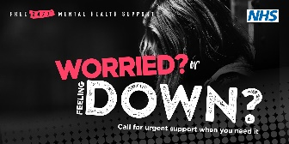  Alt text: A young person is leaning against a wall with their head bowed down. Text reads ‘Free 24/7 mental health support’ alongside the NHS logo.  A heading reads: Worried or feeling down? Call for urgent support when you need it. | 1. Festive season:  The festive season can be difficult if you’re struggling with your #mentalhealth.  📱If you need to talk to someone, call NHS trained advisors for urgent support and advice, any time of the day.  Find more information at: www.healthylondon.org/urgentsupportlines  #urgentMHsupport_youngLDN  2. Return to school or college:  It’s ok to feel nervous about getting back to school or college in the new year.  💬If things feel too much, you can call NHS trained advisors for free #mentalhealth support, day or night. Find help here: www.healthylondon.org/urgentsupportlines  3. 24/7 support:  If you’re a young person in London struggling with your #mentalhealth, you can contact NHS trained advisors 24/7 for free support and advice.  ℹ️ Find more information at: www.healthylondon.org/urgentsupportlines  #urgentMHsupport_youngLDN | 1. Festive season:  The festive season can be overwhelming. If you’re concerned about a young person’s #mentalhealth, you can contact NHS trained advisors for free advice, any time of the day.  ℹ️ Find more information here: www.healthylondon.org/urgentsupportlines  #urgentMHsupport_youngLDN  2. Return to school or college:  Young people may feel anxious getting back to school in January. If you’re concerned about their #mentalhealth, you can contact trained NHS advisors for free professional advice.  ℹ️ Find telephone numbers for London's urgent mental health helplines at: www.healthylondon.org/urgentsupportlines  3. 24/7 support:  If you’re concerned about a young person’s mental health, you can call NHS urgent #mentalhealth support helplines for free 24/7 professional advice.  ℹ️ Find more information at: www.healthylondon.org/urgentsupportlines  #urgentMHsupport_youngLDN
Social media channel | Imagery for channel | Messaging for young people | Messaging for parents, carers or other supporters of young people
Facebook asset 2 | 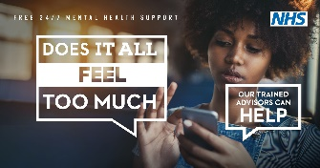  Alt text: A young woman looks at a smartphone in her hands. Text reads: ‘Free 24/7 mental health support, alongside the NHS logo.’  A large speech bubble on the left reads: ‘Does it all feel too much?’  To the right, a smaller speech bubble reads: ‘Our trained advisors can help.’ | 1. Festive season:  The festive season can be a lonely time if you’re struggling with your mental health. Don’t struggle alone – support is always there if you need it.  📱You can call NHS trained advisors, any time, any day, for free urgent #mentalhealth support.  ℹ️Find more information on the NHS helplines, and other mental health support here:  www.healthylondon.org/urgentsupportlines  2. Return to school or college:  January can feel like a tough month. It’s ok to take things one day at a time but if things do feel too much, you can call NHS trained advisors, any time, any day, for free urgent #mentalhealth support.  ℹ️ Find more information on the NHS helplines, and other mental health support here:  www.healthylondon.org/urgentsupportlines  3. 24/7 support:  If you feel like things are too much and you’re struggling with your mental health, you can contact NHS trained advisors 24/7 for free support and advice.  ℹ️Find more information on the NHS helplines, and other mental health support here:  www.healthylondon.org/urgentsupportlines | 1. Festive season:  The festive season can be challenging. If a young person you are caring for is struggling with their mental health, support is available to help you help them.  📱Call NHS trained advisors for free urgent #mentalhealth support when you need it.  ℹ️ Find more information on the NHS helplines, and other mental health support here:  www.healthylondon.org/urgentsupportlines  2. Return to school or college:  Young people may feel anxious about returning to school after the Christmas break.  If you are concerned about their mental health, call your local NHS urgent #mentalhealth helpline and speak to a trained advisor for free support and advice.  ℹ️ Find more information on the NHS helplines, and other mental health support here:  www.healthylondon.org/urgentsupportlines  3. 24/7 support:  There are many resources to help support young people’s mental health and wellbeing, but if you are concerned and need urgent support, you can contact local NHS mental health helplines for free 24/7 professional advice from trained advisors.  ℹ️Find more information on the NHS helplines, and other mental health support here:  www.healthylondon.org/urgentsupportlines
Social media channel | Imagery for channel | Messaging for young people | Messaging for parents, carers or other supporters of young people
Instagram post asset 1, also suitable for use on WhatsApp | 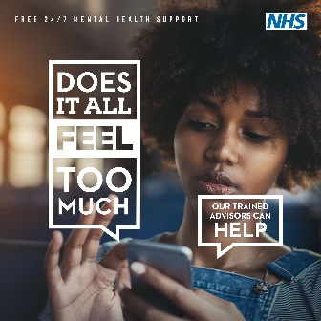  Alt text: A young woman looks at a smartphone in her hands. Text reads: ‘Free 24/7 mental health support’, alongside the NHS logo.  A large speech bubble on the left reads: ‘Does it all feel too much?’  To the right, a smaller speech bubble reads: ‘Our trained advisors can help.’ | 1. Festive season:  The festive season can be a lonely time if you’re struggling with your mental health. Don’t struggle alone – support is always there if you need it.  You can call NHS trained advisors, any time, any day, for free urgent #mentalhealth support.  🔍Search ‘NHS urgent mental health support’ or find more information here: www.healthylondon.org/urgentsupportlines  #urgentMHsupportyoungLDN  2. Return to school or college:  January can feel like a tough month. It’s ok to take things one day at a time but if things do feel too much, you can call NHS trained advisors, any time, any day, for urgent #mentalhealth support.  🔍Search ‘NHS urgent mental health support’ or find more information here: www.healthylondon.org/urgentsupportlines  #urgentMHsupportyoungLDN  3. 24/7 support:  If you feel like things are too much and you’re struggling with your mental health, you can contact NHS trained advisors 24/7 for free support and advice.  🔍Find more information on urgent mental health support from the NHS, and other organisations, here: www.healthylondon.org/urgentsupportlines  #urgentMHsupportyoungLDN | 1. Festive season:  The festive season can be challenging. If a young person you are caring for is struggling with their mental health, support is available to help you help them.  Call NHS trained advisors for free urgent #mentalhealth support when you need it.  🔍Search ‘NHS urgent mental health support’ or find more information here: www.healthylondon.org/urgentsupportlines  #urgentMHsupportyoungLDN  2. Return to school or college:  Young people may feel anxious about returning to school after the Christmas break.  If you are concerned about their mental health, call your local NHS urgent #mentalhealth helpline and speak to a trained advisor for free support and advice.  🔍Search ‘NHS urgent mental health support’ or find more information here: www.healthylondon.org/urgentsupportlines  #urgentMHsupportyoungLDN  3. 24/7 support:  There are many resources to help support young people’s mental health and wellbeing, but if you are concerned and need urgent support, you can contact local NHS mental health helplines for free 24/7 professional advice from trained advisors.  🔍Find more information about urgent mental health support in London here: www.healthylondon.org/urgentsupportlines
Instagram Story asset 2 | 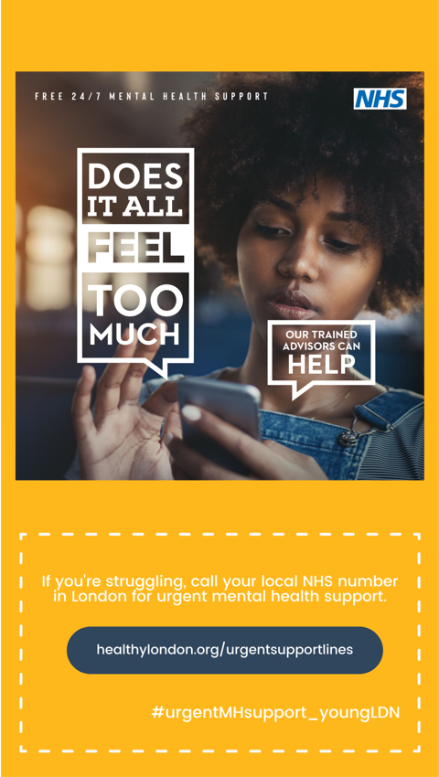 | Add click-through link to: https://www.healthylondon.org/urgentsupportlines
Social media channel | Imagery for channel | Messaging for young people | Messaging for parents, carers or other supporters of young people
LinkedIn asset 2 | 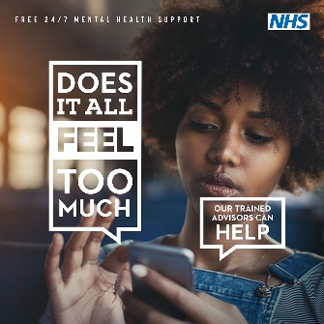  Alt text: A young woman looks at a smartphone in her hands. Text reads: ‘Free 24/7 mental health support’, alongside the NHS logo.  A large speech bubble on the left reads: ‘Does it all feel too much?’  To the right, a smaller speech bubble reads: ‘Our trained advisors can help.’ | 1. Festive season:  The festive season can be a lonely time if you’re struggling with your mental health. Don’t struggle alone – support is always there if you need it.  You can call NHS trained advisors, any time, any day, for free urgent #mentalhealth support.  Find more information here:  www.healthylondon.org/urgentsupportlines  2. Return to school or college:  January can feel like a tough month. It’s ok to take things one day at a time but if things do feel too much, you can call NHS trained advisors, any time, any day, for free urgent #mentalhealth support.  Find more information here:  www.healthylondon.org/urgentsupportlines  3. 24/7 support:  If things are feeling too much and you’re struggling with your #mentalhealth, you can contact NHS trained advisors 24/7 for urgent support and advice.  Find more information on London’s NHS urgent mental health helplines here: www.healthylondon.org/urgentsupportlines | 1. Festive season:  The festive season can be challenging. If a young person you are caring for is struggling with their mental health, support is there to help you help them.  Call NHS trained advisors for free urgent #mentalhealth support when you need it.  Find more information on urgent mental health support in London, provided by the NHS, and other organisations, here: www.healthylondon.org/urgentsupportlines  2. Return to school or college:  Young people may feel anxious about returning to school or college after the Christmas break.  If you are concerned about their mental health, call your local NHS urgent #mentalhealth helpline and speak to a trained advisor for free support and advice.  Find out more here: www.healthylondon.org/urgentsupportlines  3. 24/7 support:  There are many resources to help support young people’s mental health and wellbeing, but if you are concerned and need urgent support, you can contact local NHS mental health helplines for free 24/7 professional advice from trained advisors.  Find more information on London’s NHS urgent mental health helplines here: www.healthylondon.org/urgentsupportlines
Social media channel | Imagery for channel | Messaging for young people | Messaging for parents, carers or other supporters of young people
Twitter asset 2 | 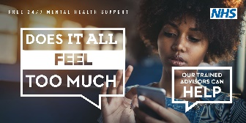  Alt text: A young woman looks at a smartphone in her hands. Text reads: ‘Free 24/7 mental health support’, alongside the NHS logo.  A large speech bubble on the left reads: ‘Does it all feel too much?’  To the right, a smaller speech bubble reads: ‘Our trained advisors can help.’ | 1. Festive season  The festive season can be a lonely time if you’re struggling with your mental health. Don’t struggle alone – support is always there.  📱Call NHS trained advisors, any time, any day, for free urgent #mentalhealth support  www.healthylondon.org/urgentsupportlines  #urgentMHsupport_youngLDN  2. Return to school or college:  January can feel like a tough month. It’s ok to take things one day at a time but if things feel too much, you can call NHS trained advisors, any time, any day, for free urgent #mentalhealth support.  ℹ️ Find more information here:  www.healthylondon.org/urgentsupportlines  3. 24/7 support:  📱If you feel like things are too much and you’re struggling with your mental health, you can contact NHS trained advisors 24/7 for free support and advice.  Find more information here: www.healthylondon.org/urgentsupportlines | 1. Festive season  The festive season can be challenging. If a young person you're caring for is struggling with their #mentalhealth, support is there to help you help them.  📱Call NHS trained advisors for free urgent #mentalhealth support. Find more information at:  www.healthylondon.org/urgentsupportlines  2. Return to school or college:  Young people may feel anxious about returning to school after the Christmas break.  ℹ️ If you’re concerned about their mental health, you can call your local NHS urgent #mentalhealth helpline and speak to trained advisors for support. Learn more here: www.healthylondon.org/urgentsupportlines  3. 24/7 support:  There are many resources to support young people’s mental health and wellbeing. But if you're concerned that they need urgent support, call your local NHS mental health helpline and speak to trained advisors any time, any day.  ℹ️ Find more information here: www.healthylondon.org/urgentsupportlines
Social media channel | Imagery for channel | Messaging for young people | Messaging for parents, carers or other supporters of young people
Facebook asset 3 | 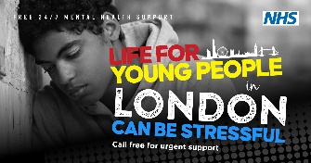  Alt text: a close up of a teenage boy looking down with his head resting against a wall.  Text reads: ‘Free 24/7 mental health support’ alongside the NHS logo.  A larger heading reads: ‘Life for young people in London can be stressful. Call free for urgent support’, alongside a graphic of the London skyline. | 1. Cost of living:  Money worries can affect your #mentalhealth, but it’s important not to struggle alone.  The NHS has set up telephone lines across London providing urgent mental health support 24/7 from trained mental health advisors and clinicians.  🔍Find your local number here: www.healthylondon.org/urgentsupportlines  #urgentMHsupportyoungLDN  2. January worries:  January can feel like a hard month. If you’re struggling and need to talk to someone about your mental health, you can call NHS trained advisors for free advice and support.  📱 Find more information on London’s NHS urgent #mentalhealth helplines here: www.healthylondon.org/urgentsupportlines  3. 24/7 support:  Life for young people in London can be stressful.  The NHS has set up telephone lines across London providing urgent mental health support 24/7 from trained mental health advisors and clinicians.  ℹ️Find your local number here: www.healthylondon.org/urgentsupportlines | 1. Cost of living:  Young people you are caring for may be concerned about the financial strain at the moment. If you are worried that they are not coping, the NHS has set up telephone lines across London providing 24/7 urgent mental health support and advice from trained #mentalhealth advisors and clinicians.  🔍Find your local number here: www.healthylondon.org/urgentsupportlines  2. January/back to school or college:  Young people might feel anxious about getting back to school or college in January.  If you are concerned that their mental health is suffering, you can direct them to NHS urgent mental health support lines, or speak to a trained advisor yourself for free, professional advice.  📱 Find more information on London’s NHS urgent #mentalhealth helplines here: www.healthylondon.org/urgentsupportlines  #urgentMHsupportyoungLDN  3. 24/7 support:  The past few years have been tough on young Londoners. The NHS has set up telephone lines across London providing urgent mental health support 24/7 from trained mental health advisors and clinicians.  ℹ️Find your local NHS number here: www.healthylondon.org/urgentsupportlines
Social media channel | Imagery for channel | Messaging for young people | Messaging for parents, carers or other supporters of young people
Instagram post asset 3 - also suitable for use on WhatsApp | 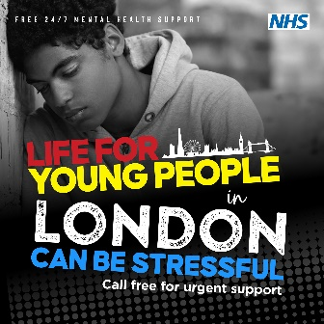  Alt text: a close up of a teenage boy looking down with his head resting against a wall.  Text reads: ‘Free 24/7 mental health support’ alongside the NHS logo.  A larger heading reads: ‘Life for young people in London can be stressful. Call free for urgent support’, alongside a graphic of the London skyline. | 1. Cost of living:  Money worries can affect our #mentalhealth, but it’s important not to struggle alone.  The NHS has set up telephone lines across London providing urgent mental health support 24/7 from trained mental health advisors and clinicians.  🔍Search ‘NHS urgent mental health support’ or find your local number here: www.healthylondon.org/urgentsupportlines  #urgentMHsupportyoungLDN  2. January worries:  January can feel like a hard month. If you’re struggling and need to talk to someone about your mental health, you can call NHS trained advisors for free advice and support.  🔍Find more information on iurgent mental health support in London here: www.healthylondon.org/urgentsupportlines  #urgentMHsupportyoungLDN  3. 24/7 support:  Life for young people in London can be stressful.  📱The NHS has set up telephone lines across London providing urgent mental health support 24/7 from trained mental health advisors.  🔍Search ‘NHS urgent mental health support’ for more information, or find your local number here: www.healthylondon.org/urgentsupportlines  #urgentMHsupportyoungLDN | 1. Cost of living:  Young people you are caring for may be worried about the financial strain at the moment. If you are concerned that they are not coping, the NHS has set up telephone lines across London providing urgent mental health support and advice, 24/7 from trained #mentalhealth advisors and clinicians.  🔍Search ‘NHS urgent mental health support’ or find your local number here: www.healthylondon.org/urgentsupportlines  #urgentMHsupportyoungLDN  2. Back to school or college:  Young people might feel anxious about getting back to school or college in January.  If you are concerned that their mental health is suffering, you can direct them to NHS urgent mental health support lines, or speak to a trained advisor yourself for free, professional advice.  ℹ️Visit: www.healthylondon.org/urgentsupportlines for more information on London’s urgent mental health support.  3. 24/7 support:  The past few years have been tough on young Londoners.  📱The NHS has set up telephone lines across London providing urgent mental health support 24/7 from trained mental health advisors and clinicians.  🔍Search ‘NHS urgent mental health support’ for more information, or find your local number here: www.healthylondon.org/urgentsupportlines  #urgentMHsupportyoungLDN
Social media channel | Imagery for channel | Messaging for young people | Messaging for parents, carers or other supporters of young people
LinkedIn asset 3 | 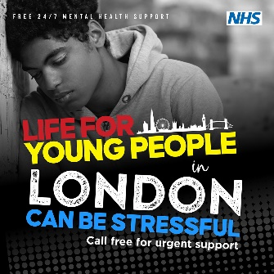  Alt text: a close up of a teenage boy looking down with his head resting against a wall.  Text reads: ‘Free 24/7 mental health support’ alongside the NHS logo.  A larger heading reads: ‘Life for young people in London can be stressful. Call free for urgent support’, alongside a graphic of the London skyline. | 1. Cost of living:  Money worries can affect our #mentalhealth, but it’s important not to struggle alone.  The NHS has set up telephone lines across London providing urgent mental health support 24/7 from trained mental health advisors and clinicians. Find your local number here: www.healthylondon.org/urgentsupportlines  2. January worries:  January can feel like a hard month. If you’re struggling and need to talk to someone about your mental health, you can call NHS trained advisors for free advice and support.  Find more information and local London numbers here: www.healthylondon.org/urgentsupportlines  3. 24/7 support:  Life for young people in London can be stressful.  The NHS has set up telephone lines across London providing urgent mental health support 24/7 from trained #mentalhealth advisors and clinicians. Find your local number here: www.healthylondon.org/urgentsupportlines | 1. Cost of living:  Young people you are caring for may be worried about the financial strain at the moment. If you are concerned that they are not coping, the NHS has set up telephone lines across London providing urgent mental health support and advice, 24/7 from trained #mentalhealth advisors and clinicians.  Find your local number here: www.healthylondon.org/urgentsupportlines  2. Back to school or college:  Young people might feel anxious about getting back to school or college in January.  If you are concerned about their mental health, you can call your local NHS urgent #mentalhealth support helpline, to speak to a trained advisor for free, professional advice.  www.healthylondon.org/urgentsupportlines  3. 24/7 support:  The past few years have been tough on young Londoners but urgent mental health support is there if they need it.  Visit: www.healthylondon.org/urgentsupportlines for more information on mental health support from the NHS, and other organisations.
Social media channel | Imagery for channel | Messaging for young people | Messaging for parents, carers or other supporters of young people
Twitter asset 3 | 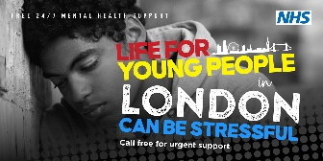  Alt text: a close up of a teenage boy looking down with his head resting against a wall.  Text reads: ‘Free 24/7 mental health support’ alongside the NHS logo.  A larger heading reads: ‘Life for young people in London can be stressful. Call free for urgent support’, alongside a graphic of the London skyline. | 1. Cost of living:  Money worries can affect our #mentalhealth, but it’s important not to struggle alone. The NHS has set up telephone lines across London providing 24/7 urgent #mentalhealth support from trained advisors and clinicians.  🔍Find your local helpline here: www.healthylondon.org/urgentsupportlines  2. January worries:  January can feel like a hard month. If you’re struggling and need to talk to someone about your mental health, you can call NHS trained advisors for free advice and support 📱  Find more information about NHS #mentalhealth helplines, and other support at: www.healthylondon.org/urgentsupportlines  3. 24/7 support:  Life for young people in London can be stressful.  The NHS run telephone lines across London providing free 24/7 urgent #mentalhealth support from trained advisors.  📱 Find your local number here: www.healthylondon.org/urgentsupportlines | 1. Cost of living:  Young people you're caring for may be concerned about the financial strain. If you’re worried that they’re not coping, you can call trained NHS advisors for urgent #mentalhealth support.  ℹ️ Visit: www.healthylondon.org/urgentsupportlines to find your local NHS urgent #mentalhealth helpline.  2. Back to school or college:  Young people might feel anxious about getting back to school or college in January.  ℹ️ If you are concerned that their mental health is suffering, you can direct them to NHS urgent mental health support lines, or speak to a trained advisor yourself for free, professional advice.  www.healthylondon.org/urgentsupportlines  3. 24/7 support:  The past few years have been tough on young Londoners. The NHS run free 24/7 urgent #mentalhealth support helplines to anyone who needs it.  ℹ️ Visit: www.healthylondon.org/urgentsupportlines for more information on mental health support from the NHS, and other organisations.

Additional resources
Asset | File | Usage
Gif: for use on social media, community websites or WhatsApp | 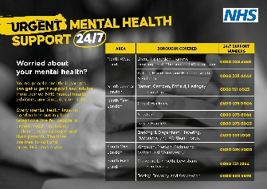 | Suggested messaging to accompany gif:  - The NHS has set up free telephone helplines across London, supported by trained mental health professionals and available every day, day or night. Find your local number here: https://www.healthylondon.org/urgentsupportlines  - Young people face a lot of pressures in London. NHS trained advisors can be contacted 24/7 for free, urgent mental health support if you need it. Find out more here: https://www.healthylondon.org/urgentsupportlines
Poster: Worried or feeling down? | 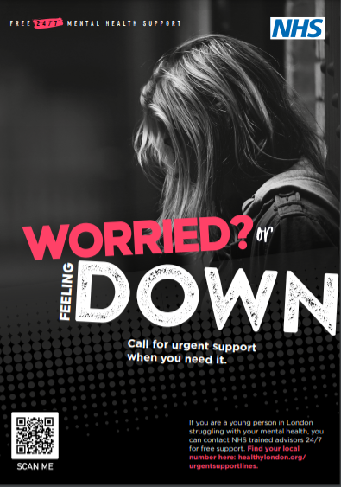 | Right click to download:  - A4 size for printing or digital use  - A3 size for printing or digital use
Poster: Does it all feel too much? | 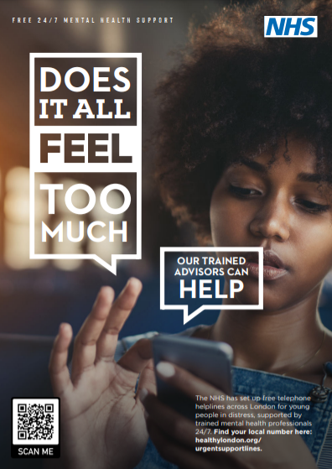 | Right click to download:  - A4 size for printing or digital use  - A3 size for printing or digital use
Poster: Life for young people in London can be stressful | 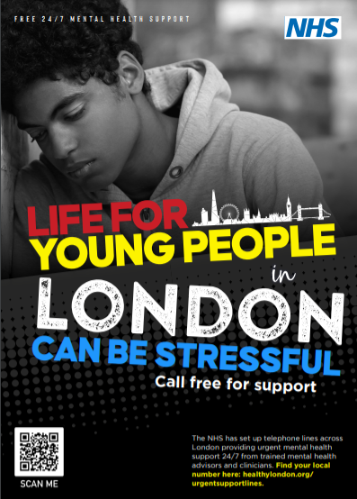 | Right click to download:  - A4 size for printing or digital use  - A3 size for printing or digital use
E-signature | 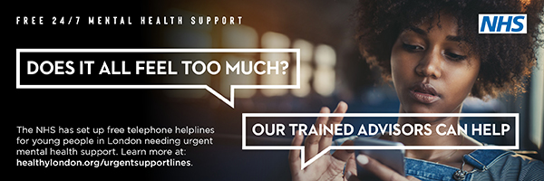 | To add to e-signatures
Digital background image | 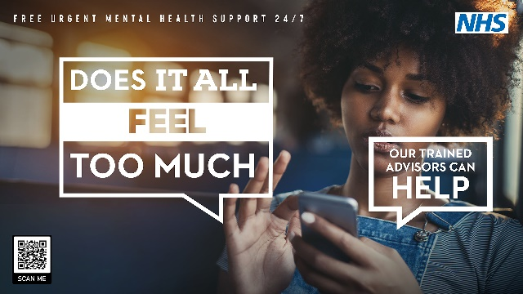  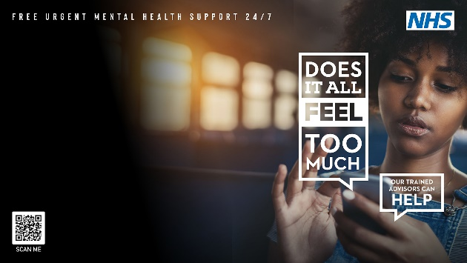 | For use as a desktop background image or MS Teams background filter (choose from two design options)
Digital postcard (gif format) |  | For use on organisations’ emails, e-newsletters, social media and websites (animation enabled when image is uploaded at full size)
Digital animation (48 second landscape format) | 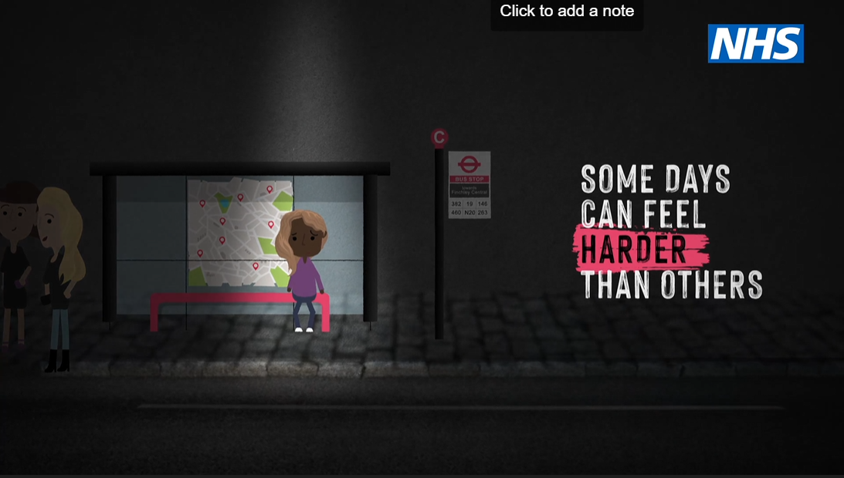 | Landscape format for use as Twitter, LinkedIn or Facebook posts.  Download .mp4 file here.  Or embed via: https://youtu.be/CF40VZEB_MY  Link to: https://www.healthylondon.org/urgentsupportlines
Digital animation (15 second vertical format) | 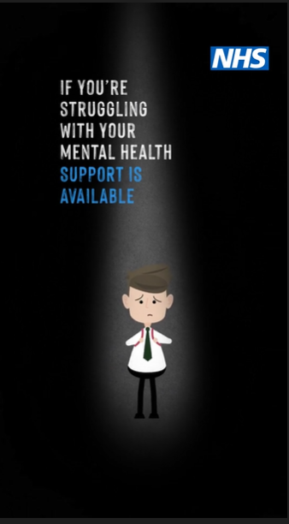 | Vertical format for use on Instagram Reels or Stories.  Download .mp4 file here.  Link to: https://www.healthylondon.org/urgentsupportlines

2023 calendar of mental health awareness days and key dates for schools/colleges

Date | Event
27 January 2023 | Great Mental Health Day
6-12 February 2023 | Children’s Mental Health Awareness Week
March 2023 – date to be confirmed | University Mental Health Day
April 2023 | Stress Awareness Month
15-21 May 2023 | Mental Health Awareness Week
May-June 2023 | Exam period for A Level, AS Level, GCSE and other equivalent qualifications
17 August 2023 | Results for May/June 2022 AS, A-level and other equivalent qualifications released to students
24 August 2022 | Results for May/June 2022 GCSE and other equivalent qualifications released to students
From 1 September 2023 | Phased return to primary schools
From 1 September 2023 | Return to secondary school and colleges
September 2023 | Freshers’ week from 18 September  University first term begins from 25 September
10 September 2023 | World Suicide Prevention Day
10 October 2023 | World Mental Health Day
2 November 2023 | National Stress Awareness Day

Other mental health and wellbeing resources

- Debt Free Advice website
- Good Thinking website and app – free digital mental wellbeing website and apps for Londoners
- Healthy London Partnership schools mental health toolkit:
  - Information hub for young people
  - Information hub for parents/carers
- This may help – resources for parents/carers on supporting young people’s mental health, sponsored by Healthy Minds and run by Bradford District and Craven Health and Care Partnership
- Thrive LDN – Getting Through This Together campaign resources to support Londoners in response to the increased cost-of-living pressures
- Young Minds – national charity providing mental health information and support for young people, parents/carers and professionals

