#AskAboutAsthma 2023 communications toolkit for Primary Care
#AskAboutAsthma returns for its seventh year, led by the NHS England – London Babies, Children and Young People’s Transformation team. The #AskAboutAsthma campaign is about making simple changes to children and young people’s care that will make a big difference to how they experience their asthma. The campaign week of learning and engagement events takes place this year from 11-17 September 2023.

Our aims
The #AskAboutAsthma campaign encourages children and young people, their families, and those involved in their care, to follow four simple and effective measures to help manage their asthma:

1. Get an asthma action plan in place
A written asthma action plan drawn up between a clinician and patient means people are four times less likely to have to go to hospital for their asthma.

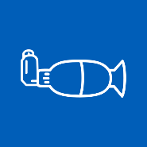
2.Understand how to use inhalers correctly
Less than three-quarters of children and young people have any form of instruction in how to use their inhaler. Poor inhaler technique means patients don’t get the full benefit of their asthma medication.

3. Schedule an asthma review – every year and after every attack
An asthma review by an appropriately trained clinician after every attack helps to work out what went wrong. An annual review ensures effective management of the condition.

4. Consider air pollution and its impact on lung health
We want to ensure that every asthma conversation considers the impact of outdoor and indoor air pollution on children and young people’s asthma.

Theme:
This year’s theme is “Widening our view”. We’re shining a light on the wider factors of children and young people’s asthma care including issues such as housing, mould and vaping.
We also recognise that health inequalities mean that not everyone gets the same standard of care. By widening our view, we can help to raise the profile of asthma by reaching out to everyone who has asthma, their friends, families and the whole system that cares for them.

Toolkit contents
- How to get involved with the #AskAboutAsthma 2023 campaign
  - Suggested copy for your websites, newsletters and publications
  - Social media assets and accompanying messages for Twitter, Facebook, Instagram and LinkedIn
  - Downloadable resources
- Asthma fact sheet
- Other useful resources

How to get involved with the #AskAboutAsthma 2023 campaign

Getting ahead of week 38
#AskAboutAsthma campaign week will take place from 11-17 September 2023.
Supporters of the campaign can take the learning, resources and key information shared to be even more prepared for week 38 (in 2023 this is from 18-24 September) – the week where, nationally, there is a rise in asthma attacks following the return to school after the summer holidays.

How to get involved in the #AskAboutAsthma 2023 campaign week
This communications toolkit is tailored for primary care colleagues to get involved in the #AskAboutAsthma 2023 campaign week and help raise awareness of the measures that should be taken to manage all children and young people with asthma.
If you work in primary care, you can support this campaign in a number of ways:
- Developing your own understanding of children and young people’s asthma by attending the #AskAboutAsthma conference and daily webinars, reading our blogs, watching our videos and listening to our podcasts.
- GPs and Practice nurses can talk to their patients with asthma – and their parents/carers – about their asthma care, helping them to understand that asthma is a chronic condition and can be managed with four asks.

  - Are they aware of the four asks? Do they have an asthma action plan? Have they had an inhaler technique check and asthma review by an appropriately trained clinician in the last year? Do they know how air pollution, smoking and vaping affects their asthma?
  - Using nebuliser devices at home for the acute treatment of asthma in children and young people without medical supervision can make it harder to spot signs of worsening asthma. Inform young patients and their families that this could mean that treatment is sought too late, with serious and even fatal consequences. (See MHRA for more info).
  - Sharing messaging with your asthma patients and their parents/carers around asthma triggers and why it’s important to minimise exposure where practical and possible:
    - Smoking: support and more information is available on smoking cessation from Stop Smoking London.
    - Vaping: Vaping is not recommended for young people under 18 and parents/carers of older children and teenagers can visit the Better Health website for support about talking to young people about vaping. Parents/carers of children with asthma can be reminded that although vaping can help smokers quit and there is currently no evidence that vaping is harmful to people around you, as a precaution, it is best not to vape around babies and children if you can avoid it. Young children often copy what adults do.
    - Damp and mould: babies, small children, older people, people with asthma, and people with allergies are more likely to be affected by damp and mould. Parents/carers of children with asthma can visit the Asthma + Lung UK website for information if they are concerned about mould or damp in their homes.
- Practice managers and reception staff can:
  - check records and call in patients who have not had an asthma review in the past year or have been prescribed reliever inhalers but not preventers.
  - Check if patients under 18 are using a nebuliser. If they are, remind them that nebulisers should only be used at home for the acute treatment of asthma in under 18s if recommended, initiated, and managed by an asthma specialist.
- You can display the #AskAboutAsthma campaign poster (found later in this toolkit) in reception areas to encourage patients and parents/carers to speak to their GP, nurse or pharmacist if they need help managing their asthma. Also see our spotting signs of asthma poster to help families understand if their child might have asthma and should be assessed.

A week of events is planned, with daily webinars, an online conference, podcasts, videos, blogs and other content from people working with children and young people with asthma from all over the country. Information about the events will be uploaded throughout the week so do check the page for more details and join in with as much as you can.
Find the latest information and links to register to join the virtual events by visiting the 2023 campaign web page.
This toolkit contains a range of resources to help publicise the campaign locally, including newsletter copy, social media assets and other resources to use in primary care settings. You may wish to highlight local examples of good practice or innovations as part of the campaign.

Tailored resources for your use

Long form article copy for websites, blogs, publications etc:

#AskAboutAsthma 2023: widening our view
#AskAboutAsthma is back for 2023. Now in its seventh year the campaign encourages simple changes to children and young people’s care that will make a big difference to how they experience their asthma. The 2023 #AskAboutAsthma campaign will run from 11 – 17 September, ahead of the rise in asthma attacks in September when children and young people go back to school after their summer holidays. The campaign is run by the NHS England – London Babies, Children and Young People’s Transformation team and centres around four steps to help manage asthma:
1. get an asthma action plan in place.
2. understand how to use inhalers correctly.
3. schedule an asthma review every year and after every attack.
4. consider air pollution and its impact on lung health – every asthma conversation should include indoor and outdoor air pollution.
This year’s theme is “Widening our view” and is shining a light on the wider factors of children and young people’s asthma care including housing, mould and vaping. “Widening our view” also helps us to raise the profile of asthma; reaching out to everyone who has asthma, their friends, families and the whole system that cares for them.
Healthcare professionals in primary care play a crucial role in supporting children and young people with asthma, and their families, from diagnosis to referral as necessary, and helping to explain what asthma is and how it can be managed by putting these four asks in place.
Join us in sharing the #AskAboutAsthma campaign so more families in London can learn about asthma care. Visit the 2023 campaign webpage for more information and resources.
(267 words)

Short form article copy for newsletters, bulletins, community forums or WhatsApp groups:

#AskAboutAsthma 2023 – widening our view
#AskAboutAsthma 2023 takes place from 11 – 17 September. The campaign encourages children, young people and their parents and carers to understand how to best manage their asthma by following four steps:
1. get an asthma action plan in place,
2. understand how to use inhalers correctly,
3. schedule an asthma review – every year and after every attack, and
4. consider air pollution and its impact on lung health.
This year’s campaign theme is widening our view – shining a light on the wider factors of children and young people’s asthma care.
Visit the campaign webpage at www.transformationpartnersinhealthandcare.nhs.uk/ask-about-asthma for more information and to sign up to virtual events and training.
(108 words)

Social media assets and accompanying messaging

You can use the following social media assets and messaging to raise awareness around #AskAboutAsthma on your channels.

Remember to tag us on social media using the campaign hashtag: #AskAboutAsthma. We will retweet and like any messages you share. Follow the NHS England – London babies, children and young people’s transformation team on:

Twitter: @BCYP_NHSLDN
Instagram: @BCYP_NHSLDN

You can find social media suggested messaging below. To download full-sized images for each social media channel, follow this link to our Google Drive folder.

Suggested messaging and which assets to use
Twitter asset 1 (carousel) – four asks:  - 4 asks overview:  There are four steps that can help children and young people to manage their asthma and live full, active lives.  🔗Learn more about asthma care: https://www.transformationpartnersinhealthandcare.nhs.uk/your-asthma-care/  #AskAboutAsthma  2.1  An asthma action plan has all the information you need to manage a child or young person’s asthma. Speak to a GP or asthma nurse if you do not have an asthma plan.  🔗Find out more about asthma action plans for children and young people: http://www.asthmaandlung.org.uk/conditions/asthma/child/manage/action-plan  #AskAboutAsthma  2.2  Knowing how to use an inhaler correctly can help prevent 75% of asthma hospital admissions in London each year.  Check if you or your child is using their inhaler correctly: www.asthmaandlung.org.uk/conditions/asthma/child/medicines/help  #AskAboutAsthma  2.3  Scheduling an asthma review once a year (and after every attack) can help children and young people to manage their symptoms.  Speak to your GP or asthma nurse to book your next asthma review.  🔗Learn more about asthma care: https://www.transformationpartnersinhealthandcare.nhs.uk/your-asthma-care/  #AskAboutAsthma  2.4  Indoor and outdoor air pollution can trigger asthma, but knowing the triggers can help children and young people to manage their condition.  🔗Learn more about managing air pollution triggers: https://www.asthmaandlung.org.uk/living-with/air-pollution  #AskAboutAsthma | 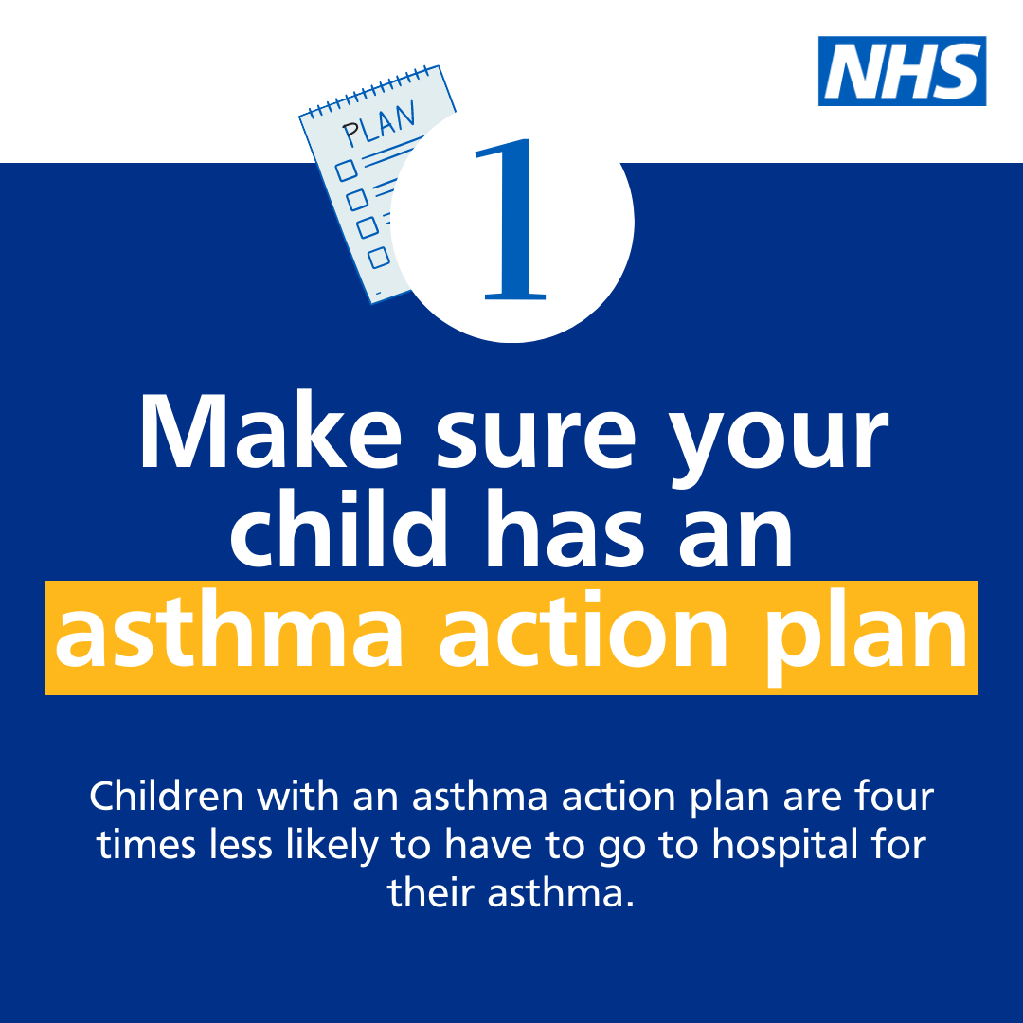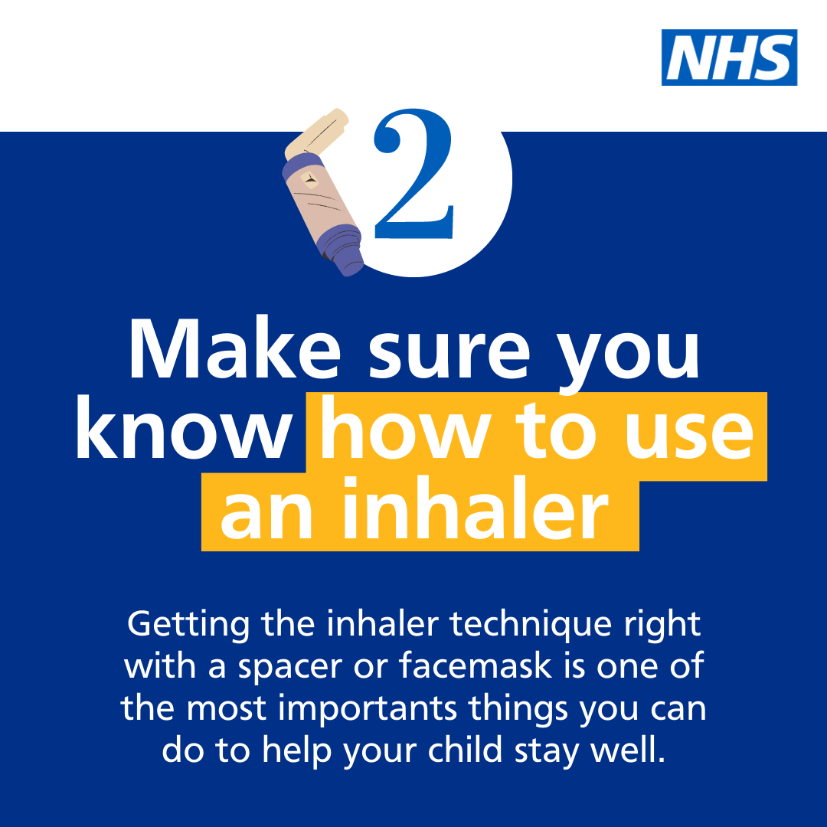  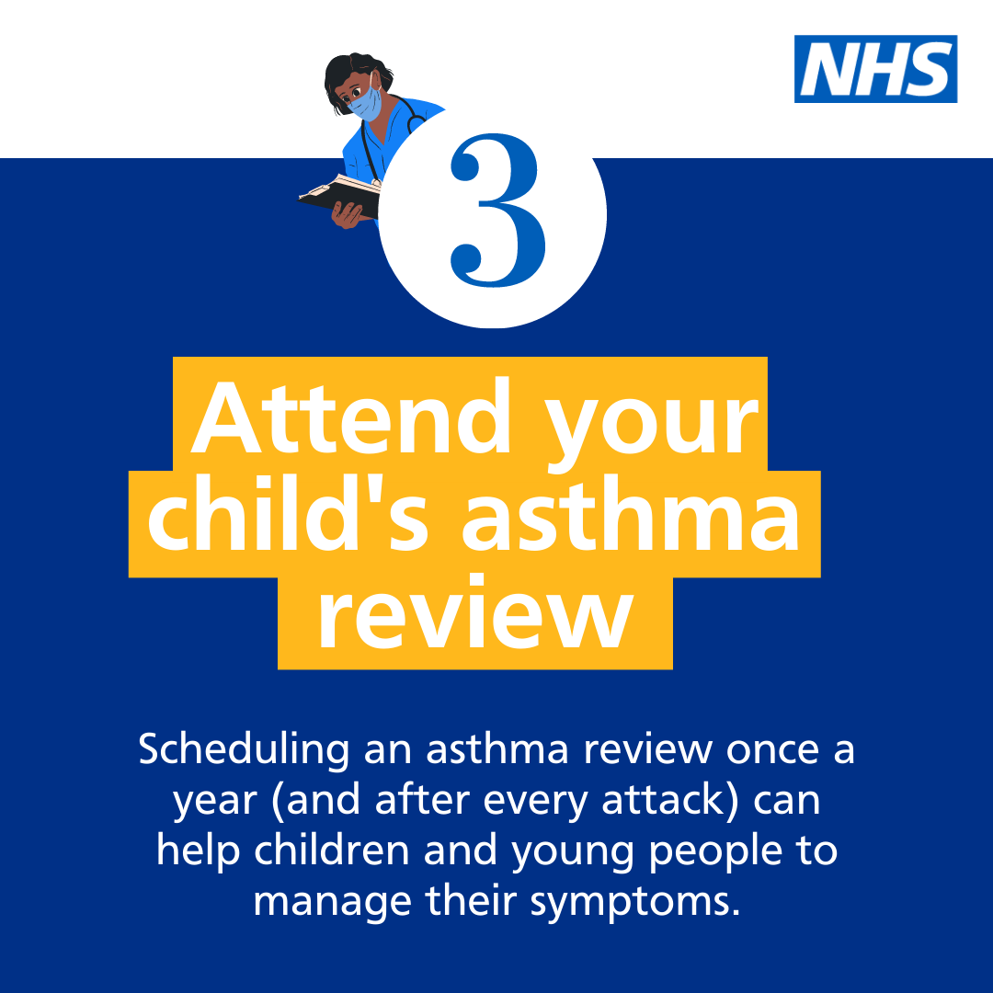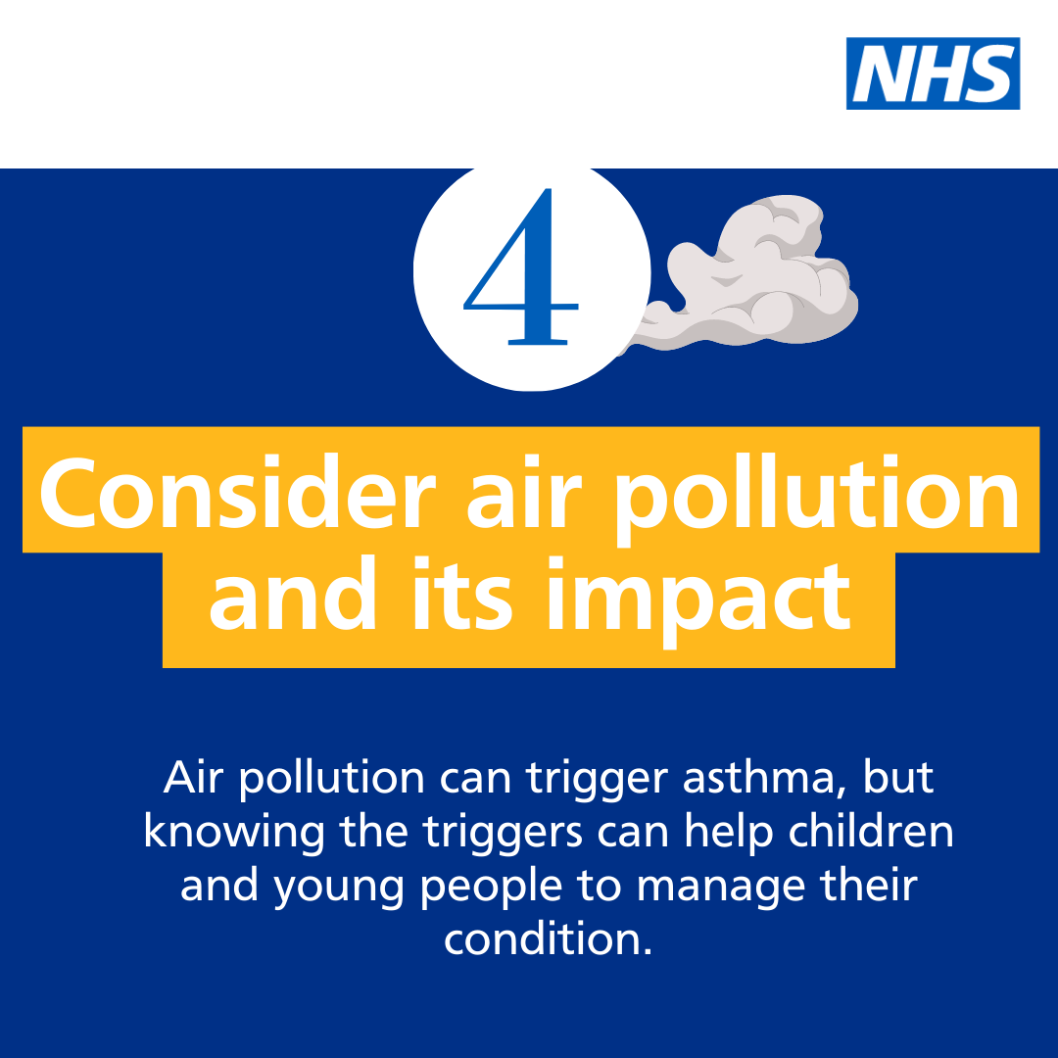  Asset: Upload rotating .mp4 file  Alt text: Text reads: Follow the four steps to help manage your child’s asthma. 1. Get an asthma action plan in place. Children with an asthma action plan are four times less likely to have to go to hospital for their asthma. 2. Understand how to use inhalers correctly. Getting the inhaler technique right with a spacer or facemask is one of the most important things you can do to help your child stay well. 3. Schedule an asthma review – every year and after every attack. Scheduling an asthma review once a year (and after every attack) can help children and young people to manage their symptoms. 4. Consider air pollution and its impact on lung health. Air pollution can trigger asthma, knowing the triggers can help children and young people to manage their condition.  Tag: @BCYP_NHSLDN  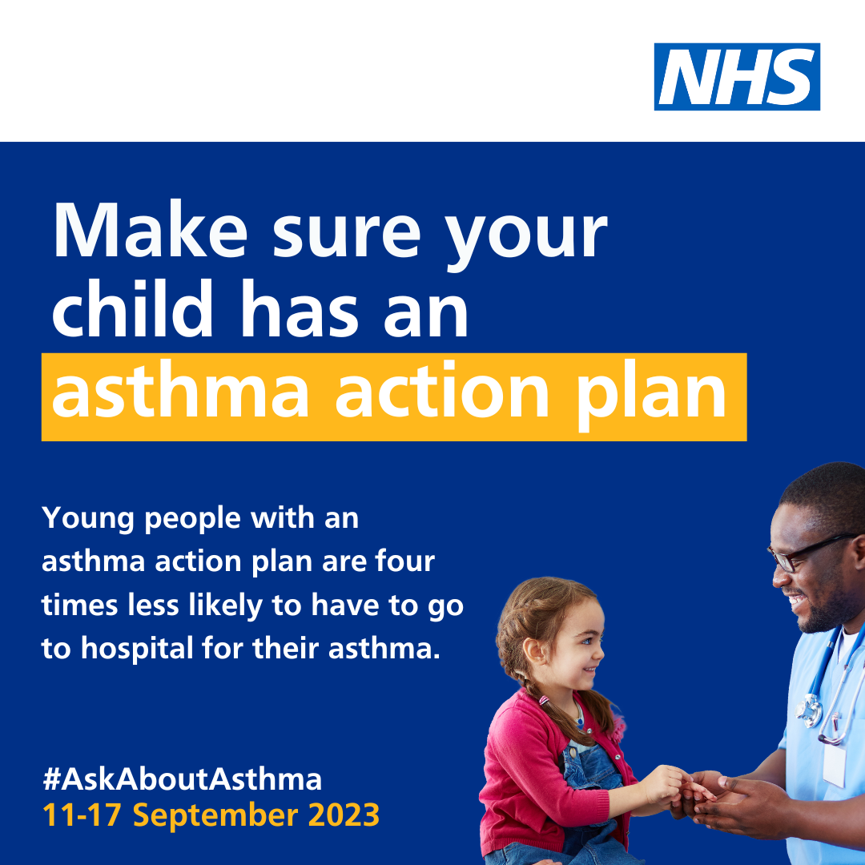  Alt text: An image of a young girl and an asthma nurse. Text reads: Make sure your child has an asthma action plan. Children with an asthma action plan are four times less likely to have to go to hospital for their asthma. #AskAboutAsthma. 11-17 September 2023  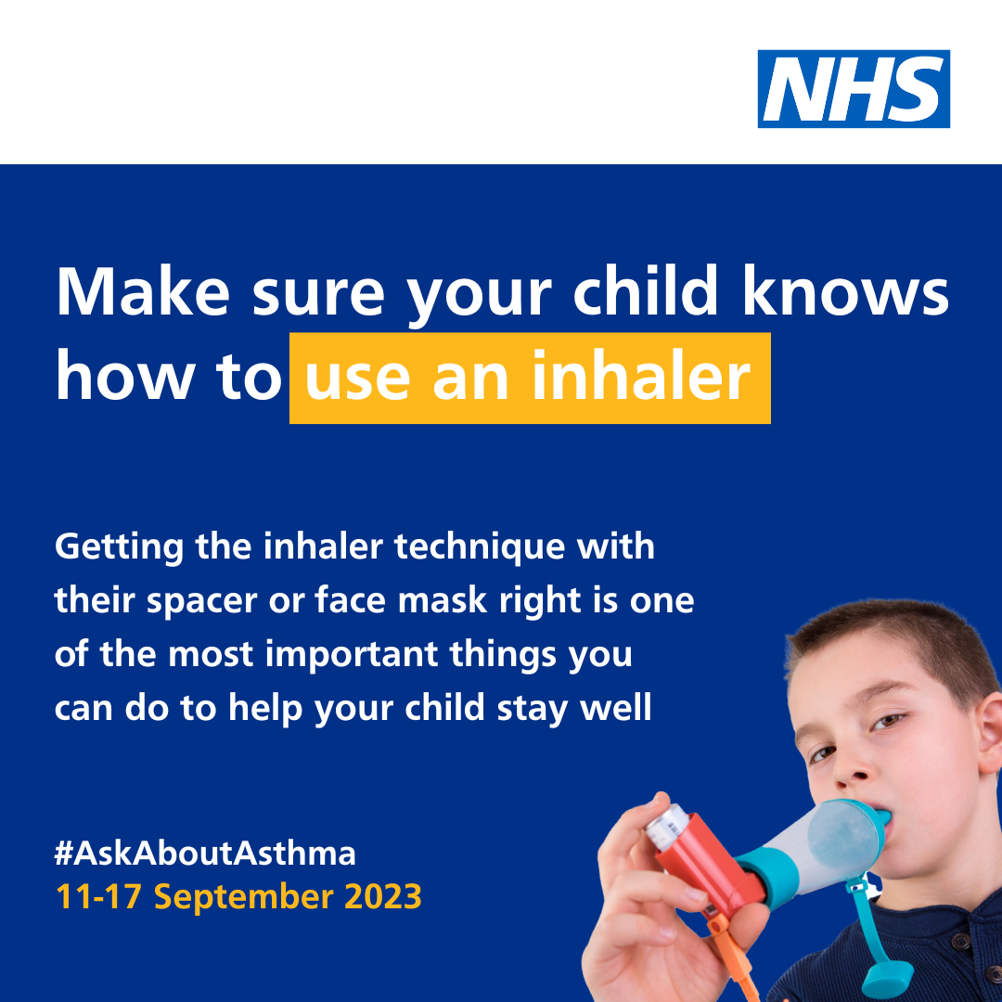  Alt text: An image of a young boy using an inhaler and spacer device. Text reads: Make sure your child knows how to use an inhaler. Getting the inhaler technique with their spacer or facemask right is one of the most important things you can do to help your child stay well. #AskAboutAsthma. 11-17 September 2023  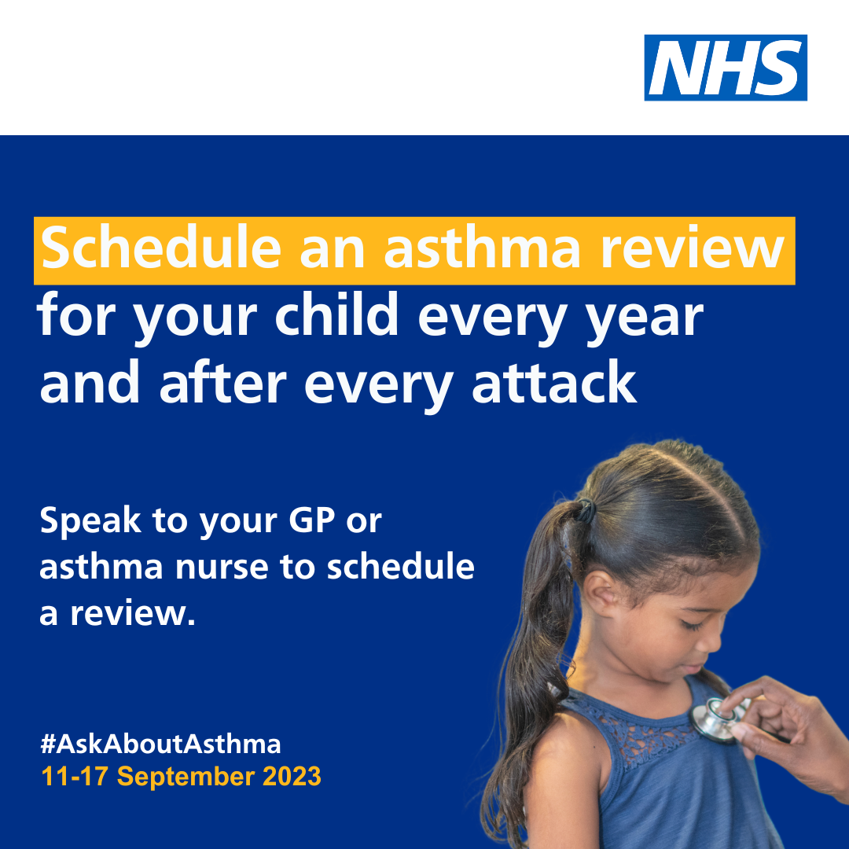  Alt text: An image of a young girl being checked with a stethoscope. Text reads: Remember to schedule an asthma review for your child every year and after every attack. Speak to your GP or asthma nurse to schedule a review. #AskAboutAsthma. 11-17 September 2023  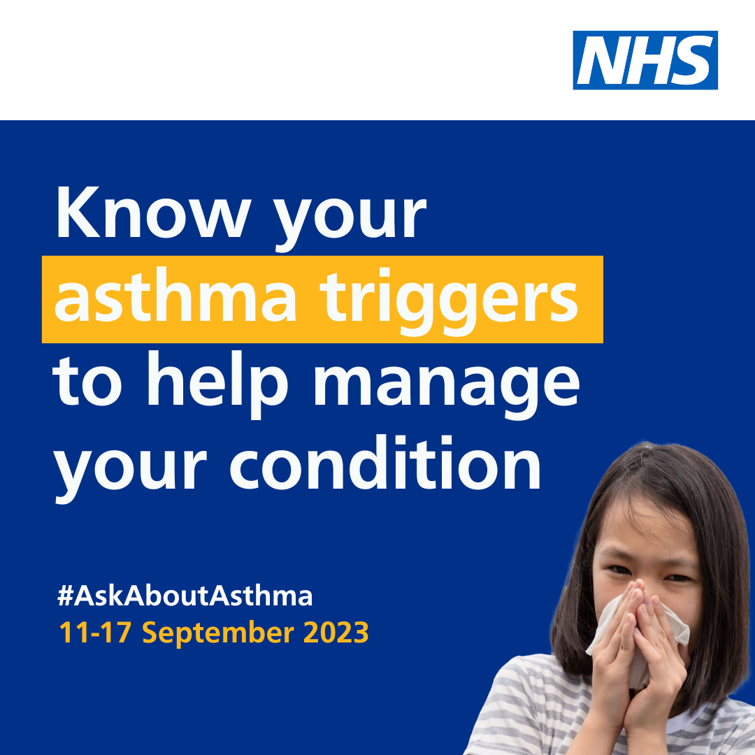  Alt text: An image of a young girl coughing into a tissue. Text reads: Know your child’s asthma triggers to help manage their condition. #AskAboutAsthma. 11-17 September 2023
Twitter asset 2: widening our view  With the right support, every child and young person with asthma can learn to manage their condition.  That’s why #AskAboutAsthma 2023 is encouraging us all to widen our view of children and young people’s asthma.  🔗Learn more at: https://www.transformationpartnersinhealthandcare.nhs.uk/your-asthma-care/ | 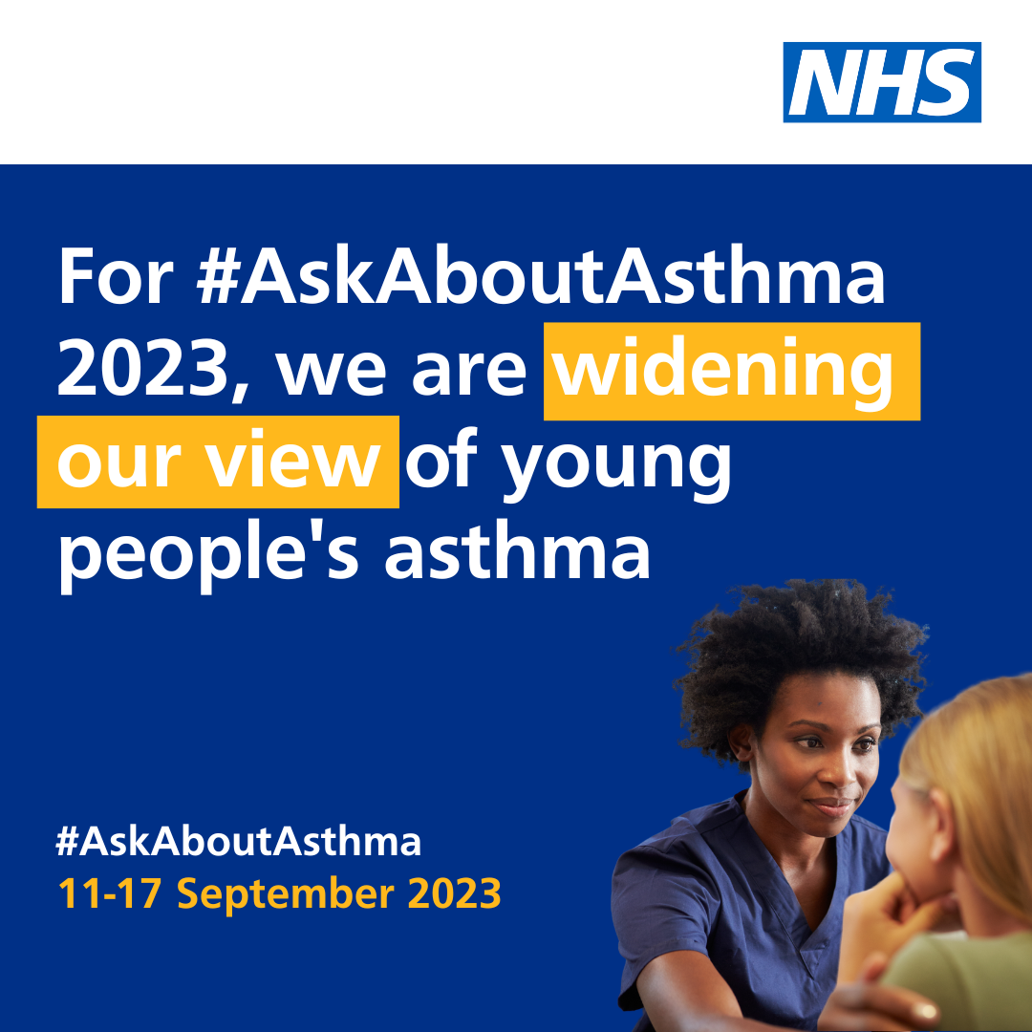  Alt text: An image of a nurse and a young patient. Text reads: For #AskAboutAsthma 2023, we are widening our view of young people's asthma. #AskAboutAsthma. 11-17 September 2023  Tag: @BCYP_NHSLDN
Instagram asset 1 (carousel video post) – four asks:  There are four steps that can help children and young people to manage their asthma and live full, active lives:  1. Get an asthma action plan in place  2. Understand how to use inhalers correctly  3. Schedule an asthma review – every year and after every attack  4. Consider air pollution and its impact on lung health  🔗 Search #AskAboutAsthma or follow the link in our bio to learn more about children and young people’s asthma care. | Asset: Upload rotating .mp4 file  Alt text: Text reads: Follow the four steps to help manage your child’s asthma. 1. Get an asthma action plan in place. Children with an asthma action plan are four times less likely to have to go to hospital for their asthma. 2. Understand how to use inhalers correctly. Getting the inhaler technique right with a spacer or facemask is one of the most important things you can do to help your child stay well. 3. Schedule an asthma review – every year and after every attack. Scheduling an asthma review once a year (and after every attack) can help children and young people to manage their symptoms. 4. Consider air pollution and its impact on lung health. Air pollution can trigger asthma, knowing the triggers can help children and young people to manage their condition.  Tag: @BCYP_NHSLDN  Change bio link to: https://www.transformationpartnersinhealthandcare.nhs.uk/your-asthma-care/
Instagram asset 2 – widening our view:  #AskAboutAsthma 2023 encourages us to  widen our view of children and young people’s asthma and highlight wider factors of asthma care.  Housing, mould and vaping all have an impact on young people’s asthma and can cause serious problems.  Following four key steps can help to manage asthma, reduce the risk of asthma attacks and help children and young people manage their condition:  1. Get an asthma action plan in place  2. Understand how to use inhalers correctly  3. Schedule an asthma review – every year and after every attack  4. Consider air pollution and its impact on lung health.  🔗 Search #AskAboutAsthma or follow the link in our bio to learn more about children and young people’s asthma care. | Alt text: An image of a nurse and a young patient. Text reads: For #AskAboutAsthma 2023, we are widening our view of children and young people's asthma. #AskAboutAsthma. 11-17 September 2023  Tag: @BCYP_NHSLDN  Change bio link to: https://www.transformationpartnersinhealthandcare.nhs.uk/your-asthma-care/
Facebook/LinkedIn asset 1 – 4 asks (carousel video post):  There are four steps that can help children and young people to manage their asthma and live full, active lives:  1. Get an asthma action plan in place  2. Understand how to use inhalers correctly  3. Schedule an asthma review – every year and after every attack  4. Consider air pollution and its impact on lung health.  Learn more about children and young people’s asthma care at: https://www.transformationpartnersinhealthandcare.nhs.uk/your-asthma-care/ | Asset: Upload rotating .mp4 file  Alt text: Text reads: Follow the four steps to help manage your child’s asthma. 1. Get an asthma action plan in place. Children with an asthma action plan are four times less likely to have to go to hospital for their asthma. 2. Understand how to use inhalers correctly. Getting the inhaler technique right with a spacer or facemask is one of the most important things you can do to help your child stay well. 3. Schedule an asthma review – every year and after every attack. Scheduling an asthma review once a year (and after every attack) can help children and young people to manage their symptoms. 4. Consider air pollution and its impact on lung health. Air pollution can trigger asthma, knowing the triggers can help children and young people to manage their condition.  Tag: @BCYP_NHSLDN  Change bio link to: https://www.transformationpartnersinhealthandcare.nhs.uk/your-asthma-care/
Facebook/LinkedIn asset 2 – widening our view:  #AskAboutAsthma 2023 encourages us to  widen our view of children and young people’s asthma and highlight wider factors of asthma care.  Housing, mould and vaping all have an impact on young people’s asthma and can cause serious problems.  Following four key steps can help to manage asthma, reduce the risk of asthma attacks and help children and young people manage their condition:  - have an asthma review after every attack and at least once a year by an appropriately trained clinician,  - know how to use your inhaler correctly,  - have a written asthma action plan, and,  4. know about the potential impact of air pollution on your lungs.  🔗Learn more at: www.transformationpartnersinhealthandcare.nhs.uk/ask-about-asthma | Alt text: An image of a nurse and a young patient. Text reads: For #AskAboutAsthma 2023, we are widening our view of children and young people's asthma. #AskAboutAsthma. 11-17 September 2023

Downloadable campaign poster

Downloadable campaign resources
- #AskAboutAsthma campaign poster and easy read version which can be printed out and displayed locally
- Click here to download a digital poster about signs/symptoms of asthma
- Click to download a campaign desktop background image to display on waiting room screens in public/patient areas

Other useful resources

- Children and young people’s asthma fact sheet
- Asthma and Lung UK
- NHS England – London children and young people’s asthma programme
- London toolkit for children and young people with asthma
- London schools’ guide for the care of children and young people with asthma
- The International Primary Care Respiratory Group (IPCRG) image gallery
- Messaging on vaping for young people
- Advice on indoor allergies including mould and damp

We do not have to wait for new medicines or a cure for asthma: we need to educate and support everyone treating or supporting children and young with asthma to use these tools and work together to achieve improved outcomes.

