Operational Policy for

Working Post Lockdown

## **Contents**

|  |  |
| --- | --- |
| **Contents** | **Page Number** |
| Objectives | 1 |
| Entering/Exiting Isleworth Centre | 2 |
| Evacuation Procedures | 2 |
| Plan – Room Use | 3 |
| Personal Protection Equipment (PPE) | 5 |
| Cleaning | 6 |
| Equipment | 6 |
| Work Bubbles | 6 |
| What to do if safety guidelines are not being followed | 7 |
| Symptoms | 7 |
| Self-Isolation (Households) | 7 |
| Frontline Staff Testing for Covid-19 at West London NHS Trust | 8 |
| Informing the GP Practice | 11 |
| Local Lockdowns | 11 |
| National Lockdowns | 11 |
| Lunch | 11 |
| Temperature Checks | 12 |
| Administration Team | 12 |
| Go To | 12 |
| FAQ’s | 10 |
| Appendix | 11 |

## **Objectives**

Following the period of lockdown due to COVID-19, the NHS and all services within the organisation are being asked to return to a ‘new normal’ and restore as many aspects of their service as possible. In line with this Hounslow IAPT is now moving towards staff being in the shared office at the Isleworth Centre and resuming face to face appointments with service users.

This will be a new service model based on the risk assessments completed and Government guidelines on COVID-19 safety measures. This document aims to give detailed guidance on how we are going to keep ourselves and our service users safe.

Please note we are currently only working on restoring service at the Isleworth Centre, other locations will follow.

## **Entering/Exiting Isleworth Centre**

Currently we are entering through the main entrance; please ensure you are wearing your face mask if you walk through the entrance for the surgery.

We are hoping to get keys cut to be able to exit/enter through the back gate and door. When this is in place, please note to come up the back stairs and not enter the surgery.

All **MUST** remember to sign in and out, there will be a list in each room

* Wear mask when entering / exiting.
* Maintain 2 meter distance from GP patients
* Respect confidentiality when reception is speaking to a patient in the lobby at main entrance
* Use back door to enter and exit for breaks
* The guidance stipulates only one person on the stairwell. Try to avoid crossing any staff members on the stairs as you walk to the IAPT office.

## **Evacuation Procedures**

The official guidance on evacuation procedures, as stated in the Trust Risk Assessments does not require staff or services users to social distance in order to exit the building, however, once outside, all should maintain a reasonable distance from each other rather than huddle together.

There will be an allocated Evacuation Lead in each work bubble that will check the fire panel and advise all whether to evacuate, they will request someone from each office to take the signing in sheets with them.

A Fire Warden high visibility vest is available in the Triage Office and CBT Office

## **Plan- Room Use**

At any one time the maximum number of staff that can safely socially distance in the Isleworth centre is 12. Please see plans for each room below along with the PPE required for that space.

Senior Office: Maximum 3 Staff

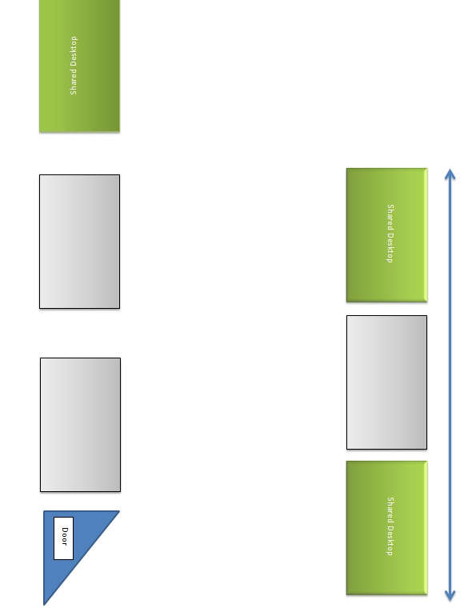

**Evacuation Response (Rooms to check)**

Senior Office

Room 208

Room 206

Staff Toilet

Exit via the back stairs

**Needed:**

3X Sanitizer

3X Disinfectant Wipes

1X Box of Face Masks

1X Box of Gloves

Remove additional chairs

Clear un-necessary clutter on desks

**CBT Office:** Maximum 5 Staff

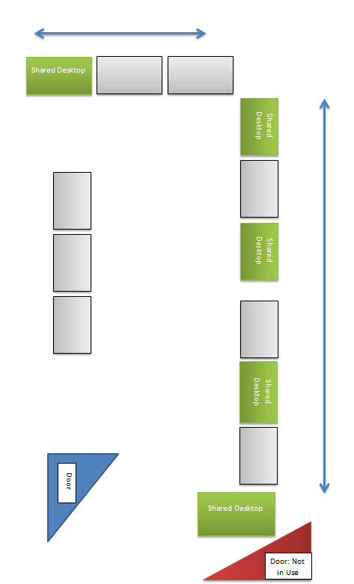

**Needed:**

5X Sanitizer

5X Disinfectant Wipes

2X Box of Face Masks

2X Box of Gloves

Remove additional chairs

Clear un-necessary clutter on desks

**Evacuation Response (Rooms to check)**

CBT Office

Interview Room

Kitchen

Patient Toilet

Exit via the main stairs

**Triage Office:** Maximum 4 Staff

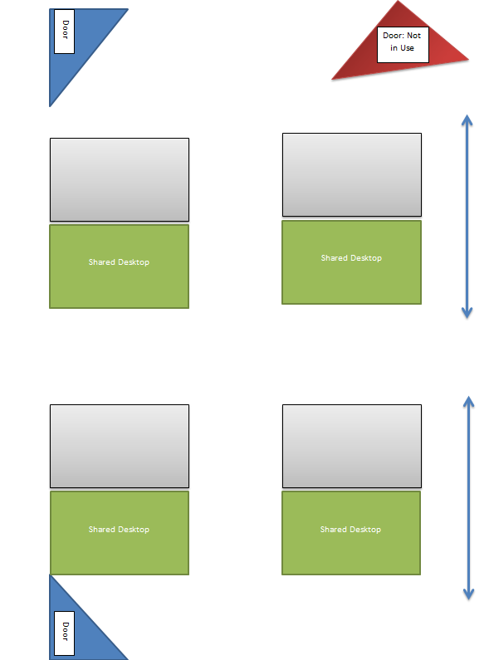

**Needed:**

4X Sanitizer

4X Disinfectant Wipes

2X Box of Face Masks

2X Box of Gloves

Remove additional chairs

Clear unnecessary clutter on desks

**Evacuation Response (Rooms to check)**

Triage Office

Room 210

Room 211

Waiting Area

Exit via the main stairs

**Other spaces within the Isleworth Centre:**

**Waiting Area / Consultation Rooms / Kitchen**

|  |  |  |
| --- | --- | --- |
| **Room** | **Guidance** | **Needed** |
| Interview | * Maximum 2 people * Chairs to remain as they are * Windows to be opened | 2X Sanitizer  2X Disinfectant Wipes  1X Box of Face Masks  1X Box of Gloves  Remove additional chairs  Clear un-necessary clutter on tables |
| 211 | * Maximum 2 people * Chairs to remain as they are * Windows to be opened | 1X Sanitizer  1X Disinfectant Wipes  Remove additional chairs  Clear un-necessary clutter on table |
| 210 | * Maximum 2 people * Chairs to remain as they are * Windows to be opened | 1X Sanitizer  1X Disinfectant Wipes  Remove additional chairs  Clear un-necessary clutter on table |
| 206 | * Maximum 3 people * Chairs to remain as they are * Windows to be opened | 2X Sanitizer  2X Disinfectant Wipes  1X Box of Face Masks  1X Box of Gloves  Remove additional chairs  Clear un-necessary clutter on tables |
| 208 | * Maximum 3 people * Chairs to remain as they are * Windows to be opened | 2X Sanitizer  2X Disinfectant Wipes  1X Box of Face Masks  1X Box of Gloves  Remove additional chairs  Clear un-necessary clutter on tables |
| Waiting Area | * Maximum 2 people * Chairs to remain as they are * Skylights to be opened | 1X Sanitizer  1X Disinfectant Wipes  1X Box of Gloves  Remove additional chairs  Clear un-necessary clutter on table |
| Kitchen | * Maximum 2 people * Door to remain closed * Windows to be opened |  |
| Staff Room | * NOT IN USE |  |
| Toilet  (near Waiting Area) | * Service User use ONLY | 1X Sanitizer  1X Disinfectant Wipes  1X Box of Gloves |
| Toilet  (in corridor) | * Staff use ONLY | 1X Sanitizer  1X Disinfectant Wipes  1X Box of Gloves |

## **Personal Protection Equipment (PPE)**

Personal Protection Equipment (PPE) is to be worn when interacting with service users. All service users should be wearing a mask/face covering as this is a Government requirement when entering an NHS building such as a hospital or GP surgery. In line with this staff should also be wearing masks during these interactions at all times. It is recommended that staff wear disposable masks during sessions, rather than their own cloth covering.

PPE will be provided and available to you at all times. A nominated member of staff will be checking the levels of PPE each day and ensuring we have stocks in place so we do not run out. Zita the office manager will be ordering the PPE on a regular basis. Please ensure if you see PPE running low that your bubble lead e-mail’s Zita so she can re-order.

Please note if you wish to wear your own mask this is a personal choice. If you are using disposable masks they can be placed in normal waste. However, if you come into contact with someone who has COVID-19 then you must place the PPE in the correct coloured refuse sack. If you are using a washable mask, please ensure you wash your mask regularly. Ideally after each day’s use. Please remember a new mask should be worn after each patient contact or when moist.

An aside note, you do not have to wear a mask all day when sat at your desk unless you are unable to keep a safe distance from your colleagues.

**Please do not take the disposable masks home, there is a limited stock and they MUST be reserved for service user contact ONLY**

## **Cleaning**

Regular cleaning will be taking place, however your work station and clinical room will need to be cleaned down by yourself. Sanitizer and disinfectant wipes will be available in every room. Before starting a session, you should wipe down all surfaces in the room including door handles. Once your session has ended the same procedure should be followed again (please see checklists in the appendices). Due to this you will need to leave a 30 minute gap between patients (no back to back sessions). After cleaning the room, you must open the door leave it to ventilate for 30 minutes (please see job plans for the day in the appendices).

As you go about the day please ensure high contact areas are wiped down regularly, these would be door handles. Please also encourage service users to wipe down toilet area and door handles if they use the facilities. If you use the lift or aid a service user in using the lift please wipe down the buttons using disinfectant wipes.

It is imperative that we ensure desks do not become cluttered; please ensure all paper, clipboards, booklets and pens are placed in your drawer at the end of your shift.

## **Equipment**

As it is very difficult to clean a desk top computer thoroughly we will be asking staff where possible to bring their laptop to the office and work off this. We know this will not be possible for everyone, therefore we ask that you wipe down your desk top before and after use to try and minimise any possible transference of bacteria etc. There are reminders on each desk to wipe down, keyboard, mouse, mouse mat and screen plus the desk.

## **Work Bubbles**

Due to maximum numbers we can safely have in the office we will be working in ‘work bubbles’. In principle work bubbles will operate in the same manner as classroom bubbles in schools. The same people will work on the same day each week and therefore minimising contact with others. We will continue to operate under a 2-meter social distancing policy where possible. Where this is not possible masks should be worn. Due to the nature of the bubble, this allows people within the bubble to car share and hopefully reduces the need for any staff to use public transport. If you are car sharing remember you must all be wearing a face covering as you cannot socially distance within the confines of a car.

If you are sick (not COVID-19) or unable to come to work for other reasons (unrelated to coronavirus symtoms) please drop your bubble a message to let them know you are not coming in so they do not need to plan around your attendance.

Please note that the first person to arrive each morning will need to open the windows and doors for all rooms to ensure they are sufficiently ventilated. Please ensure all are closed when you leave in the evenings.

All work bubbles should have an introduction meeting before going back into the office. Please see meeting check list to cover all the points needed. (Checklist in appendices). As part of this meeting you will need to nominate a lead person in case of evacuation from the building as there will not be a fire marshal in every bubble.

## **What to do if safety procedures are not being followed**

As individuals we all might have different ideas about what is/is not safe practice. The guidelines we are following are social distancing of 2 meters and regular hand washing. Added to this is the correct use of PPE.

If you are unhappy or concerned with someone’s lack of social distancing or hand washing please speak to them and express your concerns. All staff have agreed they would rather be approached in a friendly manner as we are all learning a new way of working.

There will be a named person within each bubble. If you have any concerns about others not following guidelines and you have approached them yourself with no luck then please speak to the bubble lead.

The Senior Managers on-site will undertake regular walkabouts to ensure staff are following the guidance and in particular **ensuring that face masks are being worn correctly**

## **Symptoms**

If you begin to experience symptoms, please let you bubble lead know, your line manager and Zita. The line manager and bubble lead will then inform the rest of your bubble. Please ensure you book your COVID-19 test for within 1-3 days of starting to experience symptoms. As an ‘essential worker’ you will be prioritised for testing. Please send a copy of your booking confirmation receipt to your line manager and Zita. During this time before you receive your test results everyone in your household will need to self-isolate. If however the test comes back negative you can return to work. Please note that it can take up to 72 hours to receive the results of the test. Please send a copy of your test results to your line manager and Zita. If it is positive, then the 14 days’ quarantine must be completed. Admin will need to contact any patients that you were in contact with during this period as guided by Go-To Senior. Anyone in your bubble experiencing symptoms must also self-isolate and arrange testing.

If any member of your household has symptoms you must also self-isolate and the same procedure above to be followed. If you have a cold you cannot self-diagnosis that it is just a cold, you will need to follow the procedures above and act as if it is COVID-19 unitl you get your test results back.

|  |  |
| --- | --- |
| * A high temperature or fever - a high temperature, 37.5C or higher – this means you feel hot to touch on your chest or back (you do not need to measure your temperature) | * A new, continuous cough – this means coughing a lot for more than an hour, or 3 or more coughing episodes in 24 hours (if you usually have a cough, it may be worse than usual) |
| * Loss or change of taste and smell | * Fatigue |
| * Chest pain | * Shortness of breath |
| * Sore Throat |  |

## **Self-Isolation (Households)**

If a household member has been informed that they have been in contact with a positive case of Covid-19 through track and trace or a letter from school they must self-isolate. That person is the only one who needs to self-isolate for 14 days from the day they were in contact with the person who has tested positive. As long as that person is asymptomatic the rest of the household can continue with their normal daily activities.

If that person develops symptoms within the self-isolation period, then they need to be tested for Covid-19 and the rest of the household need to self-isolate until they receive their test result. If the result is negative then the household members can resume their normal daily activities and the symptomatic person remains at home until either 14 days or when they have been 48 hours clear of symptoms.

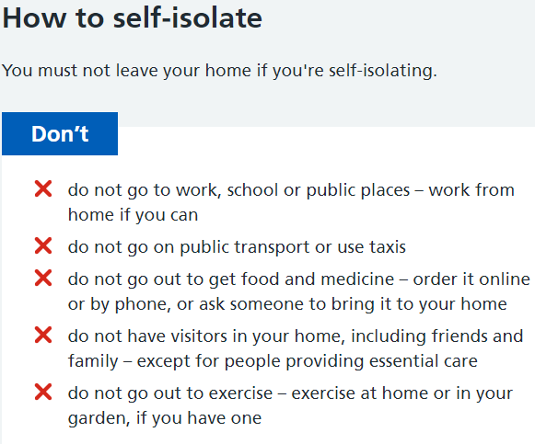

**Source: www.nhs.uk**

## **Frontline Staff Testing for Covid-19 at West London NHS Trust**

**Who can get tested?**

For testing to be accurate you (or the person in your household needing testing) should be on days 1–3 of the onset of Covid-19 symptoms at the time the swab is taken.

To book a test you will need to meet the below criteria to access a test:

* An individual (adult or child) with Covid-19 symptoms living in the same household as a member of NHS staff or staff working in a care setting OR a member of NHS staff or staff working in a care setting, with Covid-19 symptoms
* Testing is only open to people with a booked and confirmed appointment letter, at the designated time. Under no circumstances should anyone travel to a testing location without a confirmed booking

**West London Staff now have options to test themselves and household members:**

1. Local Testing Hubs (coming soon)  
   We are currently working with colleagues in local acute Trusts to help our staff with accessing tests through their services and hope to have this in place soon, along with a localised option at Armstrong Way from October.
2. Drive-through testing

To book an appointment for the drive-through testing services please visit the [**Essential workers self-referral**](https://self-referral.test-for-coronavirus.service.gov.uk/)[**portal**](https://self-referral.test-for-coronavirus.service.gov.uk/)and follow instructions provided. To see how the drive though testing site works, please see [this animation](https://www.youtube.com/watch?v=JVB6TC49ss0).

You or someone in your household will need to have a car and be able to drive to access these test sites. Taxis or other means of public transportation are not permitted.

Help with getting a test:

**Coronavirus Test Process and Recording**

All the Trust guidance that is produced regarding Covid is on the Exchange but a number of our staff don’t have access to the Exchange or have now been locked out of their West London emails as they are unable to attend on site.  
  
If you experience any Coronavirus symptoms, you and anyone you live with must self-isolate and unfortunately cannot leave the house for any reason other than emergencies, see guidance below:

<https://www.nhs.uk/conditions/coronavirus-covid-19/self-isolation-and-treatment/when-to-self-isolate-and-what-to-do/>

You or anyone in your household will not be able to attend any Trust site or leave the house (other than to get a test or for an emergency) until you have all received a negative test result. As an essential worker you and your household will be prioritised for tests. See the link below. Do this as soon as you or anyone you live with experiences symptoms as places go very quickly.  
  
<https://www.gov.uk/get-coronavirus-test>

The test itself can be done as soon as on the day but it can take up to 72 hours to receive the results. You can register you and up to 3 other people in your household to get tested all at once. The easiest way is to travel by car to a test centre, if you do not have access to car, they can post the tests to you.

You will receive a confirmation email once the test is booked and a receipt card once the test is completed. We will need to store a copy of these so please send them to your Line Manager.  
  
If you cannot get booked through the national NHS test service above, try the Trust one, but places are very limited.  
  
<https://www.surveymonkey.com/r/6XCQTRQ>

Once you receive your test result please email it to and liaise with your Line Manager regarding returning to on site working.​



## Informing the GP Practice

We have discussed our return with the GP Practice and have shared contact details to ensure we keep each other updated, should there be a suspected case of Coronavirus.  
  
The GP Practice will contact IAPT either via email or telephone call to the following:

|  |  |  |
| --- | --- | --- |
| **​Role** | **​Email** | **​Telephone** |
| ​Admin | ​[houccg.hounslowiapt@nhs.net](mailto:houccg.hounslowiapt@nhs.net)  [z.shah@nhs.net](mailto:z.shah@nhs.net) | 07548 143 077 |
| ​Clinical Lead | ​[lenapaul@nhs.net](mailto:lenapaul@nhs.net) | ​07837 835 315 |
| ​Deputy Clinical Lead | ​[bev.edwards@nhs.net](mailto:bev.edwards@nhs.net) | ​07756 500 034 |

​  
Lena, Bev or Zita will inform the GP Practice via email and / or telephone as follows

|  |  |  |
| --- | --- | --- |
| **Role** | **​Email** | **​Telephone** |
| ​Practice Manager  Assist Practice Manager  Reception Manager | ​[carey.musgrove@nhs.net](mailto:carey.musgrove@nhs.net)  [sharon.fifield@nhs.net](mailto:sharon.fifield@nhs.net)  [claire.correia@nhs.net](mailto:claire.correia@nhs.net) | 07786 400 065  0208 326 7904  0208 326 7902 |
| ​Dr Abbas Jabir Clinical Lead | ​[abbas.jabir@nhs.net](mailto:abbas.jabir@nhs.net) | ​0208 326 7902 |
| ​Chief Operations Officer | ​[farid.fouladinejad@nhs.net](mailto:farid.fouladinejad@nhs.net) | ​07972 765 775 |

## **Local Lockdowns**

As NHS workers, we are classified key workers and therefore can continue to come into the office under our safety guidelines, unless staff are travelling by public transport from a locally locked down area to work. Therapists must also check whether any service users accessing face to face appointments fall into shielding categories

## **National Lockdown**

If there is another wave and we have a national lockdown, as we have previously, all shielding service users and staff will be requested to move to remote therapy options immediately. All those that need to attend the office (due to inadequate home working facilities or face to face appointments not being able to move to remote therapy), will be expected to continue to attend the office, to ensure that client access to treatment is not affected.

## **Lunch**

Please remember some basics for lunch such as your own cutlery and crockery including a cup if you want to make a beverage. Where possible we should not be sharing these objects. In addition, due to social distancing guidelines the staff room is out of use so lunch will either be eaten out or at your desk/clinic room. With this in mind please be mindful of the food you bring and odours that it may give off.

If you go out for lunch (shop/café) please ensure you take your mask, adhere to social distancing and wash your hands upon entering the building.

All areas **MUST** be wiped down after eating.

## **Temperature Checks**

It is a requirement that all patients entering the building have their temperature check. We will all receive training on how to do this. In order to limit any transmission, the masked therapist will meet the patient to carry out the temperature check ensure each patient only has contact with one person within the building. (Please see How To guide on temp checking)

There is currently no requirement for staff to be temperature checked upon entering the building. (We will continue to monitor Trust guidelines and update is required).

## **Administration Team**

There will be one member of the Admin Team in each work bubble, the duties of the Administrator on their day in the office will vary depending on service needs, however, will always include batch printing and answering the main phone line between 9am and 2pm.

The Administration Team will **not** be responsible for temperature checking service users when they arrive, in order to minimise the number of contacts in line with guidance.

The Administration Team will complete the screening questions with service users before booking any face to face appointments and this will be documented on IAPTus (screening questions available on Documents Tab: Letters: Covid-19) this will include using telephone interpreting to complete with any non-English speakers that may require a face to face appointments.

**GO TO**  
On most days the senior who is covering Go To will be in the office as part of that days working bubble. the senior team love to see people face to face but please remember social distancing when coming to the senior office. If it is safe to enter please do so to ask your question, if there are 3 people please stay by the door. If the office and corridor etc is busy please stick to e-mail or phone call.

## **FAQ’s**

**What if I forget my mask?** If you forget your mask, please ring someone in your bubble to let you in and bring you a mask.

**How do I connect my laptop to a big computer screen**? Unplug the HDMI cable from the back of the desktop that goes into the screen and plug this into your laptop.

**Do I have to change masks in-between patients?** Yes, to avoid cross contamination and the mask becoming redundant it needs to be changed at regular intervals. This means either between each patient contact (best guidance) or when the mask becomes moist.

**How do I complete a temperature check?** The temperature gun is very easy to use, simply turn on and direct toward patient’s forehead, the reading appears on the screen. If you are unsure about this, training can be given.

**Is cleaning taken into account in my job plan?** We have worked out the following:

* **Step 2:** 2 x GSH and 1 Assessment / 3X GSH *(alternate weeks)*
* **Step 3:** 2 x treatment or 1 x treatment and 1 x assessment.

This covers a half day period where you will have a clinic room. An example could be:

**Step 3 (AM)**

* 9:30am Treatment
* 10:30am Clean and Air the room
* 11am Treatment or Assessment
* 12:00 -12.30pm Clean and Air the room

PM clinic will start at 1pm

**Step 2 (AM)**

* 9:00am Treatment
* 9:45am Clean and Air the room
* 10:15am Treatment
* 11:00am Clean and Air the room
* 11:30am Assessment
* 12:30pm Clean and Air the room

PM clinic will start at 1pm

**Step 3 (PM)**

* 1:00pm Treatment
* 2:00pm Clean and Air the room
* 2:30pm Treatment or Assessment
* 3:30pm – 4:00pm Clean and Air the room

PM clinic will start at 1pm

**Step 2 (PM)**

* 1:00pm Assessment
* 2:00pm Clean and Air the room
* 2:45pm Treatment
* 3:30pm Clean and Air the room
* 4:00pm Treatment
* 4:45pm Clean and Air the room

This fits with both job plans and should not affect your targets. Please ensure you take all materials (pens, photocopies etc.) with you into the room in order to minimise movement around the building. If this does affect your targets, please discuss with your Line Manager

**What if I need to complete a behavioural experiment?** If your experiment involves someone else such as in social anxiety, please DO NOT invite another person into the room. Please use video conferencing.

**What if my client is exempt from wearing a mask?** If your client has a disability which exempts them from wearing a mask, please check if they can wear a face visor and try to ensure you book the bigger of the clinic rooms and maintain a 2-meter distance. Where possible keep the window open to ensure good ventilation.

* Exemptions are: children under the age of 11 (Public Health England does not recommend face coverings for children under the age of 3 for health and safety reasons)
* people who cannot put on, wear or remove a face covering because of a physical or mental illness or impairment, or disability
* where putting on, wearing or removing a face covering will cause you severe distress
* if you are speaking to or providing assistance to someone who relies on lip reading, clear sound or facial expressions to communicate
* to avoid harm or injury, or the risk of harm or injury, to yourself or others ‒ including if it would negatively impact on your ability to exercise or participate in a strenuous activity
* police officers and other emergency workers, given that this may interfere with their ability to serve the public

**What if my client refuses to wear a mask?** The Admin Team will explain the need to wear a mask to enter the building and throughout their appointment before booking the appointment. The guidance will also be sent to the service user with their appointment confirmation. Any exemptions will be discussed with the client and the therapist prior to booking.

If the Service User refuses to wear a mask when they arrive for their appointment, please discuss this with them and refer them back to the guidance that was sent. If you are unsure or feel unable to have this conversation with them, they will need to remain outside the building while you speak to your bubble lead or a senior member of staff.

**What if I need an interpreter?** We recommend that you continue to book and use remote interpreters through telephone and video conferencing. If (under exceptional circumstances) you require face to face interpretation, you can book this as you previously would and will need to screen and temperature check the interpreter as you would the client. You also need to have one of the 2 biggest clinic rooms to ensure social distancing.

## **Appendix**

* Check lists
* Work bubble meeting questions
* Screening questions for patients
* Job plans

## **Check lists**

**Desk checklist**

* Check if the desk has a bottle of hand sanitizer and wipe
* Wipe down desk area with disinfectant wipes
* Use laptops and work phones

**Checklist for therapy rooms**

Each room should contain:

1. Hand sanitizer
2. Disinfectant wipes
3. Face mask
4. Gloves

**Checklist – Prior to F2F session**

* Complete COVID-screening questions prior to client entering
* Check seating is 2 meters apart
* Ensure windows are open and the room is well ventilated
* Wipe down room prior to use
* Print all materials/questionnaires in advance of session
* Have all personal stationary ready
* Inform client to only use toilet in lobby area

**Checklist – After F2F session**

* Wipe down room
* Remove all personal stationary/ notes from room
* Remove PPE safely
* Ensure client is safely out the building
* Wash hands

## **Work Bubble – Agenda Items to Discuss**

1. a) Choose your ‘work bubble’ lead person. This person is the point of contact if there are any concerns about others not following guidelines.

|  |  |
| --- | --- |
| **Bubble Lead** |  |

b) Choose your lead for any emergency procedures (e.g. Fire Marshall duties in the event of evacuation).

|  |  |
| --- | --- |
| **Evacuation Lead** |  |

c) Choose a nominated person to check all PPE is available in all rooms and report to Zita if anything needs to be replenished.

|  |  |
| --- | --- |
| **PPE Checks** |  |

1. What hours will people in your bubble be working? Staggered times are recommended e.g. 8am-4pm, 9am-5pm, 10am-6pm. The GP surgery will be open until 6:30pm so no one will be lone working.

|  |  |  |
| --- | --- | --- |
| **8am – 4pm** | **9am – 5pm** | **10am – 6pm** |
|  |  |  |

1. Isleworth clinic rooms will be allocated to clinicians in half-day chunks only. Please discuss and make note of who will need rooms in the morning or afternoon.

|  |  |  |  |  |  |
| --- | --- | --- | --- | --- | --- |
|  | **Int Room**  **(MAX 2)**  **(Only AVB Thurs & Fri)** | **Room 211 (MAX 2)** | **Room 210 (MAX 2)** | **Room 208 (MAX 3)** | **Room 206 (MAX 3)** |
| **AM** |  |  |  |  |  |
| **PM** |  |  |  |  |  |

**Email the above to Bev and Zita**

1. Is everyone clear on the guidelines to follow at work? Are there any specific concerns anyone in your bubble might have about returning to work? Please discuss.
2. Discuss any special considerations that anyone might want shared with the work bubble/work bubble lead. E.g. person A may prefer to be emailed about something rather than spoken to.
3. If you begin to experience symptoms, you will inform your bubble lead, line manager and Zita. The line manager and bubble lead will then let the rest of your bubble know that they have to begin quarantine process until you have received your test results. When the lead bubble communicates this to your bubble
4. Coordinate what times people in your bubble will be arriving as not all will have a key. Agreed how/people will be let into the building.
5. Who in your group will be relying on public transport/needing a lift? Who is able to give lifts? Agreed specific pick up points and write below.
6. What is the best way to keep in touch as a bubble e.g. NHS Email, Whatsapp, Slack messenger?

**Please share this document with the rest of the bubble so that it is easily accessible.**

## **Information for Service Users Hounslow IAPT COVID Conscious Measures**

|  |
| --- |
| **Appointments at The Isleworth Centre** |

We have worked hard to ensure our premises are covid-safe, by ensuring social distancing measures are in place and the rooms are well ventilated.   
  
Prior to being admitted to the premises, all service users are being screened by the treating clinician (these are the same questions you were asked by our Administration Team prior to booking your appointment). This allows us to assess whether it is safe for all parties to proceed with your appointment.

In line with government guidance we will inform you if anyone has reported symptoms that have attended our clinics within 14 days either side of your attendance. Likewise, you should inform us of any symptoms following your appointment; we are obliged to inform any other individuals that may have attended the same premises.

No identifiable information will be shared. The safety and health of our clients is paramount.

|  |
| --- |
| **When Attending your appointment** |

* Please attend your appointment alone. However, should you need a carer to attend with you, please speak to a member of our admin team as soon as possible before your appointment
* You will need to call your therapist on their work mobile when you arrive (their number is on the appointment letter / email) who will ask the screening questions and whether you are wearing a mask / face covering before meeting you at the door.

If you do not have a mask / face covering, one will be provided

* It is mandatory that you wear a mask upon entering the building, during your appointment and when leaving the building. If you have any concerns about this, please discuss with your therapist or a member of our admin team before your appointment
* We are required to take your temperature before you enter. If your temperature is above 37 or above you will be asked to return home.
* Your therapist will ensure they wear a mask / visor; as well as ensuring the environment is sanitised before your session.
* Please maintain a social distance of 2 metres
* All of our clinic rooms have been assessed and arranged to ensure social distance can be maintained during your appointment
* Hand washing facilities and anti-bacterial gel is provided for you in the waiting area and clinic rooms
* Please do not attend the clinic if you have any symptoms as noted below

|  |
| --- |
| **What to expect in the event of a Local / National Lockdown** |

**Local or National Lockdown**

Should the government advise of the need for a local lockdown we may be unable to continue with face-to-face appointments.

Your therapist will contact you to discuss the guidance that is available and your needs at this time and alternatives relevant to your treatment. We may need to move to remote sessions, via telephone or video conferencing

**-----------------------------------------------------------------------------------------------**

**Symptoms**

|  |
| --- |
| * A high temperature or fever (37.5C or higher) |
| * Loss or change of taste and smell |
| * A new, continuous cough (coughing for more than an hour or 3 or more coughing episodes in 24 hours) |

## **Screening Questions for  Face to Face Appointments**

|  |  |
| --- | --- |
| **Covid Screening for:** | [PAT_FNAME] [PAT_LNAME] |
| **Date Screening completed:** | [DATE_TODAY_1] |
| **Completed by:** | [USER_FNAME] [USER_LNAME] ([USER_JOB]) |

**READ:**Before booking your appointment, we will complete a brief screening questionnaire which consists of 8 questions. The therapist you will be seeing for your appointment, will go through the same questions with you prior to letting you into the building. This allows us to assess whether it is safe for all parties to proceed with your appointment.In the interest of safety for our service users and staff it is important that you inform us of any symptoms you may experience 14 days before or 14 days after your appointment.  
  
Your answers will remain confidential and will only be accessed by those involved in your care.

|  |  |  |
| --- | --- | --- |
|  | **Screening Questions** | **Answer (Yes or No)** |
| **1** | Have you or anyone in your household tested positive for COVID-19 in the past 7 days? |  |
| **2** | Are you waiting for a COVID-19 test or the results? |  |
| **3** | Have you now, or in the past 14 days, had any of the following symptoms:   * A high temperature or fever (37.5C or higher) * Loss or change of taste and smell * A new, continuous cough (coughing for more than an hour or 3 or more coughing episodes in 24 hours) |  |
| **4** | Has anyone in your household or any close contact had any COVID-19 symptoms (detailed above) in the last 14 days? |  |
| **5** | Have you returned from travel in the last 14 days?  *(If yes: please state which country)* |  |
| **6** | Due to social distancing arrangements within the building, it is recommended that you attend the appointment alone. Do you have a carer or someone that you would need to attend the appointment with you?  *(If yes, please ascertain reason and discuss with therapist before booking)* |  |
| **7** | When attending your appointment, you will be required to wear a mask / face covering, as will your therapist. Do you have any concerns about this? |  |
| **8** | In the previous national lockdown, were you advised to Shield?  *(If yes, please select the shielding label on IAPTus)* |  |
| **NB** | **AT BOOKING PLEASE READ:** Thank you for answering these questions with me today.   Once we have booked your appointment, I will send confirmation of the booking via email, with an attachment containing important guidance about what to expect when you attend your appointment. |  |

## **HOUNSLOW IAPT – CLIENT COVID SCREENING QUESTIONS**

|  |  |  |  |
| --- | --- | --- | --- |
| Question to ask client | Original source of info | Response to a Yes | Reason |
| 1. Have you been diagnosed with coronavirus in the last 14 days? | <https://www.nhs.uk/conditions/coronavirus-covid-19/what-to-do-if-you-or-someone-you-live-with-has-coronavirus-symptoms/staying-at-home-if-you-or-someone-you-live-with-has-coronavirus-symptoms/> | Send home | Anyone who lives in a household where someone has coronavirus should self-Isolate |
| 1. Has anyone in your household been diagnosed with coronavirus in the last 14 days? | <https://www.nhs.uk/conditions/coronavirus-covid-19/what-to-do-if-you-or-someone-you-live-with-has-coronavirus-symptoms/staying-at-home-if-you-or-someone-you-live-with-has-coronavirus-symptoms/> | Send home | Anyone who lives in a household where someone has coronavirus should self-Isolate |
| 1. Have you or anybody in your household been advised to self-isolate because you have coronavirus symptoms? | <https://www.nhs.uk/conditions/coronavirus-covid-19/what-to-do-if-you-or-someone-you-live-with-has-coronavirus-symptoms/staying-at-home-if-you-or-someone-you-live-with-has-coronavirus-symptoms/> | Send home | Self-Isolation means you cannot leave home for any reason. |
| 1. Have you been advised to self-isolate because you have been in close contact with someone who has tested positive for coronavirus? | <https://www.gov.uk/guidance/nhs-test-and-trace-how-it-works> | Send home | You will directly help to contain the virus by reducing its spread. |
| 1. Are you or is anyone in your household suffering from flu, high temperature, new continuous cough or loss or change of sense of smell or taste? | Same as if been diagnosed with coronavirus above | Send home | Anyone with symptoms of coronavirus should be tested and self-isolate until they receive a negative result. |
| 1. Have you been advised to self-isolate because you have entered the UK from abroad in the last 14 days? | <https://www.gov.uk/uk-border-control> | Send home | Self-Isolation means you cannot leave home until the quarantine period has finished. |

## **Rough plan for step 3’s job plan**

(Based on one day in the office, if your day in office is a duty day)

|  |  |  |  |
| --- | --- | --- | --- |
|  | **AM** | **PM** | **EVE**  **Total**   * 14 Treatments * 3 Assessments   This will change, depending on your job plan |
| **Day 1** | Duty | 1X Treatment  1X Assessment |  |
| **Day 2** |  | 1X Treatment | 3X Treatment |
| **Day 3** | Screening  Supervision | 3X Treatment |  |
| **Day 4** | 2X Assessment | 2X Treatment |  |
| **Day 5** | 2X Treatment | 2X Treatment |  |

## **Rough plan for step 2’s job plan**

(Based on one day in the office)

|  |  |  |  |
| --- | --- | --- | --- |
|  | **AM** | **PM** | **EVE**  **Total**   * 17 Treatments (inc MMM) * 1 Group * 3 Triages * 1 TT+ * 1 F2F Assessment * 1 MMM   This will change, depending on your job plan  This will change, depending on your job plan |
| **Day 1** | Screening  1X TT | 2X Treatments  1X F2F |  |
| **Day 2** | 1X Group  Supervision | 3x Treatments |  |
| **Day 3** | 3X Treatments | 2X Treatments  1X MMM |  |
| **Day 4** |  | 2X Treatments  Clinical Skills | 3X Treatment |
| **Day 5** | Screening  1X TT+ | 2 TT  1 Treatment |  |