KEY MESSAGES TO SHARE ON DIGITAL CHANNELS

CYP Eating Disorders Communications Messaging Toolkit

Using this toolkit
In this pack you will find key messages and accompanying visuals for your social media channels, ideally to use during Eating Disorder Awareness Week 2021. Messages are organised by:

- Audience: Teachers, School Professionals, Parents and Carers; and General Practitioners
- Channel: LinkedIn, Twitter, Facebook, Instagram.

Please select whichever message(s) you wish to communicate and download the accompanying visual by right-clicking on the image and selecting ‘save as picture’. Suggested hashtags are listed under each message.

Social media channel | Social posts and attached images
Eating disorders | Teachers, School Professionals, Parents and Carers
Eating disorders can affect children and young people of all weights and genders
Twitter | #EatingDisorders can affect anyone. Including children and young people of all weights and genders.  Guidelines for education professionals:  https://bit.ly/3dp7CJN  *Suggested hashtags to add*  #EDAW2021  #EatingDisorders  #NHSHereForYou  #CYPMH  #MentalHealth  Please add our Twitter handle @HealthyLDN  *Tag your organisation if on Twitter * | 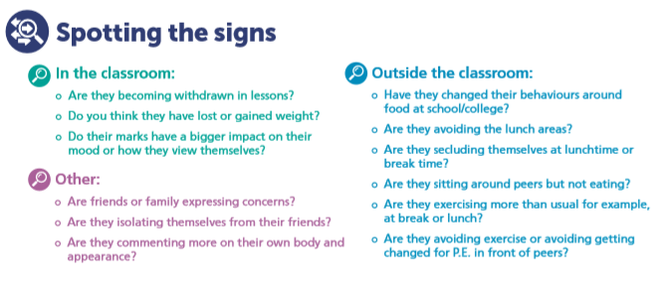
Twitter | If you suspect a child or young person has an eating disorder, speak to your local #CYP Community Eating Disorder Service for advice. Find your local service here https://bit.ly/3dp7CJN  *Suggested hashtags to add*  #EDAW2021  #EatingDisorders  #NHSHereForYou  #CYPMH  #MentalHealth  Please add our Twitter handle @HealthyLDN  *Tag your organisation if on Twitter * | 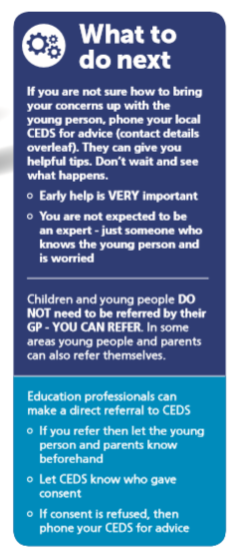
Facebook/ LinkedIn/ Instagram | Eating disorders can affect anyone including children and young people of all weights and genders. It is vital to keep an open mind when thinking about who may be affected by an eating disorder. If you suspect a child or young person has an eating disorder, speak to your local CYP Community Eating Disorder Service for advice. Find your local service here.  https://bit.ly/3dp7CJN  *Suggested hashtags to add*  #EDAW2021  #EatingDisorders  #NHSHereForYou  #CYPMH  #MentalHealth  Please add our Twitter handle @HealthyLDN  *Tag your organisation if on Facebook/ LinkedIn * | 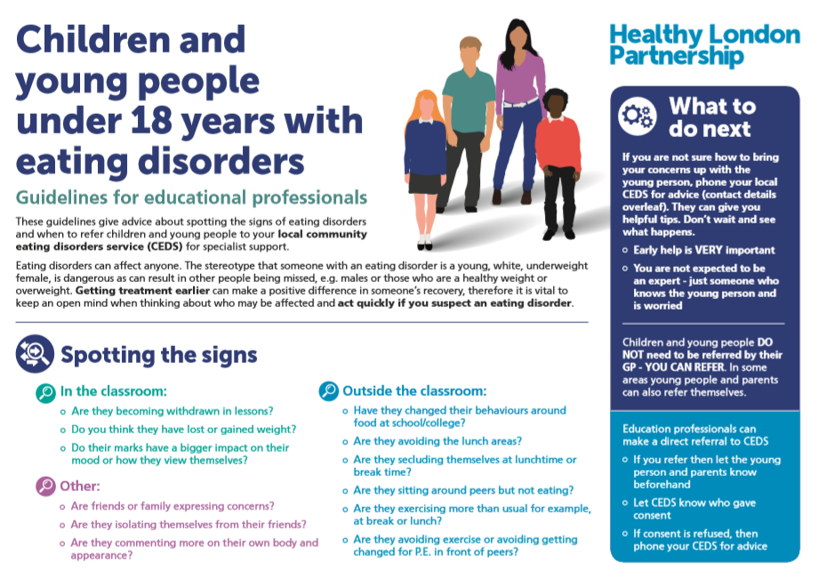
Do you know the first signs of an eating disorder in children and young people?
Twitter | Do you know the first signs of an eating disorder in children and young people? Find out here https://bit.ly/3dp7CJN  *Suggested hashtags to add*  #EDAW2021  #EatingDisorders  #NHSHereForYou  #CYPMH  #MentalHealth  Please add our Twitter handle @HealthyLDN  *Tag your organisation if on Twitter *
Twitter | Know the signs of #EatingDisorders - getting treatment earlier can make a positive difference in someone’s recovery. The early signs of eating disorders can be found here https://bit.ly/3dp7CJN  *Suggested hashtags to add*  #EDAW2021  #EatingDisorders  #NHSHereForYou  #CYPMH  #MentalHealth  Please add our Twitter handle @HealthyLDN  *Tag your organisation if on Twitter *
Facebook/ LinkedIn/ Instagram | Do you know the first signs of an eating disorder in children and young people?  Know the signs - getting treatment earlier can make a positive difference in someone’s recovery, therefore it is vital to keep an open mind when thinking about who may be affected and act quickly if you suspect an eating disorder. Find out more here https://bit.ly/3dp7CJN  *Suggested hashtags to add*  #EDAW2021  #EatingDisorders  #NHSHereForYou  #CYPMH  #MentalHealth  Please add our Twitter handle @HealthyLDN  *Tag your organisation if on Facebook/ LinkedIn *
What to do if you suspect a child or young person may have an eating disorder?

Twitter | If you’re an education professional, parent or carer and suspect a child or young person has an eating disorder, contact your local Community Eating Disorder Service. Details here:  https://bit.ly/3dp7CJN  *Suggested hashtags to add*  #EDAW2021  #EatingDisorders  #NHSHereForYou  #CYPMH  #MentalHealth  Please add our Twitter handle @HealthyLDN  *Tag your organisation if on Twitter *
Facebook/ LinkedIn/ Instagram | Early help is important - if you’re an education professional, parent or carer and suspect a child or young person has an eating disorder, you can make a direct referral to the local Community Eating Disorder Service. Before you refer, discuss your wish to refer with the young person and their parents/carers.  https://bit.ly/3dp7CJN  *Suggested hashtags to add*  #EDAW2021  #EatingDisorders  #NHSHereForYou  #CYPMH  #MentalHealth  Please add our Twitter handle @HealthyLDN  *Tag your organisation if on Facebook/ LinkedIn *

Social media channel | Social posts and attached images
Eating disorders | Primary care practitioners
Eating disorders can affect children and young people of all weights and genders
Twitter | Children and young people DO NOT need to be exceptionally underweight for a referral to a CYP Community #EatingDisorder Service. For more information https://bit.ly/3ucrnKo  *Suggested hashtags to add*  #EDAW2021  #EatingDisorders  #NHSHereForYou  #CYPMH  #MentalHealth  Please add our Twitter handle @HealthyLDN  *Tag your organisation if on Twitter * | 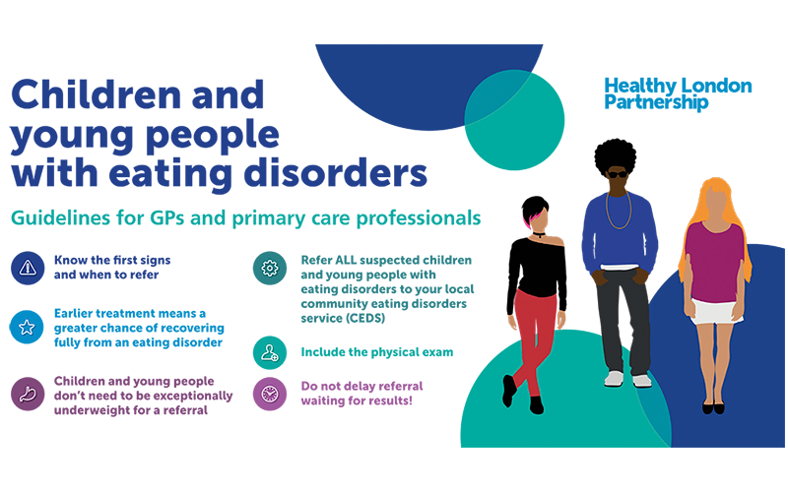  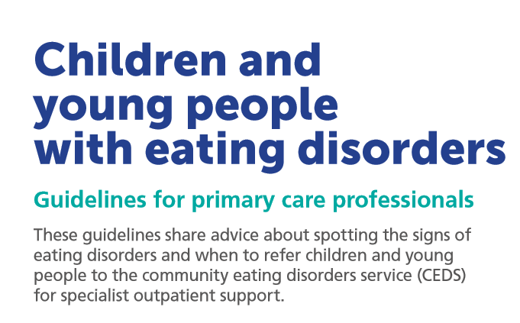
Twitter | Have you seen the @HealthyLDN children and young people with eating disorder guidelines for primary care professionals? They can be found here: https://bit.ly/3ucrnKo  *Suggested hashtags to add*  #EDAW2021  #EatingDisorders  #NHSHereForYou  #CYPMH  #MentalHealth  Please add our Twitter handle @HealthyLDN  *Tag your organisation if on Twitter * | 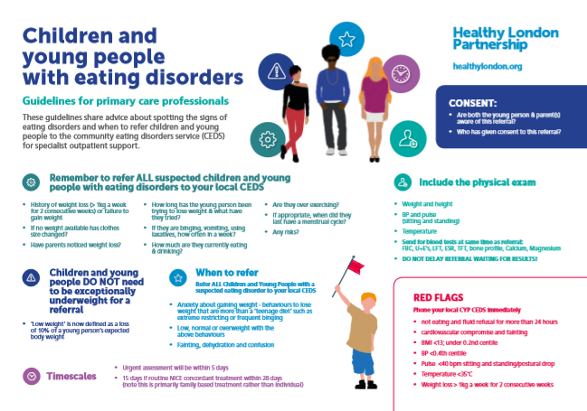
Facebook/ LinkedIn | Children and young people DO NOT need to be exceptionally underweight for a referral to a CYP Community Eating Disorder Service. For more information read our CYP ED Guidelines for GPs here https://bit.ly/3ucrnKo  *Suggested hashtags to add*  #EDAW2021  #EatingDisorders  #NHSHereForYou  #CYPMH  #MentalHealth  Please add our Twitter handle @HealthyLDN  *Tag your organisation if on Facebook/ LinkedIn * | 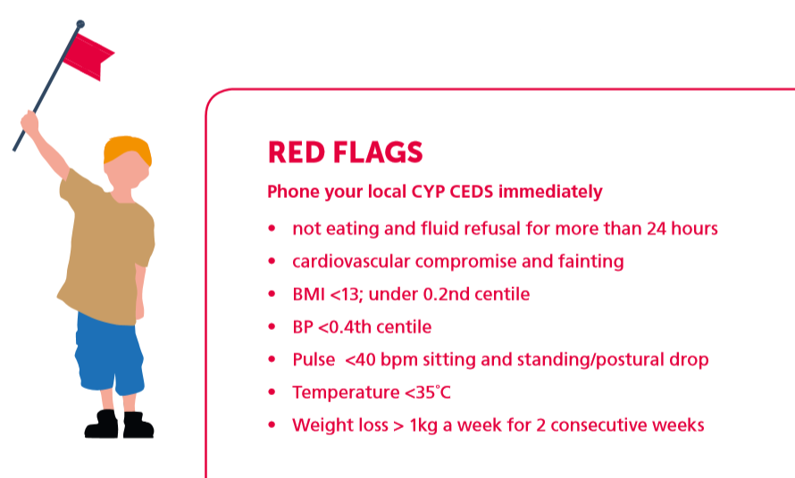

Do you know the first signs of an eating disorder in children and young people?
Twitter | Do you know the first signs of an eating disorder in children and young people? If you suspect an eating disorder refer to your local Community Eating Disorder Service. https://bit.ly/3ucrnKo  *Suggested hashtags to add*  #EDAW2021  #EatingDisorders  #NHSHereForYou  #CYPMH  #MentalHealth  Please add our Twitter handle @HealthyLDN  *Tag your organisation if on Twitter *
Facebook/ LinkedIn | Do you know the first signs of an eating disorder in children and young people?  Remember the early signs of eating disorders in children and young people. Refer ALL suspected children and young people with eating disorders to your local Community Eating Disorder Service:  https://bit.ly/3ucrnKo  *Suggested hashtags to add*  #EDAW2021  #EatingDisorders  #NHSHereForYou  #CYPMH  #MentalHealth  Please add our Twitter handle @HealthyLDN  *Tag your organisation if on Facebook/ LinkedIn*
What to do if you suspect a child or young person may have an eating disorder?

Twitter | Early help for eating disorders is important – if you’re a GP remember to refer ALL suspected children and young people with eating disorders to your local Community Eating Disorder Service  Or  Early help for eating disorders is important – if you’re a GP do not delay referral waiting for physical exam results if you suspect a child or young person has an eating disorder.  https://bit.ly/3ucrnKo  *Suggested hashtags to add*  #EDAW2021  #EatingDisorders  #NHSHereForYou  #CYPMH  #MentalHealth  Please add our Twitter handle @HealthyLDN  *Tag your organisation if on Twitter *
Facebook/ LinkedIn | Early help for eating disorders is important – if you’re a GP remember to refer ALL suspected children and young people with eating disorders to your local Community Eating Disorder Service. More info here: https://bit.ly/3ucrnKo  *Suggested hashtags to add*  #EDAW2021  #EatingDisorders  #NHSHereForYou  #CYPMH  #MentalHealth  Please add our Twitter handle @HealthyLDN  *Tag your organisation if on Facebook/ LinkedIn*

General posts:
Social media | Post | Image
Twitter | Do you know who is your local Community Eating Disorder service for children and young people? https://bit.ly/2NUdyje  *Suggested hashtags to add*  #EatingDisorders  #NHSHereForYou  #CYPMH  #MentalHealth  Please add our Twitter handle @HealthyLDN  *Tag your organisation if on Facebook/ LinkedIn | 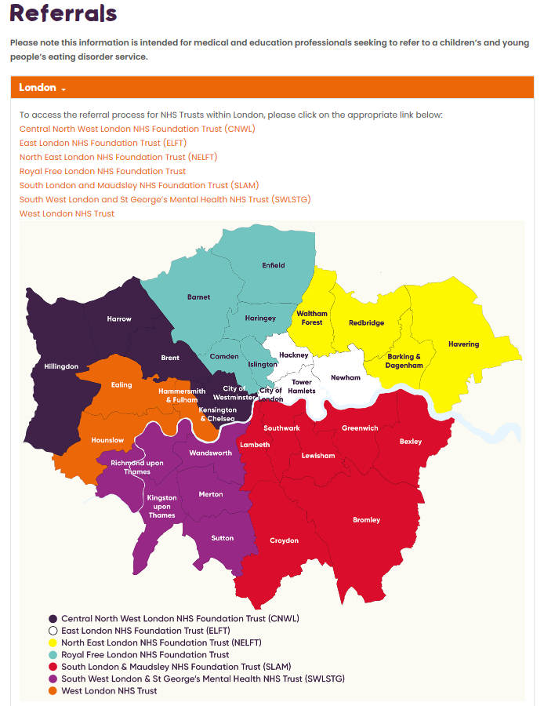
Facebook/ LinkedIn | Do you know who is your local Community Eating Disorder service for children and young people?  To access the referral process for NHS Trusts within London, click here: https://bit.ly/2NUdyje  *Suggested hashtags to add*  #EatingDisorders  #NHSHereForYou  #CYPMH  #MentalHealth  Please add our Twitter handle @HealthyLDN  *Tag your organisation if on Facebook/ LinkedIn
Twitter | For Eating Disorders Awareness Week 2021 @beatED are focussing on an often-misunderstood illness that 1 in 50 of us will experience in our lifetime, binge eating disorder.  #EDAW  *Suggested hashtags to add*  #EatingDisorders  #NHSHereForYou  #CYPMH  #MentalHealth  Please add our Twitter handle @HealthyLDN  *Tag your organisation if on Twitter | 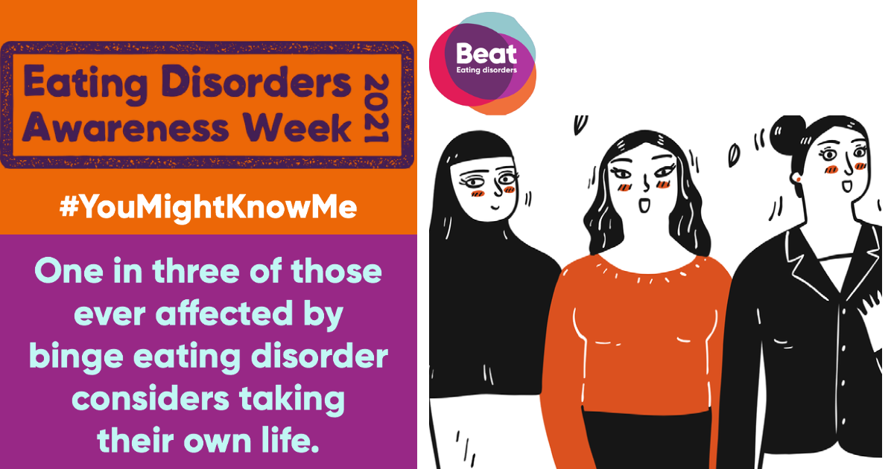
Twitter | Here is a video from @beatED  #EDAW #BingeEating  https://bit.ly/3qRA8aS  *Suggested hashtags to add*  #EatingDisorders  #NHSHereForYou  #CYPMH  #MentalHealth  Please add our Twitter handle @HealthyLDN  *Tag your organisation if on Twitter
Facebook/ LinkedIn | Here is a video from @beatED  #EDAW #BingeEating  https://bit.ly/3qRA8aS  *Suggested hashtags to add*  #EatingDisorders  #NHSHereForYou  #CYPMH  #MentalHealth  Please add our Twitter handle @HealthyLDN  *Tag your organisation if on Facebook/ LinkedIn
Twitter | Eating Disorders Awareness week 2021! Fact: Binge eating disorder will affect 1 in 50 people in their lifetime.  @beatED  #EDAW #BingeEating  https://bit.ly/3qRA8aS  *Suggested hashtags to add*  #EatingDisorders  #NHSHereForYou  #CYPMH  #MentalHealth  Please add our Twitter handle @HealthyLDN  *Tag your organisation if on Twitter | 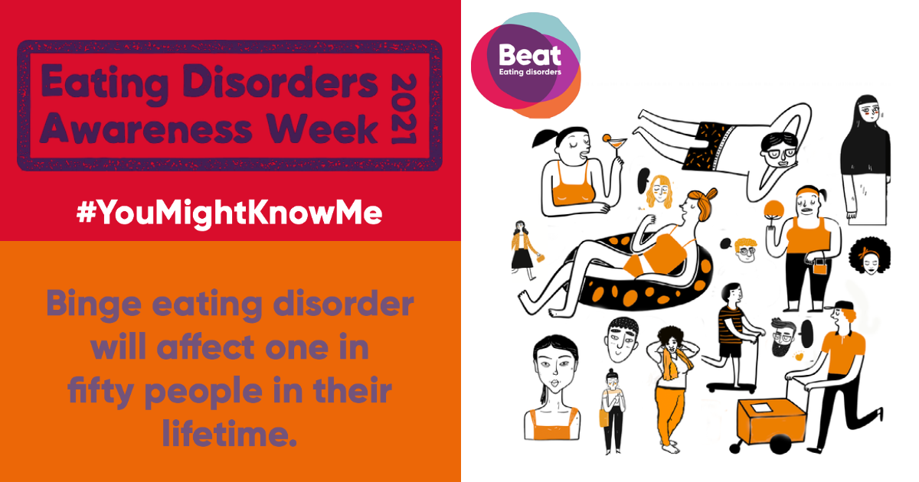
Facebook/ LinkedIn | Eating Disorders Awareness week 2021! Fact: Binge eating disorder will affect 1 in 50 people in their lifetime.  @beatED  #EDAW #BingeEating  https://bit.ly/3qRA8aS  *Suggested hashtags to add*  #EatingDisorders  #NHSHereForYou  #CYPMH  #MentalHealth  Please add our Twitter handle @HealthyLDN  *Tag your organisation if on Facebook/LinkedIn

