Young People’s Digital Platform
Campaign Toolkit

Using this document
This document contains information to support communication teams working in organisations with a focus on young people’s mental health and wellbeing.

This campaign toolkit includes:

- Narrative
- Template news story
- Press Release
- Short narrative
- Suggested newsletter copy
- Suggested staff newsletter copy
- Local Authority resident magazine copy
- Suggested social media copy
- Useful links to resources and apps
- Google Drive – download all images and videos

For further communication enquiries please contact the Good Thinking team at
info@good-thinking.co.uk or Sonia Ettetuani, Communications Lead s.ettetuani@nhs.net

Good Thinking platform extended to support the mental health of young people.

Building on three successful years of supporting those living or working in London, Good Thinking is now available to young people aged 13-18, as part of London’s health and care vision on the theme of improving the emotional wellbeing of children and young Londoners.

The new expanded digital platform has been commissioned by The Mayor’s Office and supported by Partnership for Young Londoners, and will provide young people with access to free, anonymous mental health and wellbeing support.

Good Thinking is part of London’s NHS, providing free, 24/7, digital support to Londoners seeking mental health advice and help. We offer round the clock support and self-care options that are easy to access, and simple to navigate. Through our website, you can download or follow advice and tips to care for your own mental health and wellbeing at a time and place that suits you. We provide a range of tools and apps to help manage sleeplessness, anxiety, stress, low mood, and other feelings. Good Thinking also provides help and guidance if you are concerned about somebody else’s mental wellbeing.

We are part of the NHS and work with health and care partnerships including local councils across the capital, we are supported by the Mayor of London, London Councils, Directors of Public Health and Public Health England. We are working towards Thrive LDN’s vision of helping all Londoners to live happier, healthier lives.

The digital platform has been continuously updated to support people during the COVID-19 outbreak and has a COVID-19 hub that includes tips and support on how to deal with change, uncertainty and how to look after your mental wellbeing and those you care for. It also includes practical tips on dealing with stress and anxiety, boosting your mood, sleeping better and what you can do to help others – including advice for parents and for children and young people.

More Londoners will likely need additional mental health and wellbeing support as a result of the adverse economic and social circumstances exacerbated by the pandemic.

If you would like to access the Good Thinking apps and resources, visit www.good-thinking.co.uk

Please find below some examples of copy which can be used to communicate the campaign across your networks. We need your help to spread the word!

If you have any questions, please feel free to email Sonia Ettetuani, Good Thinking

Communications Lead s.ettetuani@nhs.net

Template news story (Word Count: 369 words) to adapt and use locally.

Good Thinking platform extended to support young people’s mental health.

Good Thinking in partnership with The Mayor’s Office and with support from Partnership for Young Londoners, has launched a new expanded digital platform to provide young people aged 13-18 with access to free resources and apps to improve their mental well-being.

The expansion of Good Thinking continues the Mayor’s drive, to help and support young people on improving the mental health and wellbeing of all young Londoners. As part of this campaign, the Good Thinking team has also launched several apps to ensure that young people are getting the emotional support they need.

Children and young people across the UK have had their lives turned upside down by the pandemic. As a result of COVID-19, many experts have warned of an increase in the mental health and wellbeing of young people. Recent surveys have shown that young people have experienced anxiety, stress, sleep problems, loneliness, eating disorders, self-harm, and other mental health concerns. Many are under increasing pressure and struggling to get the right support.

Almost every young person has had to adjust to changes in their education, employment, routine, and home life. Some have experienced bereavement or other traumatic experiences during the lockdown period, whilst the pandemic has also created unprecedented challenges in effectively safeguarding children and promoting their welfare.

Coronavirus has created a new and uncertain time for us all. Many young people - particularly those who had problems before the outbreak - are worried about the effect on their mental health. The most important thing to remember is that if you find yourself worried or anxious, you are not alone, help and support is available.

Good Thinking is free for Londoners to access and provides support to those who feel anxious, sleep deprived, stressed or in low mood. The platform is continually being update with specific resources to support the mental health and wellbeing of Londoners.

You will find expert advice and links to NHS-approved wellbeing apps, as well as podcasts and blogs that highlight the impact of COVID-19 and contain tips to help you get through this difficult time.
For more information on Good Thinking for young people, visit www.good-thinking.uk/youngpeople

Short narrative (Word Count: 184 words)

Good Thinking platform extended to support young people’s mental health.

Good Thinking in partnership with The Mayor’s Office and with support from Partnership for Young Londoner’s, has launched a new expanded digital platform to provide young people aged 13-18 with access to free resources and apps to improve their mental well-being.

At the moment, you might be finding the COVID-19 pandemic particularly challenging – in fact, research shows that at least a third of children and young people have reported an increase in stress, loneliness, worry and other issues due to coronavirus. Almost every young person has had to adjust to changes in their education, employment, routine, and home life.

If you feel extremely distressed and worried that you might not be able to keep yourself safe, please reach out for help.

The Good Thinking service is here to help you to manage your mental health. You will find expert advice and links to NHS-approved wellbeing apps, as well as podcasts, blogs and details of NHS 24/7 helplines and other support organisations can help you get through this difficult time.

For more information visit www.good-thinking.uk/youngpeople

Suggested newsletter copy (Word Count: 161 words)

Supporting young people’s mental health and wellbeing

Good Thinking new enhanced platform for young people is live, online and those who are having problems with sleep, stress, anxiety, or depression to 24/7, seven days a week wellbeing support.

London’s unique digital wellbeing service is supported by London’s NHS, London boroughs, Public Health England, and the Mayor of London.

So far over 100,000 Londoners have used Good Thinking to find innovative and personalised ways to improve their wellbeing.

So far almost half a million Londoners have used Good Thinking to tackle sleep, anxiety, stress, and low mood. The digital platform hosts over 120 online resources including wellbeing information sources; guides to improving mental health; courses on and offline; mobile apps and other therapy approaches suitable for London’s modern, highly mobile population. New resources are also regularly being added in relation to the Coronavirus and Mental Health.(https://www.good-thinking.uk/coronavirus/)

All resources on Good Thinking are reviewed by an NHS Specialist Clinical Psychiatrist for their suitability.

Suggested staff newsletter copy (Word Count: 136 words)

Support your young family with their mental health and wellbeing.

Good Thinking, London’s digital mental wellbeing service, is now available to young people aged 13 -18, thanks to The Mayor’s Office as part of London’s health and care vision on
improving the emotional wellbeing of young Londoners.

Coronavirus has changed lots of things about family life. And as parents and carers we play an integral role in teaching our children to understand and manage their feelings as they grow up. Its normal for them to feel sad, worried, or stressed at times. However, if they are struggling to cope with those feelings, they might need support.

We know that things have not been easy for young people recently, there’s support available if you feel you or they need it. For more information, visit www.good-thinking.uk/youngpeople

Local Authority resident magazine copy (Word Count: 380 words)

Five ways to good mental wellbeing

Anxious about COVID-19? Worried about your family? Stressed about your job? London’s digital mental wellbeing service, Good Thinking (https://www.good-thinking.uk/) promotes self-care for the four most common mental health conditions – anxiety, sleep problems, low mood, stress – and other concerns you might have.

This includes:

- 24/7 access to a range of NHS-approved wellbeing apps, many of which are free if you live, study or work in London. Popular apps include Be Mindful, Meditainment and tomo.
- Advice for young people on the issues that matter to them, from bullying to fake news.
- More than 100 articles, podcasts, and blogs to help boost your mental wellbeing during the COVID-19 pandemic.
- A self-assessment tool so you can give your mental health a check-up.

Here, the Good Thinking team provides advice on the five ways to good mental wellbeing.

- Connect with other people
Good relationships help you to build a sense of belonging and self-worth, share positive experiences and get emotional support. Even if you can’t meet up with friends and family at the moment, make sure you call, text, email or video chat with them regularly.

- Be physically active
Being active raises your self-esteem, reduces anxiety and helps you to set goals. Try to exercise regularly – whether it’s stretching while the kettle boils, walking around your local park or doing a YouTube workout.

- Learn something new
Gaining new skills boosts your self-confidence and helps you to gain a sense of purpose. While you’re at home, could you sign up for an online course, take up a new hobby or simply try a new recipe for dinner?

- Give to others
Acts of giving and kindness create a sense of reward, give you a feeling of purpose and help you to connect with other people. Checking on a neighbour, calling a friend or volunteering for a local charity is good for both you and those you help.

- Pay attention to the present moment
Being in the moment and being aware of your thoughts, your feelings, your body and the world around you can improve your mental wellbeing. There are lots of mindfulness and meditation apps available to help you understand yourself better and enjoy life more.

Visit www.good-thinking.uk for more advice and free NHS-approved wellbeing apps.

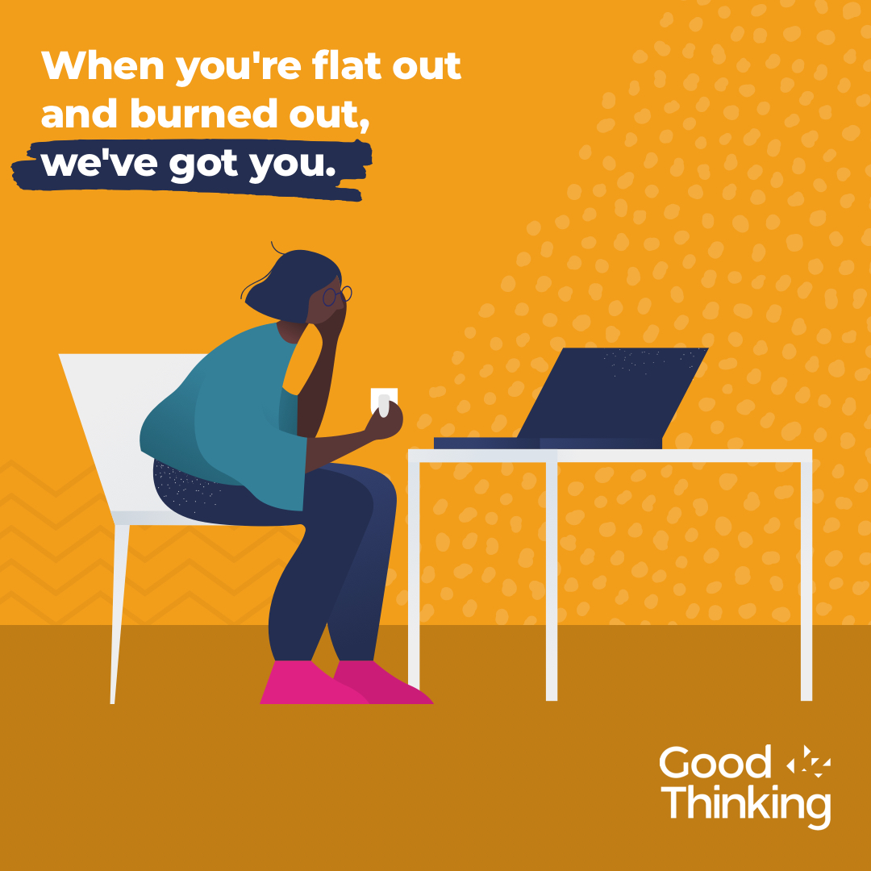

Suggested social media copy.

Please support this campaign through your own social media channels by creating your own posts or liking and sharing the social content posted from:

Facebook goodthinkinguk
LinkedIn goodthinkinguk
Instagram www.instagram.com/goodthinkinguk
Twitter @GoodThinkingUK

Images for Twitter and Instagram Stories can be downloaded here.

Please find below some example posts that can be posted on your social channels. Remember to use the campaign hashtag #YoungLondon and tag us in when you can @GoodThinkingUK and we will share and retweet every message

Theme | Copy option 1 | Images
Low Mood | Are you looking for new ways to give your wellbeing a boost?  @GoodThinkingUK guides young people to clinically trusted digital media, apps & peer support, so you can feel confident and balance today's challenges.  www.good-thinking.uk/youngpeople  #YoungLondon | 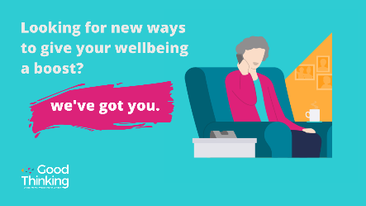
Mental Health | #YoungLondon If your mental or emotional state quickly gets worse, or you're worried about someone you know - help is available @GoodThinkingUK  Remember you're not alone; talk to someone you trust.  www.good-thinking.uk/youngpeople | 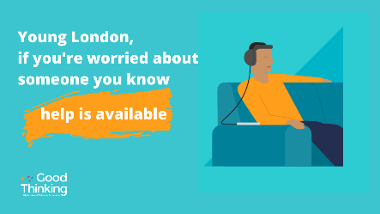
Support | #YoungLondon We know that good mental health can have great impact on you at any age.  Get the support you need to improve your mental wellbeing @GoodThinkingUK  www.good-thinking.uk/youngpeople | 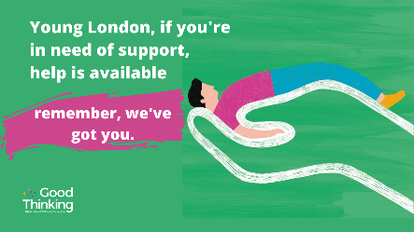
Parents/Carers | Balancing the challenges of being a parent/carer right now can be extremely difficult.  @GoodThinkingUK are committed to helping mental health within families and offer resources on how to support #YoungLondon  www.good-thinking.uk/youngpeople | 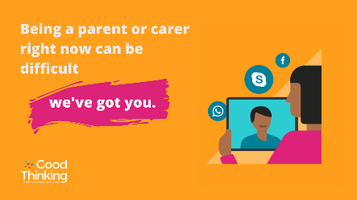
Boost Wellbeing | #YoungLondon Do you wonder when life will get back to normal?  If you’re feeling anxious or worried and need to find ways to boost your wellbeing? Find advice @GoodThinkingUK  www.good-thinking.uk/youngpeople | 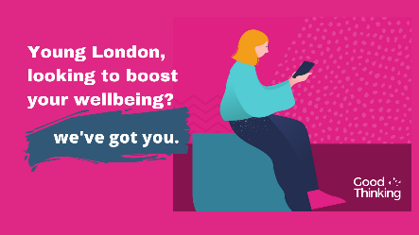
Advice | Being stressed, anxious, unable to sleep or feeling down can take its toll for #YoungLondon.  With @GoodThinkingUK there’s now a great way to get advice and make steps to improve your wellbeing – as soon as you are ready.  www.good-thinking.uk/youngpeople | 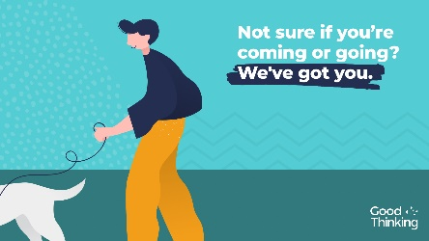
Resources | #YoungLondon Are you experiencing a range of emotions because of the pandemic.  @GoodThinkingUK they have launched resources and new apps to help support you through this uncertain time.  www.good-thinking.uk/youngpeople | 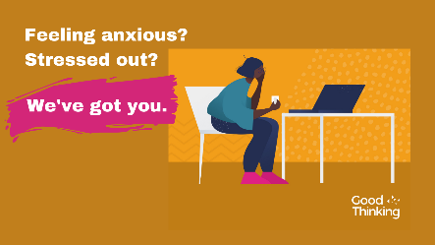
Apart of Me App (grief) | When someone you love dies, it feels like everything has turned upside down.  But you’re not alone. You will get through this💔  Don’t just take our word for it. Download @ApartOfMeApp @GoodThinkingUK  www.good-thinking.uk/apart-of-me | 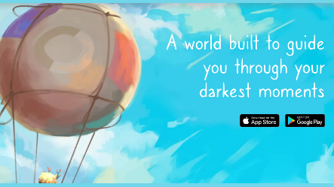
Apart of Me App (grief)\ | @ApartOfMeApp is a safe virtual space that helps families and #YoungLondon find their way through grief.  Now for free @GoodThinkingUK  Download www.good-thinking.uk/apart-of-me  https://youtu.be/NQshP1tdANA
Combined Minds App (feel positive) | @combmindsapp if a free app available through @GoodThinkingUK to help families and friends provide mental health support to teenagers.  Download the app today, take control and feel positive, free for #YoungLondon  www.good-thinking.uk/combined-minds | 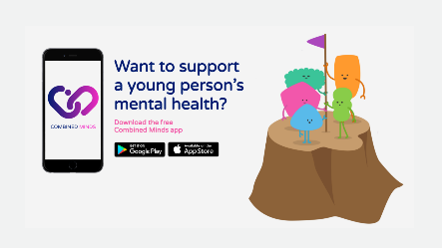
Clear Fear App  (reducing anxiety) | #YoungLondon the fear anxiety, is like a strong gust of wind. It drags you in and makes you want to fight it or run away.  @GoodThinkingUK they have teamed up with @clearfearapp an app that helps you relax, breathe and be mindful.  Download www.good-thinking.uk/clear-fear
Feeling Good App  (improving self-esteem) | #YoungLondon Stop Everything and Breathe...  Learn breathing techniques and other strategies that can help you to let go of worry and develop your self-esteem, with the #NHS approved @feelingood app through @GoodThinkingUK  Download www.good-thinking.uk/feeling-good | 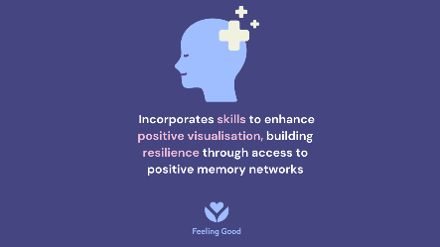
Feeling Good Teen App | #YoungLondon Feeling Good Teen is for 10-15 yr old’s to develop self-esteem, resilience and goal focused motivation through relaxing audios.  Develop an inner safe place with @feelinggoodapp available through @GoodThinkingUK  Download www.good-thinking.uk/feeling-good-teens | 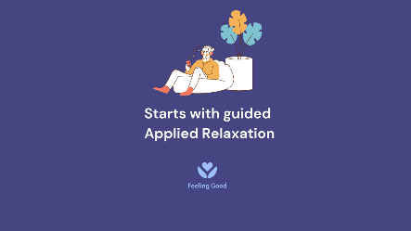
Move Mood App | #YoungLondon download @appmovemood to help increase your motivation, move forward, take control & feel positive.  Download www.good-thinking.uk/move-mood  Link to video - https://vimeo.com/485416118 | 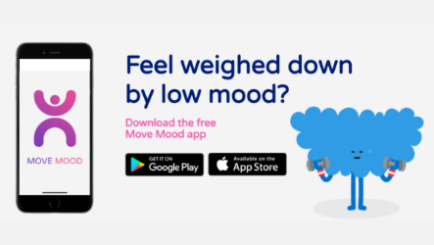
International Student App | #YoungLondon are you an international or EU student coming to the UK to study?  @GoodThinkingUK you can now access the information and support when you need it.  Download www.good-thinking.uk/international-student | 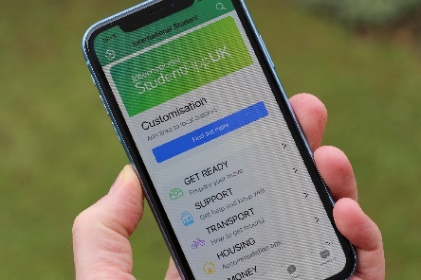
Student Health App | #YoungLondon there has never been a more crucial time for university and college students to have access to reliable, safe health information. The Student Health App provides all of this.  Download www.good-thinking.uk/student-health  @GoodThinkingUK | 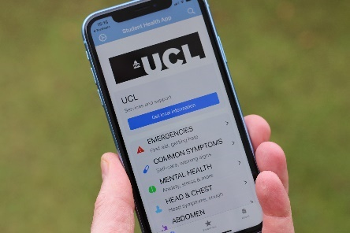

Useful Links to Resources

The extended platform has recently been updated with specific resources to support the mental health and wellbeing of young Londoners which includes:
- Urgent support
  - How to get urgent support
- Free apps

  - Feeling Good This app is based on a Swedish Olympic sports performance programme and is recommended for use by the NHS. The app offers positive mental training that will boost your resilience and mood.
  - Feeling Good Teen Offers positive mental training for 10 to 15 years old, which helps to develop self-esteem, resilience, and goal focused motivation.
  - Combined minds Developed by a teenage mental health charity, the Combined Minds app helps families and friends to support young people with their mental wellbeing.
  - Clear Fear Recommended for 11- to 19-year-olds, the Clear Fear app is a free app developed to reduce anxiety using effective Cognitive Behavioural Therapy (CBT) techniques.
  - International Student If you’re aged 17+, the International Student App can help you to find out how to prepare for study in the UK and where to get support when you need it the most.
  - Move Mood Developed to boost your mood using effective behavioural activation therapy techniques.
  - Apart of me when someone you love dies, it can feel like everything has turned upside down. But you’re not alone. Apart of me is a beautiful world, built to guide you through your darkest moments where you can feel safe and rediscover a sense of calm.
  - Student Health When you’re at university, its not always obvious what you should do if you have any concerns about your health. The Student Health app contains over 900 pages of reliable health information, including mental health advice.

- Mental wellbeing tips
  - Six things to remember if you’re being bullied
  - How to stay mentally healthy at university
  - How to cope with the death of a loved one
  - What’s real and whats not? How to spot disinformation, misinformation
  - Q&A: Eating disorders
- COVID-19 guides
  - General mental wellbeing advice for young people
  - Q&A: Counselling and other support
  - How to face uncertain times and focus on the positives
  - Feeling angry or frustrated? Tips on managing your emotions and behaviour
  - Advice for children in care and young care leaver
  - Q&A: Sex and relationships during the COVID-19 pandemic
  - Young carers: How to look after yourself
  - Six tips to help you deal with bullying
  - How to manage eating disorders
  - Advice for the children of essential workers and volunteers
  - Tips for children and young people with ADHD
  - Stressed about exam results? (August 2020)
  - Back to school advice
  - Screen time during COVID-19: Getting the balance right
  - Don’t feel safe at home? Where to find support for domestic abuse
- Podcasts
  - Want to stop bullying behaviour? It starts with the dictionary with Alex Holmes and Will Poulter
  - Mental health from a male perspective with Antonio Ferreir
  - Online safety for young people during lockdown with Catherine McAllister, Head of Editorial Standards at BBC Children’s Department
  - Supporting students through coronavirus with Mhairi Underwood, Head of Community at The Student Room
  - Sex and relationships during and after the pandemic with Amber Newman-Clark, Education & Wellbeing Specialist, Brook
  - Supporting those with eating disorders with Andrew Radford, CEO, and Caroline Price, Director of Services, Beat
  - Why a micropause can help your mental health today with Janet Wingrove, Mindfulness Trainer and Consultant Psychologist, SLaM
  - Benefits of healthy sleep patterns with Michael Farquhar - Consultant in Paediatric Sleep Medicine, Guy's & St Thomas' NHS Trust
- Blogs
  - How volunteering boosted my mental wellbeing by Carl (age 14)
  - It’s okay to not be okay! by Paige Keen (aged 15)
  - "Imagine a world in which even cartoons for children tell boys they can’t feel upset; they must be superheroes. That was my world" by Antonio Ferreira
  - Supporting the self-care and mental health of students and young people by Dr Richard Graham, Consultant Psychiatrist and Clinical Lead for Good Thinking
  - Self-isolation: Grace’s story (age 15)
  - Self-isolation: Callum's story (age 12)
  - Self-isolation: Harry's story (age 21)
  - GCSEs 2020: A student's perspective
  - Adjusting to a new way of living: Alis Rowe, autistic creator and entrepreneur
  - Reflecting on ways to live better: Taiwo's story
  - There is so much noise around: JC Candanedo
  - Facing COVID-19 with Asperger’s: Chris’ story

