Homeless Hotels Drug and Alcohol Support Service (HDAS-
London)

Heroin Workbook

Heroin recovery workbook for completion on your own or with support.
Speak to hotel staff if you feel you need support with this workbook.

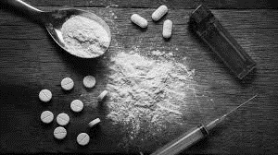

This workbook belongs to:

These workbooks have been provided by partner agencies as part of the HDAS service,

INTRODUCTION

This is a self study workbook for you to work through. Please take time to work through this pack and be as honest as possible, if you wish to discuss anything you are unsure of, please speak with the hotel staff, who can then contact HDAS or the local drug and alcohol service.

CONTENTS

Worksheet 1 | Warm up quiz
Knowledge 1 | What is heroin and what are the effects?
Knowledge 2 | Heroin’s effect on the body
Worksheet 2 | How does heroin affect me?
Worksheet 3 | How does heroin use affect my family life?
Worksheet 4 | Methods of use and the dangers
Knowledge 3 | The risks when injecting
Knowledge 4  Knowledge 5 | Safer injecting  Overdose
Worksheet 5 | Heroin and me
Worksheet 6 | Changing heroin use
Worksheet 7 | Obstacles to change
Worksheet 8 | In 5 years time...
Worksheet 9 | In 5 years time...

Worksheet 1: Warm up quiz

To lead you into the workbook, please try this short quiz:
- Heroin is:
  - A stimulant drug
  - A depressive drug
  - A hallucinogen drug

- There is only one type of heroin (brown)?
  - True
  - False

- Which of the following can you overdose from?
  - Smoking heroin
  - Snorting heroin
  - Injecting heroin
  - All of the above

- Which of these should you do if someone overdoses (select 2 answers)?
  - Inject salt water
  - Put them in a cold bath
  - Put them in the recovery position
  - Leave them
  - Phone an ambulance
  - Walk them around

Knowledge 1:

What is heroin?

- Heroin is a drug made from morphine, which is extracted from the opium poppy.
- Opium has been around for many hundreds of years and was originally used to treat pain, sleeplessness and diarrhoea.
- When morphine is made into heroin to be used as a medicine, it’s called diamorphine, and is stronger than morphine or opium.
- Heroin in its purest form is a fine, white powder. More often than not, it is found to be rose gray, brown or black. Toxic ingredients are usually mixed with heroin so the true purity of the drug and its strength is unknown.
- Like many drugs made from opium (called opiates), heroin is a very strong painkiller.

What are the effects of heroin?

- Heroin is a depressant which means that it slows down the central nervous system.
- The first dose of heroin can bring about dizziness and vomiting.
- A small dose of heroin gives the user a feeling of warmth and well-being, bigger doses can make you sleepy and very relaxed.
- Tolerance to heroin develops with regular use, so after a short time more heroin is needed to produce the same level of intensity.
- Heroin is highly addictive and people can quickly get hooked.

Knowledge 2: Heroin’s effect on the body

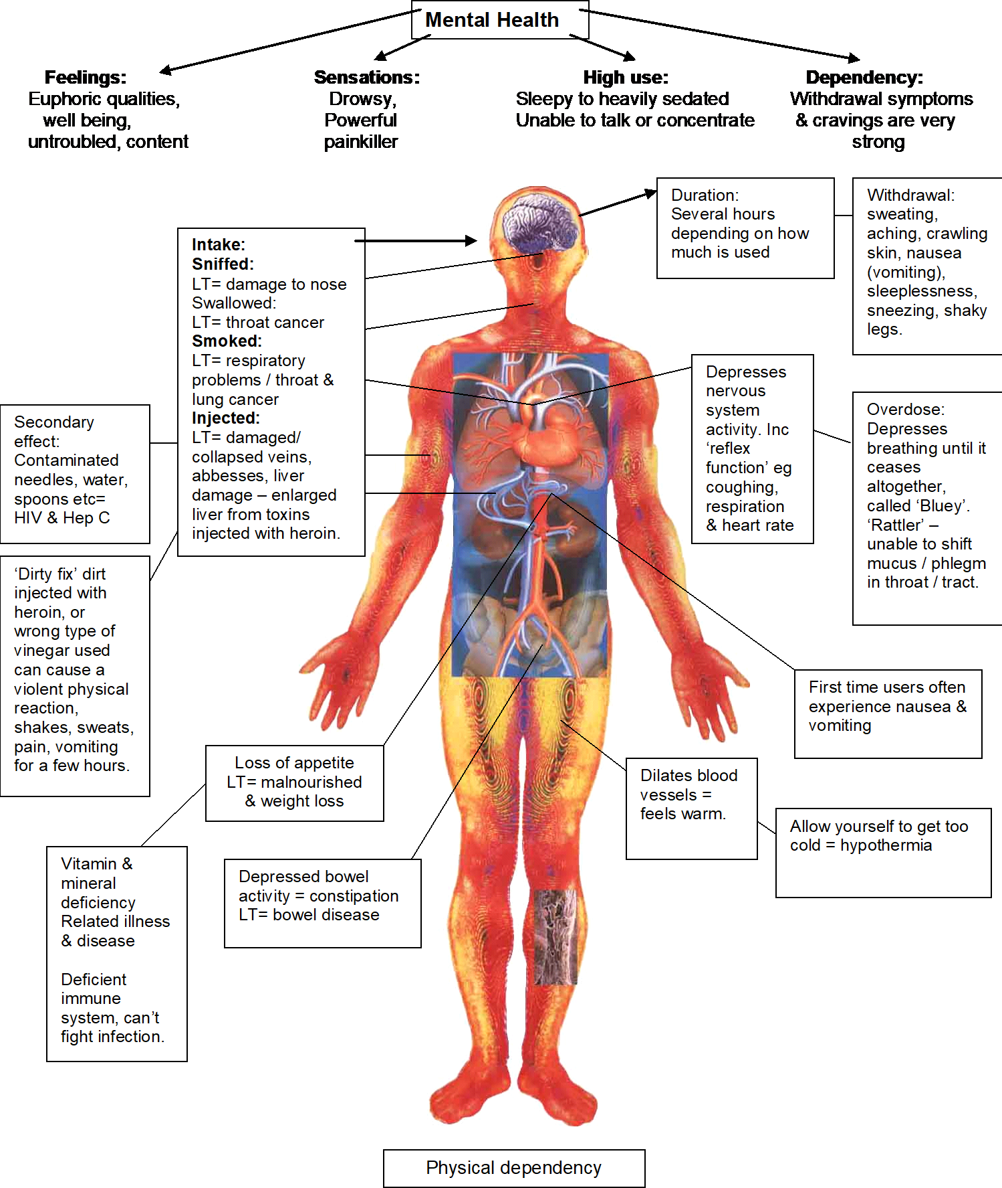
LT = long term

Worksheet 2: How does heroin affect me?

What effect does heroin have on you? Think about the health related effects (physical and psychological) and other consequences (e.g. money problems, offending). Draw lines from the centre point and write down your examples.

e.g. money problems

How does heroin affect me?

Worksheet 3: How does heroin use affect people
around me?

Think about the effect that heroin use has on people around you. Using four different people, write who they are in the box below and how they have been affected.

  - Who: Partner, How: stress, worry, arguments etc.

Who?  How? | Who?  How? | Who?  How? | Who?  How?

Worksheet 4: Methods of use and the dangers

For each of the 5 methods of using heroin, list the possible dangers.

Method of Use | The Dangers
Injecting | E.g. Overdose
Smoking
By mouth
Snorting
Anal insertion
(up the bum method)

Knowledge 3: The risks when injecting

There are many dangers associated with injecting drug use and it is largely considered the most hazardous method of use. The main risks are:

Overdose:

Overdose is defined as administering a dosage in a quantity greater than the body can handle. When injecting drugs, large quantities can be delivered directly into the blood stream in one instance. Therefore, depending on the individual’s tolerance levels and the quality and quantity of the substance used, an overdose can occur. When overdosing on depressants (e.g. heroin), the heart rate reduces, breathing slows, body temperature drops and can result in a loss of consciousness. Ultimately, overdosing is extremely dangerous and can lead to death if an individual does not receive immediate medical attention.

Blood Borne Viruses:

Blood borne viruses such as HIV (Human Immunodeficiency Virus) and Hepatitis B and C can exist within the blood and are passed on through contact with infected blood or bodily fluids contaminated with infected blood (e.g. semen and vaginal fluid). HIV is a virus that affects the immune system and is fatal due to the body no longer being able to fight off diseases and infections. Hepatitis (the main forms being A, B and C) is a disease of the liver and can lead to cirrhosis of the liver and death over time. When needles and other injecting equipment (e.g. spoons and filters) are shared, there is a chance that they may be contaminated with infected blood.
Henceforth, injecting drugs users are at an increased risk of contracting blood borne viruses.

Injury to the body:

There are many ways in which the body can be injured when drugs are injected into the body. These are as follows:

    - Abscesses: Inflammation beneath the skin caused through infections. If untreated, that can become septic and may require amputation of the affected area.
    - Blown veins: The needle goes straight through the vein and spills blood into the body. This can be extremely painful.
    - Thrombosis: A blockage of the vein caused by clotted blood or foreign debris that has been injected. Blockages can result in tissue being starved of oxygen leading to pain and swelling. In addition, an embolism can develop where the blood clot can travel through the body and can result in the brain being starved of oxygen (leading to a stroke).
    - Collapsed veins: A vein can collapse when it becomes damaged through repeated injecting or use of a blunt needle. This can result in swelling, pain and a reduced circulation.

Knowledge 4: Safer injecting

Although there are many risks associated with intravenous drug use, there are steps that can be taken in order to reduce the risk. It not possible to entirely eliminate the risk however the following practices can help to prevent some harm when injecting drugs.

- Be aware of tolerance levels. This is particularly important after a period of stopping or reduced use such as being in prison. Small quantities should therefore be used in order to gauge an appropriate dosage.
- In order to reduce the risk of contracting Blood Borne Viruses, never share injecting
equipment (needles, spoons, filters etc.). Get clean equipment from a needle exchange
- Do not reuse needles, they become blunt overtime and damage veins. Get new needles from a needle exchange.
- Injecting sites should be rotated on a regular basis in order to ensure that veins are not damaged through continued use.
- Avoid injecting in certain places. Injecting in the groin and legs can result in Deep Vein Thrombosis and injecting in the neck upwards can be deadly.
- Always clean the site of injection prior to use and the surface where equipment will be placed. This helps to decrease the likelihood of bacteria entering the body which may lead to infection.
- Use Ascorbic Acid (Vitamin C) to dissolve heroin for injecting. Other acids such as lemon juice contain bacteria and can lead to infections.
- Never mix heroin with other drugs or alcohol. Mixing drugs can increase the likelihood of an overdose.
- Never use alone to ensure that someone can help in case of an overdose.
- If someone overdoses, place them in the recovery position and phone 999 for an ambulance.

Knowledge 5: Overdose
WHAT IS AN OVERDOSE?
- Taking too much of any substance that your body cannot tolerate it.
- May cause death by heart, liver or respiratory failure.
- An overdose can happen regardless of how you take the substance.

RECOGNISING AN OVERDOSE
DEPRESSANTS (includes heroin, methadone, benzodiazepines)
- Slowed pulse, slow and shallow breathing.
- Choking or gurgling sounds.
- Drowsy or no response.
- Unconscious / coma.
STIMULANTS (includes
crack, cocaine, speed)
- Hot / clammy / flushed.
- High temperature.
- Fast pulse / breathing.
- Pressure, tightness or pain in the chest.
- Panic / fitting / unconscious / coma.

HOW TO AVOID AN OVERDOSE
- Understanding TOLERANCE levels - using less of a substance than you normally use reduces tolerance. Returning to the same amount as before can cause an overdose.
- Go easy after a break - if you decide to use again ensure to use a small amount.
- Don’t mix your drugs - alcohol and other drugs used together can lead to a higher risk of overdosing.
- Avoid using alone.

Turn over the page to see what to do if someone overdoses:

WHAT TO DO IF YOU SEE SOMEONE OVERDOSE
- Call 999
- Put them in the recovery position (Below)
- DO NOT - inject them with anything unless using NALOXONE (reverses the effects of opioid overdose).
- DO NOT - give them anything to eat or drink.
- DO NOT - place them in a cold bath.
- DO NOT - attempt to walk them around.

RECOVERY POSITION
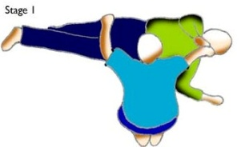
Stage 1:
- Tilt their head back and lift their chin. Make sure their legs are straight
- Bend the arm nearest to you as if they are waving
- Reach over and put the arm that’s furthest away from you across their body, putting the back of their hand against their cheek

Stage 2:
- Pull the leg furthest away from you up into a bent position and keep their foot flat on the floor
- Roll the person onto their side, keep their hand against their cheek and pull their bent knee towards you

Stage 3:
- They will now be in the recovery position.

Worksheet 5: Heroin and me

What are your 5 main triggers to using heroin (e.g. feeling depressed)?

Trigger 1:
Trigger 2:
Trigger 3:
Trigger 4:
Trigger 5:

What do you enjoy about heroin use?

-----------------------------------------------------------------------------------------------------------------------------
-----------------------------------------------------------------------------------------------------------------------------
-----------------------------------------------------------------------------------------------------------------------------
-----------------------------------------------------------------------------------------------------------------------------
-----------------------------------------------------------------------------------------------------------------------------
-----------------------------------------------------------------------------------------------------------------------------
-----------------------------------------------------------------------------------------------------------------------------
-----------------------------------------------------------------------------------------------------------------------------
-----------------------------------------------------------------------------------------------------------------------------
-----------------------------------------------------------------------------------------------------------------------------
-----------------------------------------------------------------------------------------------------------------------------

Worksheet 6: Changing heroin use

Write down what you would like to change about your heroin use and the reasons for this. This could be abstinence or you may want to stop injecting heroin.

What I want to change about my heroin use:

Why I want to make this change:

Worksheet 7: Obstacles to change

List the obstacles you may face when trying to change your heroin use. Also list as many ways as you can to help overcome these obstacles (obstacles can be people, places, situations )
Obstacles | To overcome this obstacle I can…

Worksheet 8: In 5 years time….

If you were to CONTINUE using heroin, where do you see yourself in 5 years time? Your relationships? Work? Health?

Worksheet 9: In 5 years time….

If you were to STOP using heroin, where do you see yourself in 5 years time? You’re relationships? Work? Health?

Worksheet 1: Warm up quiz ANSWERS

To lead you into the workbook, please try this short quiz:
- Heroin is:
- A depressive drug
Heroin slows down your body such as your heart rate and breathing. It is also a very powerful opiate which means that it also acts like a pain killer.
- There is only one type of heroin (brown)?
- False

It is usually sold as a white or brown powder. It is often cut with many different things and as such can vary in colour from brownish white to brown.
- Which of the following can you overdose from?
- All of the above

It’s very easy to overdose from heroin, which kills far more people in the UK than any other illegal drug. There is a risk of overdose however you take it.

- Which of these should you do if someone overdoses (select 2 answers)?
- Put them in the recovery position
- Phone an ambulance

Look at Page 12 and 13 to remind your self of what to do if someone overdoses.

Specialist support services are available to help with problems with drinking or drugs. You can access non-judgemental advice and information about how to keep safe and discuss potential treatment and support options.
Speak to the hotel staff who can help put you in touch with a local service.

