Homeless Hotels Drug and Alcohol Support Service
(HDAS-London)

Alcohol Workbook

This is an alcohol recovery workbook for completion on your own or with support.
Speak to hotel staff if you feel you need support with this workbook.
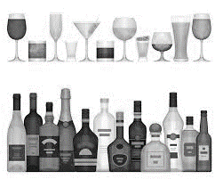

This workbook belongs to:

These workbooks have been provided by partner agencies as part of the HDAS service,

INTRODUCTION

This is an alcohol recovery workbook for you to work through. Please take time to work through this pack and be as honest as possible. If you would like to discuss this pack please speak to your hotel worker who will advise who best to talk through this with.

Contents-

Knowledge 1 Do you know your units? Worksheet 1 Warm up quiz?
Knowledge 2 Think again. Worksheet 2 Do I have a problem?
Worksheet 3 How does alcohol affect me? Knowledge 4 Binge Drinking
Worksheet 4 How does drinking affect my family life? Knowledge 5 Alcohol Poisoning
Worksheet 5 My Goals
Knowledge 6 Alcohol in the bloodstream Worksheet 6 Have you been in trouble? Knowledge 7 The risks of mixing Worksheet 7 What are my triggers?
Worksheet 8 Obstacles to change Worksheet 9 In 5 years time…..
Worksheet 10 In 5 years time….

The NHS recommends:

Men and women should not regularly drink more than 14 units a week, and this should be spaced through the week.

Regularly" means drinking this amount every day or most days of the week.

Knowledge 1: Do you know your units?

A unit is the amount of alcohol by volume (ABV) found in a drink. Many people are surprised by the number of units found in some standard drinks:

- a single measure of spirits (25ml) 1 unit
- a bottle of Alco-pops --1.4 units
- a small glass of wine (125ml) --1.5 units
- a 440ml can of standard lager, beer or bitter --1.8 units
- a 440ml can of strong lager, beer or bitter --2.2 units
- a pint of standard lager, beer or bitter --2.3 units
- a pint of strong lager, beer or bitter --2.8 units
- a large glass of wine (250ml) 3 units
- a one litre bottle of standard cider 4 units
- a standard bottle of wine 9 units
- a one litre bottle of strong cider 9 units
- a 700ml bottle of spirits 27-28 units
- a 1litre bottle of spirits approx 40 units

Bottles and cans are usually marked with the number of units. Draught beer/lager/cider will have the ABV on the pump. The lower the number the less alcohol in the drink.

Alcohol limits explained

The recommended alcohol limits are:

No more than 14 units per week.
It is recommend that the units are spaced out throughout the week. over three days or more.

One unit is roughly equivalent to half a 440ml can of export lager (5%), a small shot of spirits (25ml), or half a standard 175ml glass of wine.

Alcohol limits are often given as daily figures for regular consumption. You should not 'save up' your weekly allowance of units and drink them all at once – binge drinking is dangerous and puts you at risk of alcohol poisoning.

You should also be aware that the extent to which alcohol affects men and women can vary depending on their weight, height and many other factors.

Men and women process and tolerate alcohol differently. Women’s bodies have a higher ratio of fat to water, so they generally cannot process alcohol as easily as men.

Remember, it takes an hour for the body to process a unit of alcohol. This means that if you have a heavy drinking session you may still have alcohol in your blood the next day (or even the day after!) You may feel sober but will still have slowed reaction times and may fail a breathalyser test.

Worksheet 1: Warm up quiz

To lead you into the workbook, please try this short alcohol quiz:
- Alcohol is:
  - A stimulant drug
  - A depressive drug
  - A non-toxic beverage
  - Not a drug
  - None of the above

- Which of the following is true:
  - Everyone’s body processes alcohol units at different speeds
  - Everyone’s body processes alcohol units the same speed

3.Alcohol travels through the body by:
  - The bloodstream
  - The nervous system
  - The urine
  - The digestive juices

- Alcohol is broken down in:

- The kidneys
- The Liver
- The stomach
- The intestines

- Which of the following statements are true or false?
  - Alcohol physically warms you up True/False
  - Alcohol affects your sense of balance True/False
  - Alcohol is good for you True/False

CHECK YOUR ANSWERS AT THE BACK OF THIS WORKBOOK!

Knowledge 2: If you think only alcoholics and binge drinkers are putting their health at risk…Think Again.

'Regularly' means drinking this amount every day or most days of the week.

Many people who see themselves as "social drinkers" are at risk of developing long-term health conditions because of the amount they regularly drink. Most drinkers are unaware that regularly drinking more than the limits advised by the NHS can lead to a wide range of long-term health problems, including cancers, strokes and heart attacks.

More than 55% of people questioned in a YouGov poll thought that alcohol only damages your health if you regularly get drunk or binge drink.

The 2010 survey of 2,000 adults also found that 83% believed that regularly drinking more than the recommended daily limits didn’t put their long-term health at risk.

The survey suggests that 7.5 million people might be unaware of the damage their drinking could be causing.

Over the limit

More than 9 million people in England drink more than the recommended weekly limits. About 15,000 people in England die from alcohol-related causes each year. About 32% of these deaths are from liver disease, 21% from cancer and 17% from cardiovascular illnesses, such as heart disease and strokes.

Typically, longer-term alcohol-related illness, affects older people or people who drink more than the recommended daily limits and consider themselves to be "social drinkers".

Professor Nigel Heaton, a liver transplant consultant at King’s College Hospital, London says people who believe that drinking above the guidelines is just normal social drinking are raising their risk of developing alcohol-related illnesses.

“Some people think it’s natural to have a bottle of wine a night,” he says. “It seems respectable because you’re drinking with food and it’s not associated with any drunken behavior or even feeling drunk.

"But if it happens regularly, you may have problems later on. Most of us believe that people with alcoholic liver disease are alcoholics. We often think, ‘I’m not an alcoholic so I can’t get liver disease.’

“You may not be an alcoholic, but if the overall amount of alcohol you drink regularly exceeds the lower-risk guidelines, it may still cause serious harm.”

Worksheet 2: Do I have a problem with alcohol?
Ask yourself the following questions and answer them as honestly as you can.

1. Is drinking making my home life unhappy? | YES / NO
2. My drinking makes me careless of other peoples welfare | YES / NO
3. I drink because I am shy with other people | YES / NO
4. Drinking is affecting my reputation | YES / NO
5. I drink to escape from worries or trouble | YES / NO
6. I drink alone | YES / NO
7. I have lost time employment due to drinking | YES / NO
8. My ambition has decreased since drinking | YES / NO
9. My efficiency has decreased since drinking | YES / NO
10. Drinking is jeopardizing my employment | YES / NO
11. I feel remorseful after drinking | YES / NO
12. I am in financial difficulties as a result of drinking | YES / NO
13. I drink alcohol anywhere, anytime | YES / NO
14. I crave a drink at a certain time everyday | YES / NO
15. My drinking causes me to have difficulty in sleeping | YES / NO
16. I need a drink the next morning | YES / NO
17. I drink to build up my self-confidence | YES / NO
18. I have experienced loss of memory as a result of drinking | YES / NO
19. People tell me I should stop drinking | YES / NO
20. I have been in a hospital or prison because of drinking | YES / NO

Long term effects of alcohol
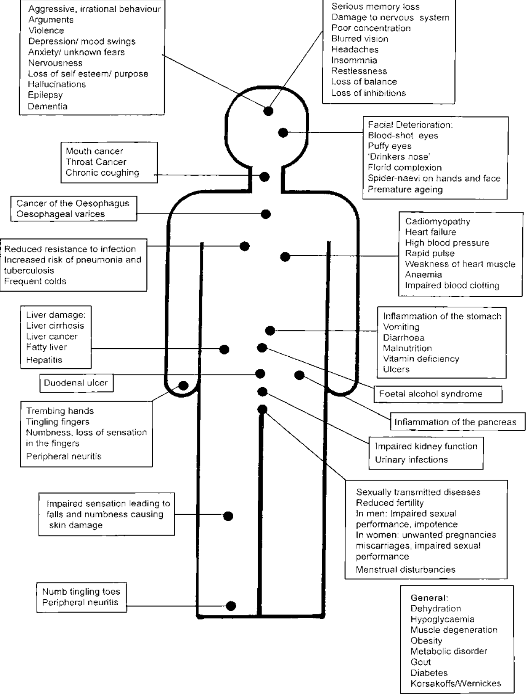

Worksheet 3: How Does Alcohol Affect Me?

Do you think your health is being affected by your drinking (mentally or physically)? Draw lines from different parts of the body and give examples of how.

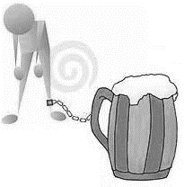
e.g. Paranoia

Stomach pains

Knowledge 4: Binge drinking usually refers to drinking lots of alcohol in a short space of time or drinking to get drunk.

Researchers define binge drinking as consuming eight or more units in a single session for men and six units for women.

However, this quantity does not affect everyone equally because tolerance to alcohol and the speed of drinking in a session vary from person to person. If you do not normally drink at high level your body has not developed a tolerance and therefore a binge may have more effect on you than on someone who does regularly drink more.

This is even more important if you are out in risky or unfamiliar circumstances. You can be at risk from others, and may not be able to look after yourself or your friends. You can easily lose control of what you do or say and may make risky decisions, thinking you’re invulnerable.

Evidence shows that people who have been drinking are more at risk of being the victim (and perpetrator) of attacks, robberies and assaults. An estimated 23,000 alcohol related incidents take place in Britain each week and regular visitors to pubs/bars are twice as likely to be victims of assault.

Every time you drink alcohol, your liver has to filter out the poisonous alcohol from your blood. Alcohol is absorbed quickly into your body (much quicker than food), but the body can only process and remove around one unit of alcohol each hour.

If you drink a lot of alcohol over a short space of time (binge drinking), such as on a night out, your body does not have time to process it all. This means that the amount of alcohol in your bloodstream, known as your blood alcohol concentration (BAC), rises. The higher your BAC, the more of an adverse effect alcohol has on the workings of your body.

Binge drinking increases the risk of heart attack. It could cause you to vomit and if you’re sick when very drunk you could breathe in your own vomit and suffocate.

Worksheet 4: How does drinking affect people around me?
Write under each picture who they are and explain how they have been affected

e.g. Mother / partner – stress, worry, arguments…etc

Who? Who? Who? Who?

How? How?
How?
How?

Knowledge 5: Alcohol Poisoning

Poisoning happens when you take into your body a substance that damages your cells and organs and injures your health. Alcohol poisoning results from drinking a toxic amount of alcohol, usually over a short amount of time (also known as binge drinking).

The signs and symptoms of alcohol poisoning include confusion & vomiting (being sick), slow breathing (less than eight breaths a minute) & cold, clammy, pale-bluish skin – caused by a dangerous drop in body temperature (hypothermia).

In severe cases, alcohol poisoning can cause unconsciousness, coma and death. If you suspect alcohol poisoning, you should dial 999 and ask for an ambulance. Never leave a person to ‘sleep it off’.
Levels of alcohol can continue to rise after drinking has stopped, so a person’s symptoms could suddenly become much more severe. This is because there may still be alcohol in the stomach which has yet to be absorbed into the blood stream.

Once the person is admitted to hospital they will be carefully monitored until the alcohol has left their system.

At very high levels, alcohol affects the nerves that control automatic actions, like breathing, your heartbeat, and your gag reflex (which stops you from choking).

Excessive alcohol consumption can slow or even shut down these functions, causing you to stop breathing and become unconscious.

If you are a heavy drinker it may be dangerous to stop suddenly. You may require a detox and you should seek medical advice.

Worksheet 5: Has your drinking affected or stopped you achieving your goals?
List 3 goals you have:

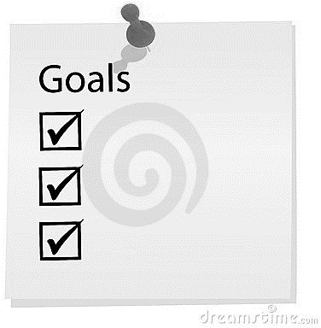
1.
2.
3.
How has alcohol stopped you achieving your goals in the past?
GOAL 3 because…
GOAL 2 because…
GOAL 1 because…

Knowledge 6: Alcohol passes quickly into your bloodstream

The physical and mental effects on your body can happen very suddenly.

To stop yourself from getting drunk and risking alcohol poisoning, it helps to be aware of how much you are drinking and the effect this could have on your body.

Remember –
1 pint of standard beer, or a 175ml glass of wine or a ‘double’ spirits = 2 units approximately

Around 2 units

- your heart rate will speed up and your blood vessels expand
- you get the warm, sociable feeling associated with moderate drinking
- You’re talkative and feel relaxed
- Your self-confidence increases as your inhibitions reduce
- Your driving ability and reflexes are already impaired

Around 4-6 units

- Your blood flow increase
- Your attention span is shorter
- Your sex drive may increase
- You start dehydrating (one of the causes of a hangover)
- your decision making and judgment will start to be affected, making you lose your inhibitions and become more reckless
- your nervous system will start to be affected, making you feel lightheaded
- your coordination will be affected and your reaction time may be slower
- Your liver is working harder

Around 8-9 units

- your reaction times will be much slower
- your speech will begin to slur
- your vision will begin to lose focus
- You are easily confused
- You are noticeably more emotional
- Your sex drive could now decrease and you become less capable
- your liver will be unable to remove all of the alcohol overnight, so it is likely you will wake up with a hangover

At this stage you should seriously consider not drinking any more - but if you do:

Around 10-12 units

- your coordination will be seriously impaired, placing you at high risk of having an accident

- you may stagger around or feel unstable on your feet
- you will feel drowsy or dizzy
- the amount of alcohol in your body will begin to reach toxic (poisonous) levels
- you may need to go to the toilet more often as your body attempts to quickly pass the alcohol out with your urine
- you will be dehydrated in the morning, and probably have a severe headache
- the excess alcohol in your system may upset your digestive system, leading to nausea, vomiting, diarrhea or indigestion

More than 12 units

- you're at high risk of developing alcohol poisoning, particularly if you are drinking lots of units in a short space of time
- the alcohol can begin to interfere with the automatic functions of your body, such as your breathing, heart rate and gag reflex
- you are at risk of losing consciousness

Some tips for drinking less-

- Replace some of your drinks with non-alcoholic or low-alcohol drinks.
- If you drink mainly when you go out, try going out later or having your first drink later.
- If you drink mainly at home, trying buying non-alcoholic or low-alcohol alternatives.
- Buy smaller glasses and watch how much you pour.
- If you enjoy drinking pints in the pub or cans of beer watching football, remember lower-strength lagers and beers are available.
- If you use alcohol to 'wind down' after a hard day, find alternatives, such as exercise classes or relaxation techniques.
- Avoid drinking on an empty stomach.
- Do not get caught up in large ‘rounds’.
- Limit the amount of money you have to spend.
- Avoid mixing different alcoholic drinks, such as beer with wine, or spirits with beer.
- Measure the drinks you pour at home, do not ‘top up’ your glass as it is difficult to judge the amount you are drinking.

Are there any ways that would help you cut down?

Worksheet 6: Has drinking been responsible for you getting in trouble with the police, being given a fine or sent to prison?

1.

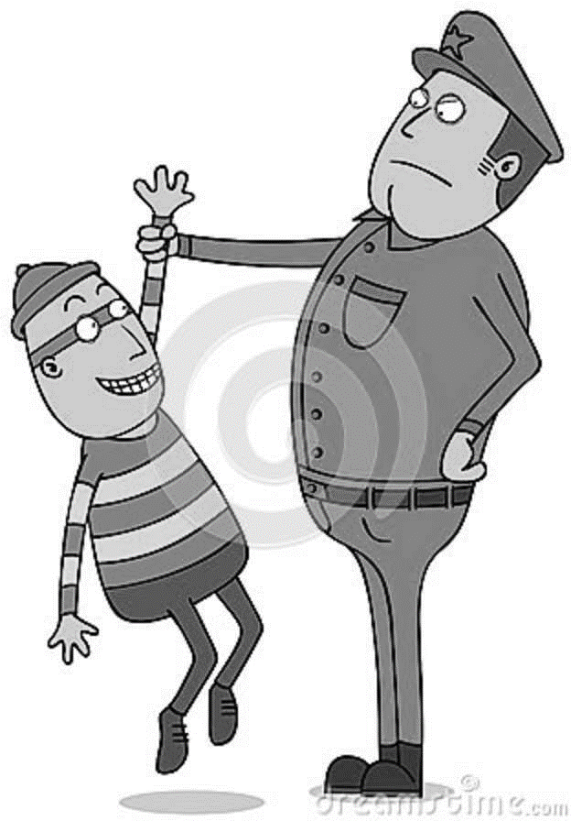
2.

3.

4.

5.

Knowledge 7: The risks of mixing alcohol with drugs.

As alcohol affects your brain and body it should be considered a ‘drug’.

It is dangerous to mix drugs together, and this can apply to illegal drugs, prescribed medications and over the counter medications.

Alcohol is a depressant and if mixed with other depressant drugs (e.g. heroin, methadone, tranquillisers, anti-depressants, anti-histamines and painkillers) can slow down your nervous system to dangerous levels and lead to a fatal overdose. You could go into a coma and stop breathing. Deaths from heroin overdose often involve alcohol.

Alcohol taken with cocaine combines in the body to produce Cocaethylene. The effects of taking these together are more dangerous than taking either alone. The cocaethylene stays in the body for much longer and recorded deaths have occurred up to 12 hours after mixing. The heart rate can increase up to 3 times which leads to a risk of heart attack. The risk of sudden death is 18 times greater. If you use alcohol and cocaine it is important to leave several days between using each to ensure it has cleared your system to reduce this risk.

If you take alcohol with a stimulant drug (e.g. Amphetamine, MDMA, caffeine) it can place additional stress on your heart and lead to increased risk of heart attack or stroke.
Combining these two substances (a depressant and a stimulant) can lead to problems associated with an inability of the heart to control what it is doing; is the heartbeat going up or down? Is there a need to speed up the process or slow it down?

Remember -always read the instructions on any medication to find out if it is safe to mix with alcohol. Sometimes alcohol can also make medication ineffective.

Worksheet 7: What are my triggers?

Please tick which ones are your triggers – add more in the blank boxes if you can think of any.

 | Sometimes | Always | Never
When I feel depressed
When I want to relax
When I’m bored
When my friends drink
When I have problems I am worried about
When I want to enjoy myself
When I feel unconfident
When I feel bad about myself
When I am angry
When I want to feel ‘normal’
When I think its not as bad as drugs
When I use other drugs

Looking at the above, how does this make you feel?:

Worksheet 8: Obstacles to change

List the obstacles that you might face if you stop or reduce your drinking. Also, list as many ways as you can to help overcome these obstacles (obstacles can be people, places, situations)

Obstacles | To overcome this obstacle I can…

Worksheet 9: In 5 years time….
If you were to CONTINUE drinking alcohol, where do you see yourself in 5 years time? Your relationships? Work?

Worksheet 10: In 5 years time….
If you were to stop or reduce drinking alcohol, where do you see yourself in 5 years time? Your relationships? Work?

Worksheet 1: Warm up quiz - ANSWERS

- Alcohol is:
- A depressive drug

Alcohol is a depressant, which means it can disrupt the way our body works slowing things down and the chemical balance in our brain affecting our thoughts, feelings and actions – and sometimes our long-term mental health.

For example, the relaxed feeling we can experience if we have a drink is due to the chemical changes alcohol has caused in the brain. A drink can make some people feel more confident and less anxious, as the alcohol begins to suppress the part of the brain associated with inhibition.

- Which of the following is true:
  - Everyone’s body processes alcohol units at different speeds
How the body processes alcohol units can vary. Factors that can affect this include weight, how much you have eaten and your physical health. Typically a body will take about 1 hour to process one unit.

3.Alcohol travels through the body by:
  - The bloodstream
Once swallowed, a drink enters the stomach and small intestine, where small blood vessels carry it to the bloodstream.

- Alcohol is broken down in:
  - The liver
Chemicals in your liver break down alcohol

- Which of the following statements are true or false?
  - Alcohol physically warms you up False
Alcohol causes your blood vessels to dilate. When you drink alcohol the volume of blood brought to the skins surface increases making you feel warm.

  - Alcohol affects your sense of balance True
As alcohol moves to the brain it affects your movement and balance.

  - Alcohol is good for you False

Alcohol can effect both your physical health and mental health.

Specialist support services are available to help with problems with drinking or drugs. You can access non-judgemental advice and information about how to keep safe and discuss potential treatment and support options.
Speak to the hotel staff who can help put you in touch with a local service.

