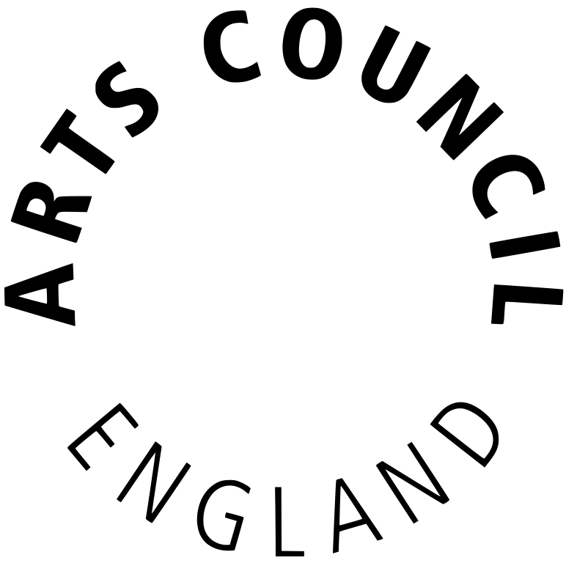
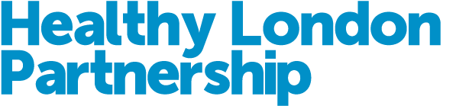

Arts and Mental Health for London application form
  - Deadline: Monday 5PM, March 16th 2020
The Healthy London Partnership in partnership with Arts Council England and the Mayor of London is inviting proposals from arts and cultural organisations who can work with us to help improve the health and wellbeing of people with mental health issues in either Southwark or Merton.
Grants from £3,000 to £10,000 per organisation are available, for programmes lasting around 3 and no more than 6 months. Any artform will be considered.
Please read the guidelines before writing your application.
Applications should be titled ‘Arts and Mental Health for London’ and sent to hlp.neighbourhood.networks@nhs.net as soon as possible and by no later than 5pm on Monday, March 16th 2020.
Your Application
Please follow the format set out below in making your application.
Please use at least a 12 point font size when completing the form and feel free to include annexes at the bottom i.e. part of this document, or as no more than one additional attachment.
There are no word limits, but brevity, bullet points, practical details, evidence of work to date, and above all vivid description of what this means in terms of user experience and ethos for people with mental health issues, are strongly encouraged.
If you have any questions about the application process please get in touch via hlp.neighbourhood.networks@nhs.net.

Application Form
You and your organisation
1. Your organisation’s name and address
2. Your organisation’s legal status e.g. charity, company limited by guarantee, Industrial and Provident Society, Community Interest Company etc.
3. Your name as lead applicant
4. Your contact details including mobile and email
5. What is the name or working title of the project you are applying to do?

6. Please give us a short summary of your project – max 50 words

7. Tell us the total amount you are applying to us for, including any personal access costs

8. Tell us the start and end dates for your project

9. Is your proposal for Southwark, Merton, or both boroughs?
Your proposal
10. Tell us more about your project and what you want it to achieve
Please cover:
- your target group
- the rationale for your approach
- some of the key hallmarks of your approach that make for an effective, high quality experience
- how you will work with and safeguard the wellbeing of vulnerable people, as well as your own staff
- how you will work with artists
- if you do not currently operate in Merton or Southwark, how this work might be sustained

11. How will you ensure that your work is able to reach vulnerable people, and those who may not have previously engaged with similar programmes? Please include examples from past and current programmes where relevant.
Impact
12. Please outline the anticipated activity and outputs from your project?
Please include:
- how many people will benefit from the project
- how many times people will take part
- what those people will do
13. Please outline any changes or outcomes that you expect to see from your work, including any impact beyond the direct participants in the programme

14. Tell us how you plan to monitor the progress of your project and evaluate your outcomes throughout the project

Planning and delivery
15. Tell us about your (or your organisation’s) recent relevant work and experience

16. Who will be involved in delivering the sessions/ activities with your target audience?

17. Are other partners involved, if so please outline how each partner will contribute to the activity, and give a brief description of their work
Finance
18. Please set out your total budget for this project (including details of any additional funding or in-kind support that you expect to receive for this work) and a high level overview of your expected expenditure (including how any larger cost items have been calculated e.g. for staff costs it is useful to include both number of days and average rate of pay).
Please note that there is no requirement for you to make a matched or in-kind contribution.

Annexes
Please feel free to add anything else below that you think will add colour or context to the work that your organisation does and to the project you are proposing.
Please include no more than one separate documents.

