Air pollution toolkit for schools

Air pollution can be damaging to everyone’s health, especially for children with asthma.

NHS North East London, together with Global Action Plan, have a number of resources, information and staff training available to help support children with respiratory conditions and reduce their exposure to air pollution.

The materials have been co-designed with local children, families and health professionals.

All of our resources can be found on our website: www.eastlondonhcp.nhs.uk/air-pollution

We need your help in sharing information with children, young people and their families - the resources are helpful for everyone, not just those with asthma.

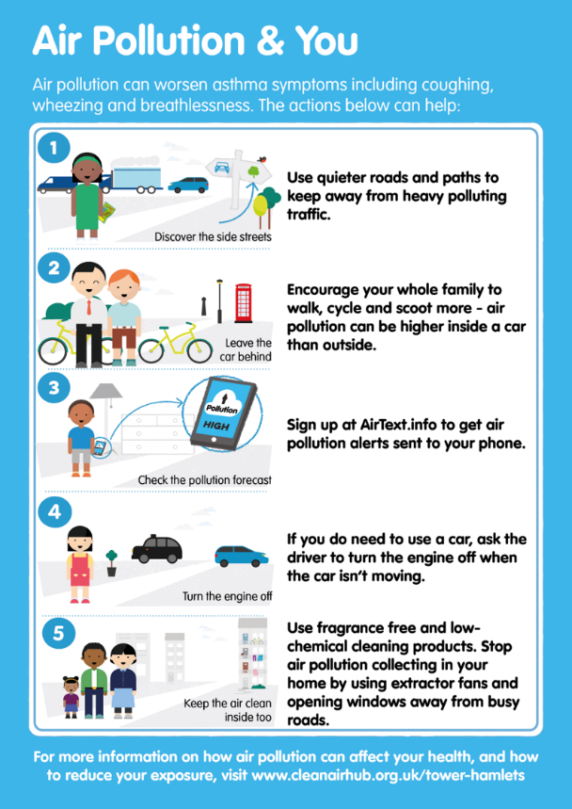
All north east London Boroughs are named air quality management areas, meaning they have high levels of air pollution. Out of the 10 places in the UK with the highest number of deaths related to air pollution, 7 of those are in north east London.
Our Air Pollution and You checklist and plan is a simple way for children and families to see what actions they can take to help reduce their exposure to air pollution.
We recommend schools sign up to receive high pollution day alerts by contacting AirqualityLondon@london.gov.uk

The table below sets out the resources available to you as a professional, and those available to your students and their families.
There is also pre-written copy and links that you can share in newsletters, on websites or on social media.
Many thanks for your help in advance in sharing these resources.
If you have any questions regarding the impacts of air pollution on health or the resources available, please contact: nelondon.teamchildhealth@nhs.net
The Babies, Children and Young People’s Programme Team
NHS North East London

Resources available

Resources available for children and their families

Item | Link
Air Pollution webpage  NHS North East London | www.eastlondonhcp.nhs.uk/air-pollution
Air Pollution and You checklist and plan | Downloadable PDF
airTEXT | Sign up at www.airtext.info
Resources available for teachers and staff

Air Pollution training slides | www.eastlondonhcp.nhs.uk/air-pollution  Downloadable PowerPoint slides in the download section on the right
Air Pollution webpage  NHS North East London | www.eastlondonhcp.nhs.uk/air-pollution
Air Pollution and You checklist and plan | Downloadable PDF
Greater London Authority High Air Pollution Alerts | AirqualityLondon@london.gov.uk

You can copy and paste the below information for your newsletters, websites and social media.

Newsletter copy

Parent newsletter

Air pollution can be damaging to everyone’s health, especially for children with asthma. Air pollution is in the air that we breathe in, and there are lots of different types, including: fires, car fumes, cleaning products and smoking, but there are simple steps we can take to help reduce our exposure to air pollution.

Visit the NHS North East London website for information about air pollution and download the Air Pollution and You checklist to see the five things you can do to help reduce your and your family’s exposure to air pollution.

Staff newsletter

Air pollution can be damaging to everyone’s health, especially for children with asthma. Out of the 10 places in the UK with the highest number of deaths related to air pollution, 7 of those are in north east London.
NHS North East London have an Air Pollution and You checklist that was co-designed with children, their families and health professionals. It’s a simple way for children and families to see what actions they can take to help reduce their exposure to air pollution, and improve symptoms like coughing, wheezing and breathlessness. The Air Pollution training slides provide helpful information so you can have confident conversations with families about the risks of air pollution and what steps they can take to help reduce their exposure. For more information and to download the Air Pollution training slides visit their website.

Medium copy

Air pollution can be damaging to everyone’s health, especially for children with asthma. For children who already have asthma, being exposed to more air pollution can increase coughing, wheezing and breathlessness.

NHS North East London have produced some helpful resources to see what actions you can take to help reduce your exposure to air pollution. The Air Pollution and You checklist shares 5 simple steps we can all take to improve our health, not just for those with asthma. Visit their website to find out more.

Short copy

Air pollution can be damaging to everyone’s health, especially for children with asthma. Take a look at the Air Pollution and You checklist, produced by children and health professionals in north east London, to see the five simple steps you and your family can take to reduce your exposure to air pollution, and improve symptoms like coughing, wheezing and breathlessness.

