Air pollution toolkit for health professionals and those working with children with asthma

Air pollution can be damaging to everyone’s health, especially for children with asthma. In the UK every year it causes 20,200 respiratory and cardiovascular hospital admissions and up to 36,000 deaths.

NHS North East London, together with Global Action Plan, have designed resources and training to provide you with the tools to talk to families and support children with respiratory conditions and reduce their exposure to air pollution.

The materials have been co-designed with local children, families and health professionals and can be found on our website: www.eastlondonhcp.nhs.uk/air-pollution.

We’re asking you to watch the short 8-minute online training video and share information regarding air pollution with children, young people and their families, to help make them understand how they can reduce their exposure.
The resources are helpful for everyone, not just those with asthma.

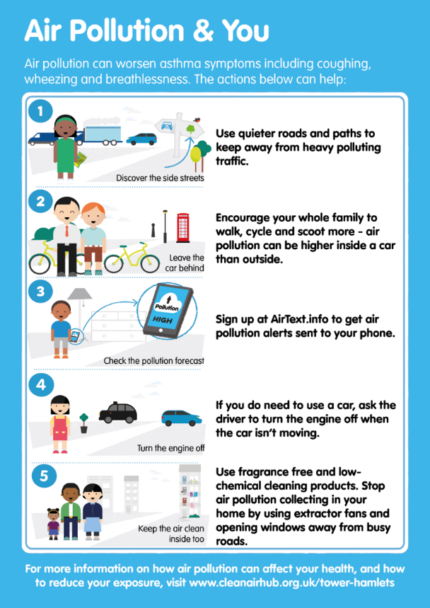
All north east London Boroughs are named air quality management areas, meaning they have high levels of air pollution. Out of the 10 places in the UK with the highest number of deaths related to air pollution, 7 of those are in north east London.
Our Air Pollution and You checklist is a simple way for children and families to see what actions they can take to help reduce their exposure to air pollution.
The table below sets out the resources available to you as a health professional, and those available to children and their families.
There is also pre-written copy and links that you can share in communication and updates to patients and their families as well as staff.
Many thanks in advance for undertaking the training and sharing these resources.
If you have any questions regarding the resources available, please contact: nelondon.teamchildhealth@nhs.net
The Babies, Children and Young People’s Programme Team
NHS North East London

Resources available

Resources available for children and their families

Air Pollution webpage  NHS North East London | www.eastlondonhcp.nhs.uk/air-pollution
Air Pollution and You checklist | Downloadable PDF  Checklist to share with patient and families with easy graphics to help understand the simple actions they can take to avoid air pollution
airTEXT | Sign up for free air pollution messages via text or email www.airtext.info/signup  Air pollution forecasts for Greater London, including air quality, UV, pollen and temperature
Resources available for health professionals

Air Pollution training video | www.youtube.com/watch?v=6W7oDZ_2VL8  Recorded presentation from Dr Rachel Parker to learn more about the impacts of air pollution on health
Air Pollution post training survey | www.surveymonkey.co.uk/r/NELairpollution  Complete this short 2-minute survey to let us know what you learnt from the training video
Stop smoking support letter | Downloadable PDF  To send to families regarding the impact of smoking on asthma
Housing support letter | Downloadable PDF  To send to local authorities, housing associations or landlords regarding the impact poor housing condition is having on a patients health
Other videos on Air Pollution and Asthma | www.cleanairhub.org.uk/mobilising-health-professionals  For more in depth information on Air Pollution and Asthma, see videos from experts in this field, Professor Grigg and Professor Holgate
Air Pollution webpage  NHS North East London | www.eastlondonhcp.nhs.uk/air-pollution  Includes air pollution posters and screensavers
Air Pollution and You checklist | Downloadable PDF
Greater London Authority  High air pollution alerts | AirqualityLondon@london.gov.uk  Sign your organisation up to receive an email on high air pollution days (3-8 times per year)
Communications to share with staff, patients and their families

You can copy and paste the below information for your clinical updates, patient text messages or your practice website.

Patient text – this copy length is within the character limit for eTexts and Whatsapp messages

Air pollution is in the air that we breathe in, there are lots of different types of pollution in the air around us and it can be damaging to everyone’s health. Take a look at the simple checklist to see what actions you can take to help reduce yours and your family’s exposure to air pollution: https://bit.ly/3ByO29E. More information on the impacts of air pollution can be found on the NHS North East London website: www.eastlondonhcp.nhs.uk/air-pollution

Staff newsletter

Air pollution can be damaging to everyone’s health, especially for children with asthma. Out of the 10 places in the UK with the highest number of deaths related to air pollution, 7 of those are in north east London.
NHS North East London have an Air Pollution and You checklist that was co-designed with children, their families and health professionals. It’s a simple way for children and families to see what actions they can take to help reduce their exposure to air pollution, and improve symptoms like coughing, wheezing and breathlessness.
The Air Pollution training video provides health care professionals with helpful information regarding the impacts air pollution has on a person’s health, so you can have confident conversations with families about the risks of air pollution and what steps they can take to help reduce their exposure. For more information and to download the Air Pollution training video visit the NHS North East London air pollution webpage.

Website

Air pollution is in the air that we breathe in, there are lots of different types of pollution in the air around us and it can be damaging to everyone’s health.

Take a look at the simple Air Pollution and You checklist to see what actions you can take to help reduce yours and your family’s exposure to air pollution, and improve symptoms like coughing, wheezing and breathlessness.
More information on the impacts of air pollution can be found on the NHS North East London website.

If you have any questions regarding the resources available, please contact: nelondon.teamchildhealth@nhs.net

