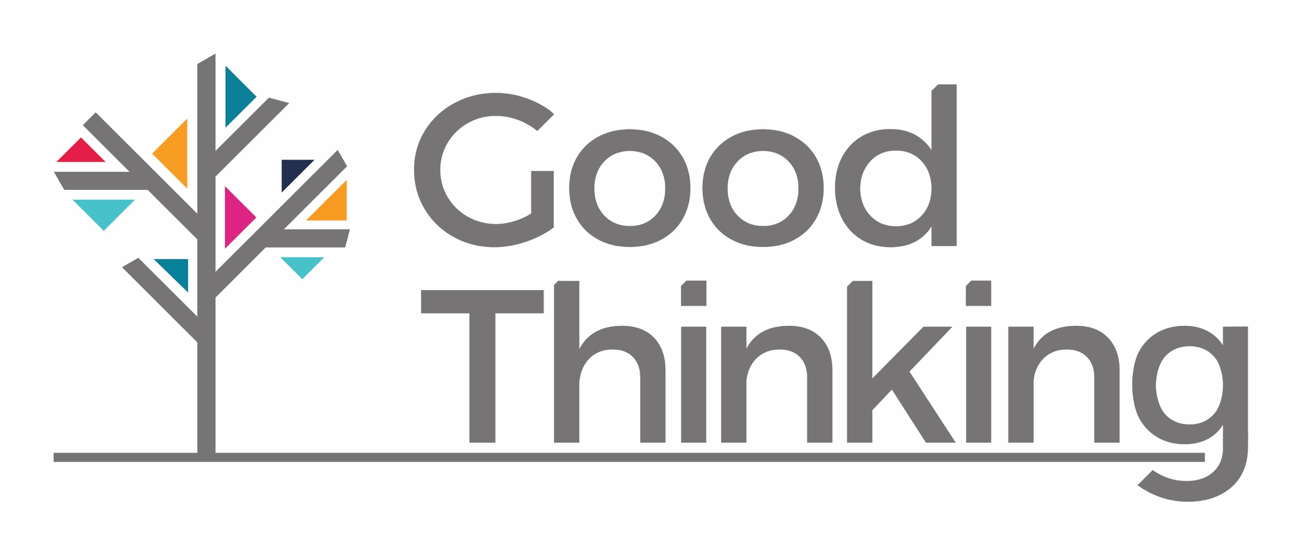
Add your organisation’s logo

XXX organisation invites XXX borough(s) to use Good Thinking to boost their wellbeing online
On 10 October 2018, World Mental Health Day, XXX CCG in partnership with London’s NHS, London Borough Councils, and Public Health England are pleased to announce that Good Thinking – London’s unique digital mental wellbeing service – has supported over 100,000 Londoners who are looking for personalised new ways to improve their mental wellbeing.
Good Thinking launched in November 2017 and developed through a partnership of XXX your organisation, London’s Borough Councils led by Directors of Public Health, London’s NHS and Public Health England. It provides safe, proactive and early intervention tools to Londoners who are experiencing the four most common mental health and wellbeing concerns: sadness, stress, sleep, and anxiety.
Good Thinking uses social media and search advertising to reach people who are seeking new ways to improve wellbeing, and directs them to its website where online self-assessment tools enable users to access a wide range of resources personalised to their needs.
Over 120 online resources are signposted to through www.good-thinking.uk, including wellbeing information sources; guides to improving mental health; courses on and offline; mobile apps and other therapy approaches suitable for London’s modern, highly-mobile population.
XXX Chair/Chief Officer/Accountable Person, of XXX your organisation, said:
Suggested quote to highlight support for these four common mental health/wellbeing concerns, accessibly 24/7: “People in XXX boroughs(s) have a unique opportunity to access the latest positive wellbeing techniques and tactics using by Good Thinking. Being stressed, anxious, unable to sleep or feeling down can take a terrible toll on you and your loved ones. With London’s Good Thinking you have a safe way to get advice and can take immediate steps as soon as you realise there is a problem, any time of the day or night.”
Paul Plant, Deputy Director, Public Health England (London), said:
“Good Thinking is an innovative digital solution designed to improve Londoner’s mental health and wellbeing. This unique online 24 hour service finds people who may be struggling with a range of issues impacting on their mental health and directs them to an extensive range of resources personalised to meet their need. It is underpinned by insights into people’s behaviour and a rigorous independent evaluation.”
Everyone who lives and works in XXX your borough is encouraged to visit www.good-thinking.uk anytime of the day or night. There they can take advantage of the simple three-question wellbeing check-ups, or more detailed self-assessment tools, to find the latest on and offline products and support that can help boost good mental health.

Notes for editors
- Insert a description of your organisation
- Good Thinking is an NHS approved online mental wellbeing service. It is made possible by funding from London’s borough councils, NHS and Public Health England and supported by Healthy London Partnership.
- Every day Good Thinking reaches out to Londoners who are stressed, can’t sleep, feeling anxious, or low.
- Users of www.good-thinking.uk are anonymous and can choose not to submit personal identifying information (IP addresses identify when users are in London).
- Via self-assessment quizzes on www.good-thinking.uk users can access over 120 different online resources. Over 90 are free or have free content. Others have a small charge or can be made available via health insurers. All are assessed by an NHS Specilaist Clinical Psychiatrist for suitability. They offer a diverse variety of approaches for managing the identified conditions via techniques and technology readily accessible in 2018.
- Two resources (Sleepio and Be Mindful) have been made completely free to Londoners via Good Thinking.
- Since its launch in November 2017, Good Thinking has had approx. 145,000 users (100,810 unique visits) across all four conditions (anxiety, sleeplessness, stress and depression).
- A formal evaluation of Good Thinking is underway by King’s College London – results are expected in Summer 2019.
- For media enquiries about Good Thinking contact Kim Boyle (kim.boyle@nhs.net) at Healthy London Partnership’s Press Office.

