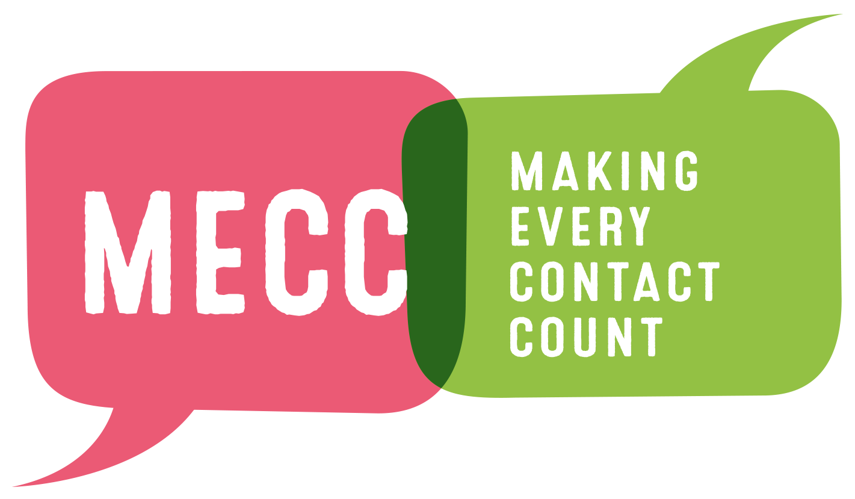



**MECC DRAFT INTRANET ARTICLE**

Here is some editable copy for an intranet article.

We’re committed to Making Every Contact Count (MECC), through a new campaign aiming to address health inequalities throughout London.

MECC is about behavioural change. It is about workforce colleagues from across NHS giving Londoners consistent, simple messages and pointing them to services that help improve their health and wellbeing.

By taking advantage of over one million interactions between the public and healthcare workers every 36 hours, conversations as brief as thirty seconds can help signpost people towards better decisions about their lifestyle.

In London, our aim is to specifically address preventable health inequalities caused by factors such as smoking, drinking and lack of exercise, as well as issues surrounding mental health.

Over the coming weeks, here at __, we will begin our MECC journey, more information will follow soon.

In the meantime, please check out the [Healthy London Partnership website](https://www.healthylondon.org/our-work/prevention/making-every-contact-count/) for more info and help spread the campaign through your networks.

You can also join the social media conversation through the hashtags **#MECC** and **#MakingEveryContactCount.**

Your MECC lead is [insert contact details]



