Annual Review template for EMIS

EMIS TEMPLATE FOR ASTHMA REVIEWS
Developed in conjunction with Camden CCG ² and The Whittington Hospital. ²

Acknowledgements: Dr Oliver Anglin¹, Mr Satya Bobba¹, Dr Reena Bhatt², Colette Datt² and Dr John Moreiras ^{1, 2}

Asthma is largely managed in the community and the need for thorough review is crucial in ensuring that any deterioration is identified.

As highlighted in the National Review of Asthma Deaths and as part of the London Asthma Standards (No 23 and 28) all patients should have at least an annual review, should have a review post exacerbation within 2 days and have a written asthma plan.

It is important at each review to ask the same questions:

- Is it asthma?
- Is it controlled?
- What is the next step in management?

Below is a template that has been developed with the above questions in mind and provide a structure for reviews done in primary care. The template is compatible with EMIS and can be adapted to local use.

For more information please contact:

Dr Reena Bhatt (reena.bhatt2@nhs.net) or
Satya Bobba (satya.bobba@comdenccg.nhs.uk)

Observations Page:
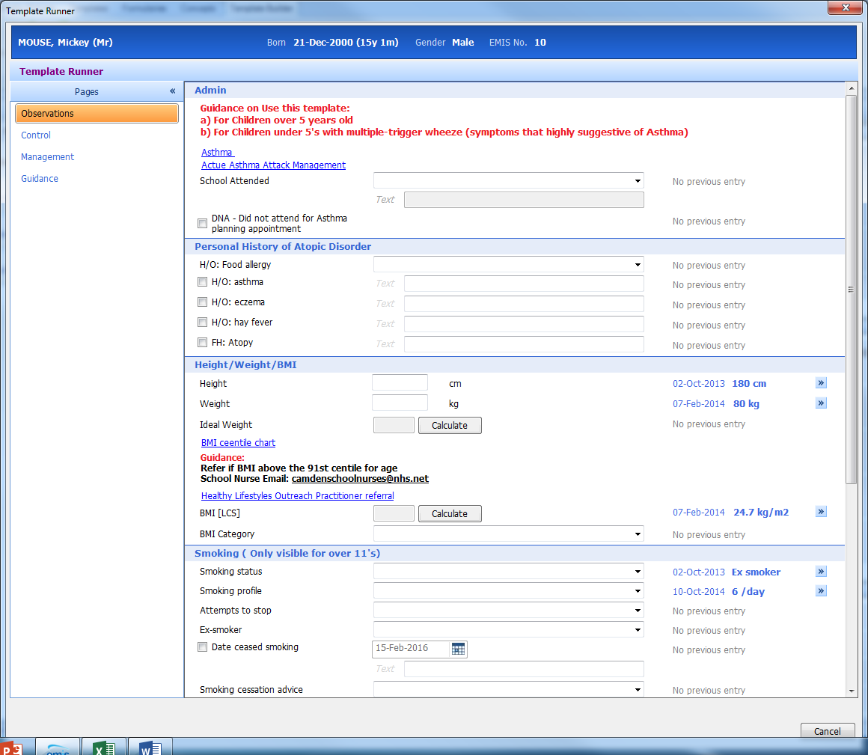
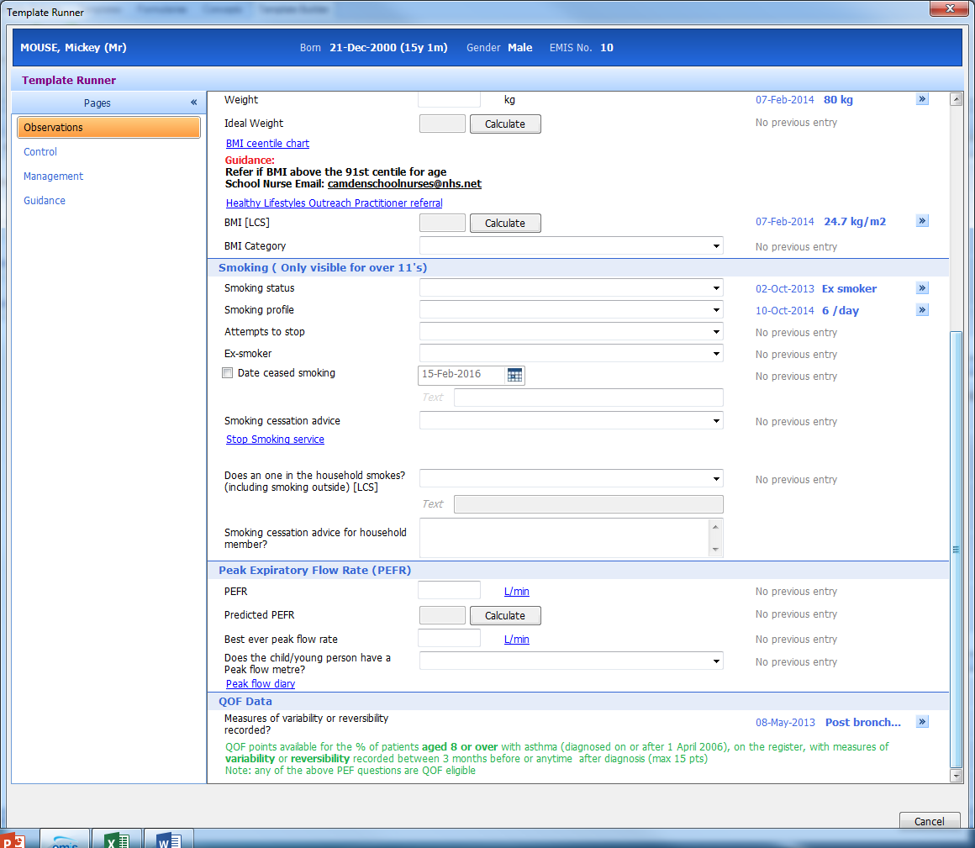

Control Page:
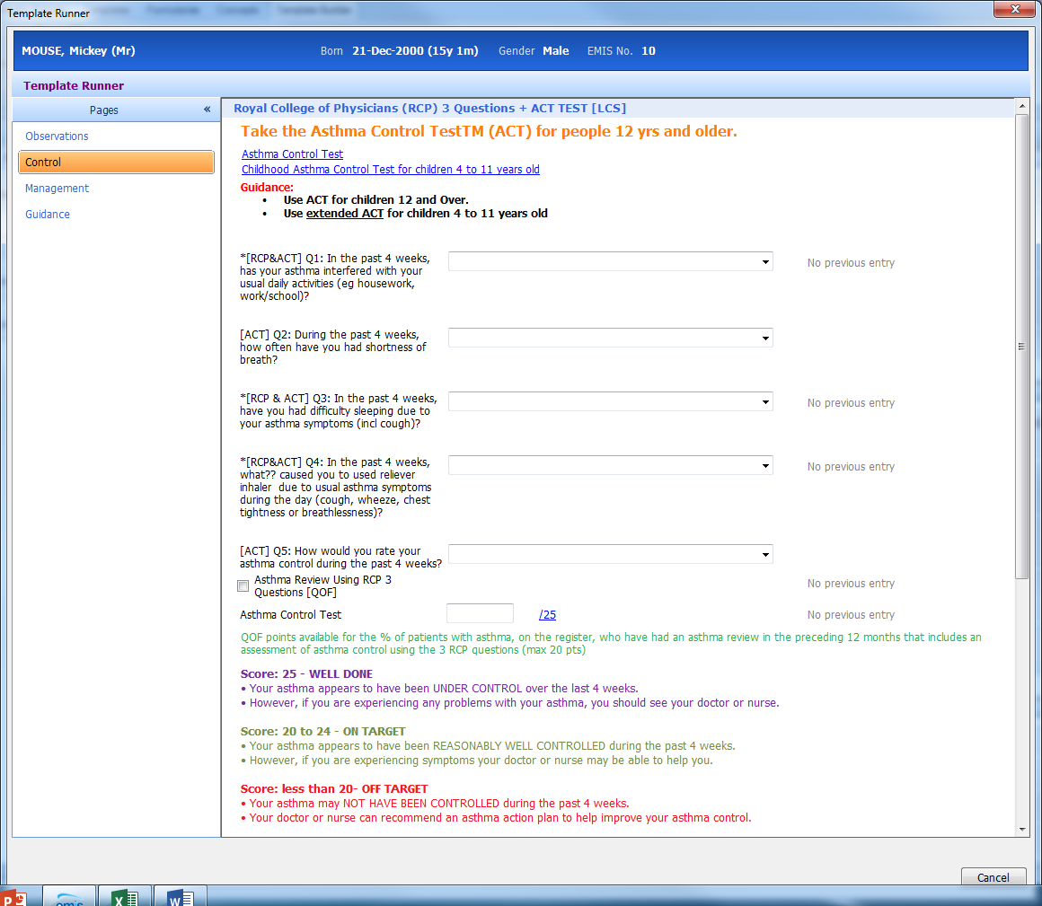
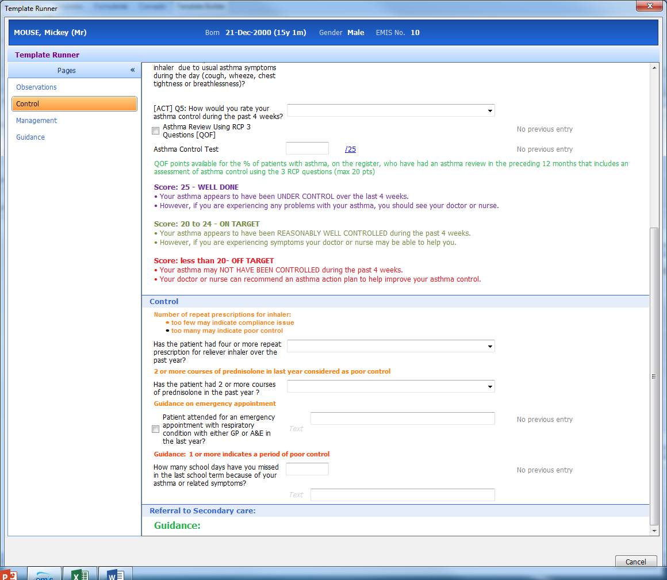

Management Page:
