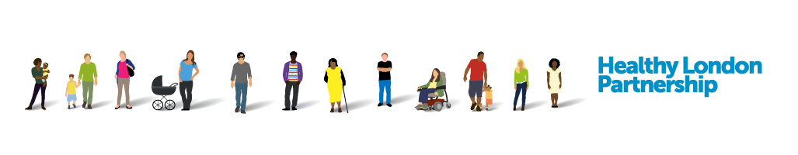

Asthma event Parkview Health Centre
1 November 2018

2.30 – 3.30pm: Session for pre-school children - bring along your Teddy Bear!
3.30 – 4.30pm: Drop-in clinic for kids after school
4.30 – 5.30pm: Drop-in session for teens

